Videos 15C2 - Work for Cycles Name

Method 1 - adding up all the processes:
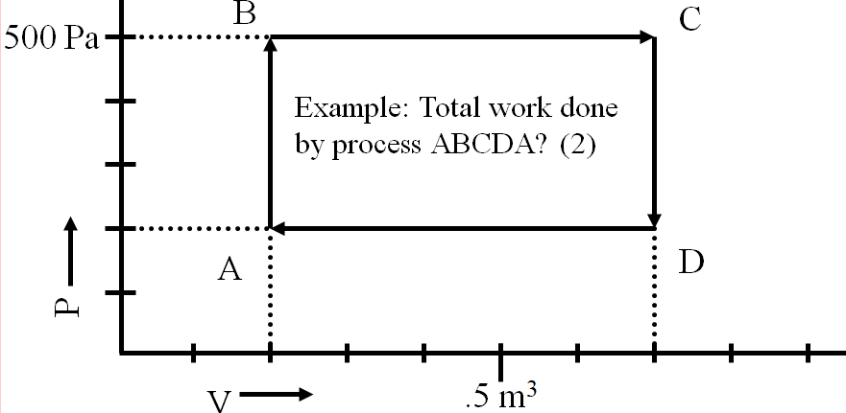

AB = BC = CD = DA =

Total Work =

Method 2 - Area inside the process:

The rule about Clockwise vs. Anti-Clockwise:

Heat engines and heat flow:
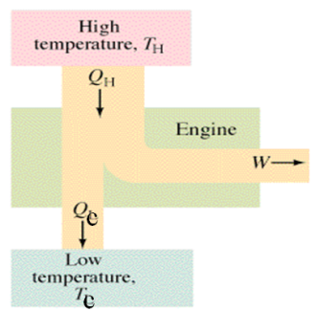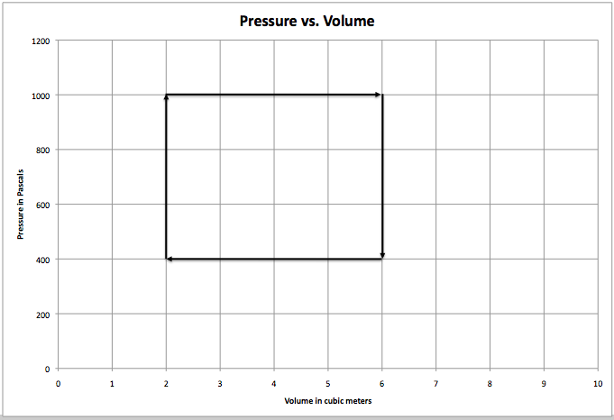

over
Whiteboards
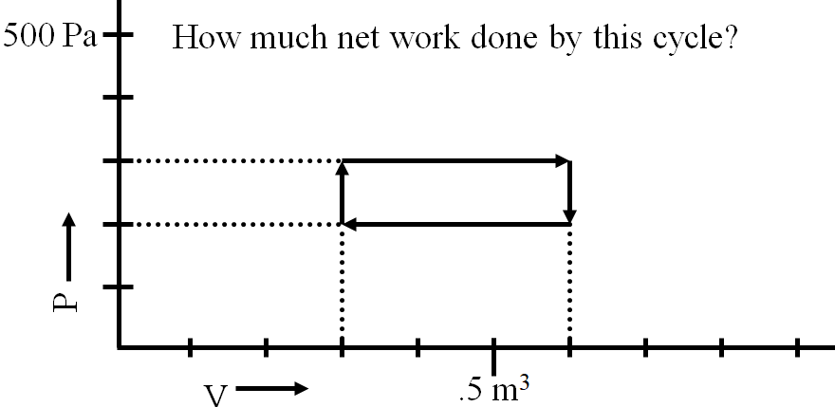  (+30 J) | What is the work done by this cycle?  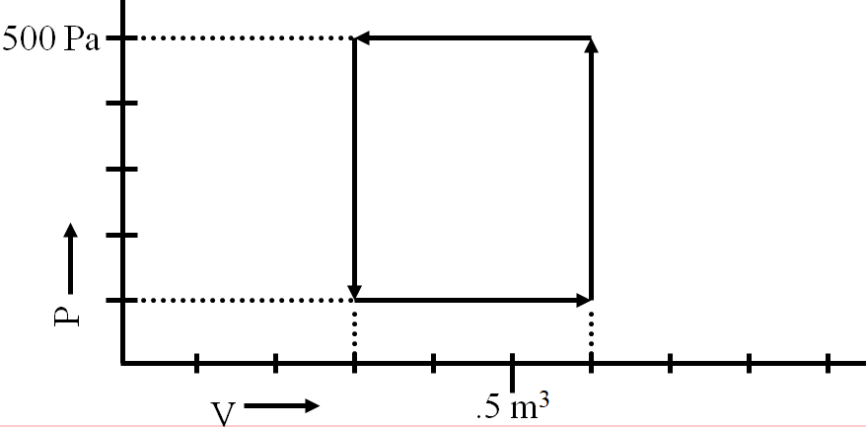  (-120 J - work on the engine)
What is the work done by this cycle?  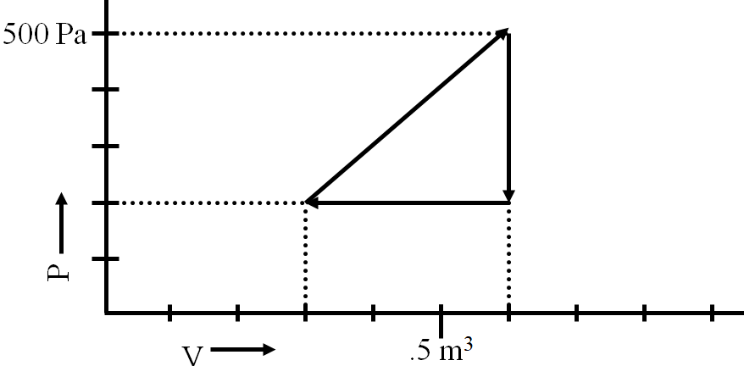  (+45 J - Use the area) | What is the work done by this cycle?  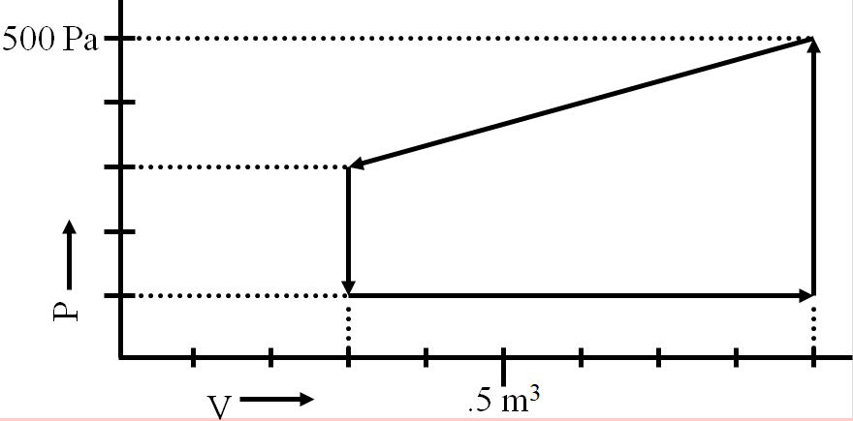  (-180 J)

