Videos 15C1 - Work, Pressure and Volume: Name
Write down the formula for work in terms of Pressure, and change in volume.

W =

Example: What work done by an isobaric compression at 500 Pa from 0.85 m³ to 0.52 m³?

PV Diagrams:
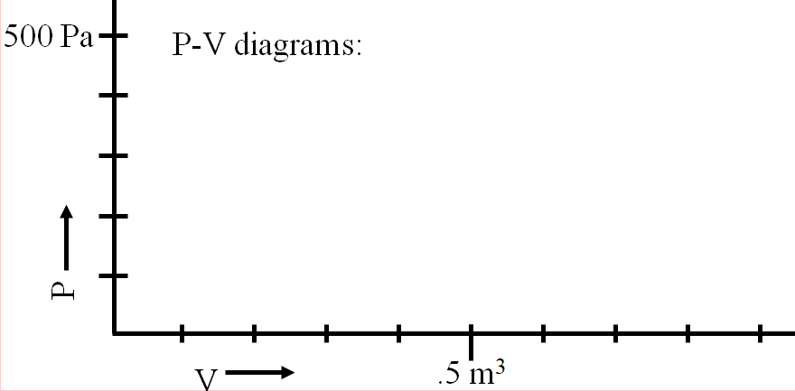

Example:
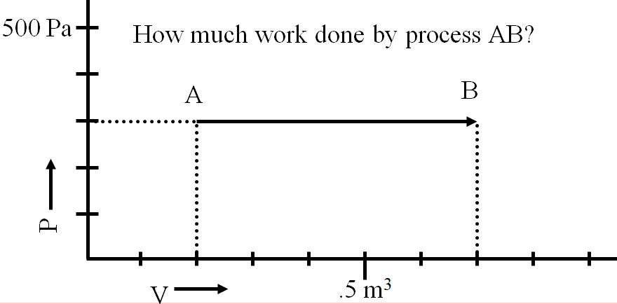

Whiteboards:
Hugo First has a gas in a cylinder that expands from 200. liters to 500. liters at a pressure of 1200 Pa. What work did the gas do? (1000 liters = 1 m³) (360 J) | Mr. Fyde compresses a cylinder from 0.0350 m³ to 0.0210 m³, and does 875 J of work. What was the average pressure?  (62500 Pa)
over

More Whiteboards
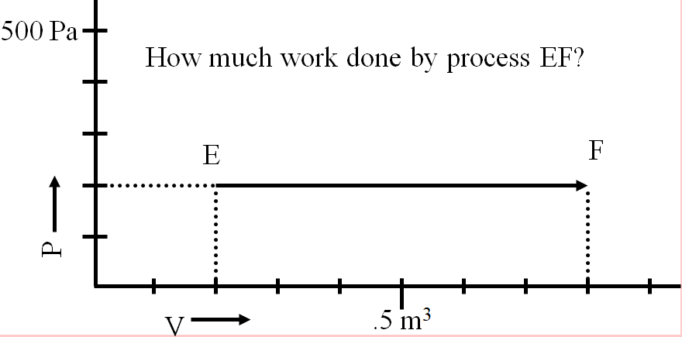  (120 J) | 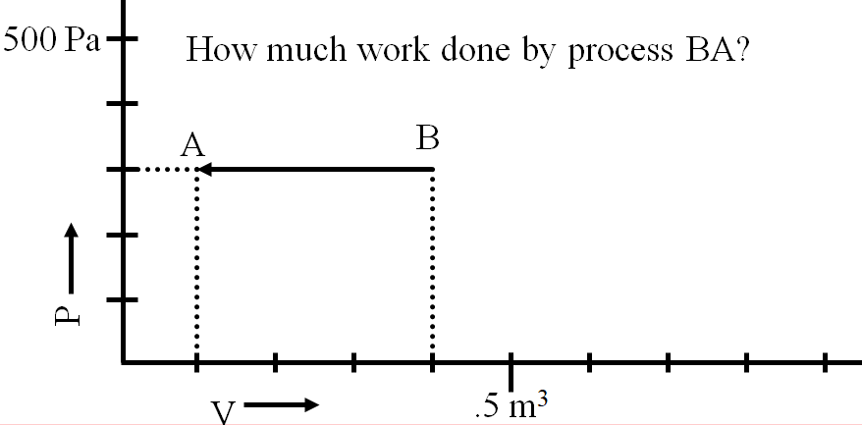  (-90 J - work on the gas)
What is the work done by this process?  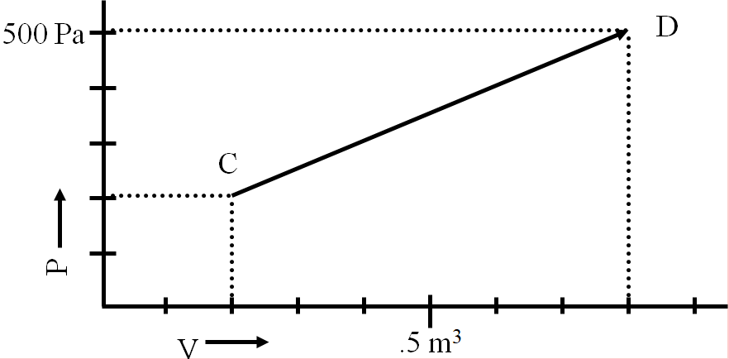  (210 J - Use an average pressure ) | 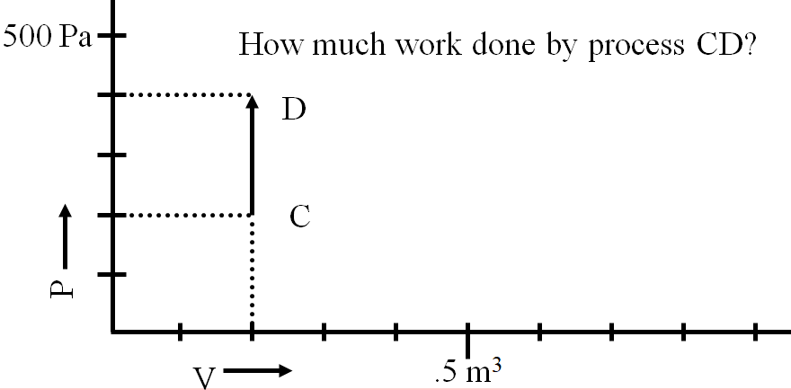  (does the piston move at all? Is there any change in volume?)

