**Worksheet 15A: Laws of thermodynamics, heat engines, and PV diagrams.**

Some specific heats

(in JoC-1kg-1)

Aluminium 900

Iron 450

Lead 130

**Objective A: Mechanical energy and heat**

**Problems:**

1. The Dryden drop tower at PSU uses inductive braking. If a 145 kg package is dropped 22.2 m, and 100% of the potential energy is absorbed as heat by the two 2.5 kg Aluminium brake fins on either side, what would be the temp. rise of the fins? (7.0 oC)
2. A biker and bike with a total mass of 87.2 kg stops, causing the 0.238 kg iron disc brake rotor to heat up from 23.0 oC to 85.1 oC. How fast was the bike going if 100% of the kinetic energy of the bike was absorbed as heat by the disc brakes? (12.4 m/s)
3. A 4.20 g lead bullet going 387 m/s strikes a block of wood. 75% of its kinetic energy is absorbed as heat. What amount of the lead would melt at its melting point of 327.5 oC if the original temperature is 23.0 oC, and the latent heat of fusion is 2.50x104 J/kg? (2.79 g)

**Objective B: Q = U + W**

**Questions:**

1. +Q means heat flows in or out of the gas?
2. How do you know if U changes? Can the temperature ever stay the same when U changes?
3. +W means the piston moves in or out? +W means work on the gas, or work on the world?

**Problems:**

1. How much heat must flow into a gas if the internal energy rises by 13 J, and it does 19 J of work pushing its piston out? (+32 J)
2. 43 J of heat flow out of a gas, and it does 72 J of work on the world. What is the change in internal energy of the gas? Did heat flow in or out? Did the piston move in or out? Did the temperature rise or fall? (-115 J, Heat flowed out, Piston moved out, Temperature fell)
3. If 67 J of heat flow into a gas, and its internal energy rises by 52 J, what is the work done? Did heat flow in or out? Did the piston move in or out? Did the temperature rise or fall? (+15 J, Heat flowed in, piston moved out, temperature rose)
4. Bob does 17 J of work on a gas, and 38 J of heat flow into the gas. What is the change in internal energy? Does the piston move in or out? Does the temperature rise or fall? (+55 J, piston moves in, temperature rises)
5. An ideal gas does 45 J of work, and the internal energy changes by -39 J. What is the heat flow? Did heat flow in or out? Did the piston move in or out? Did the temperature rise or fall? (+6 J, heat flowed in, piston moved out, and temperature fell)

**Objective C: W = PΔV**

**Questions:**

1. Why do the processes **bc**, and **da** below have zero work?
2. How could you make process **da** below happen? What would you have to do to the temperature?
3. Process **ab** below cut the volume in half, yet the pressure does not rise, and no gas leaks, so what must happen to the temperature to keep the pressure from rising?
4. Process **cd** below increases the volume by a factor of two, yet the pressure does not drop. What must happen to the temperature for this to happen?

**Problems:**

1. How much work to isobarically compress a gas at 105 kPa from 0.067 m3 to 0.045 m3? (2310 J)
2. A piston compresses isobarically from a volume of 0.035 m3 to 0.017 m3. If this requires 13,700 J of work, what was the pressure? (7.6x105 Pa)
3. (Challenge) When a gas is taken from a to c along the curved path in the figure below, the work done by the gas is W = -35 J and the heat added to the gas is Q = -63 J. Along the path abc, the work done is W = -48 J. (a) What is the Q for path abc? (b) If Pc = 1/2Pa, what is W for path cda? (c) What is Q for path cda? (d) What is Ua – Uc? (e) If Ud – Uc = 5 J, what is Q for path da? (from Giancoli) (-76 J, 24 J, 52 J, 28 J, 23 J) (Use Q = ΔU + W)
4. (Challenge) In the process of taking a gas from state a to state c along the curved path shown below, 80 J of heat leaves the system, and 55 J of work is done *on* the system. (a) Determine the change in internal energy Ua – Uc. (b) When the gas is taken along the path cda, the work done by the gas is W = 38 J. How much heat Q is added to the gas in the process cda? (c) If Pa = 2.5Pd, how much work is done by the gas in the process abc? (d) What is Q for path abc? (e) If Ua - Ub = 10 J, what is the Q for the process bc? (from Giancoli) (25 J, 63 J, -95 J, -120 J, -15 J) (Use Q = ΔU + W)

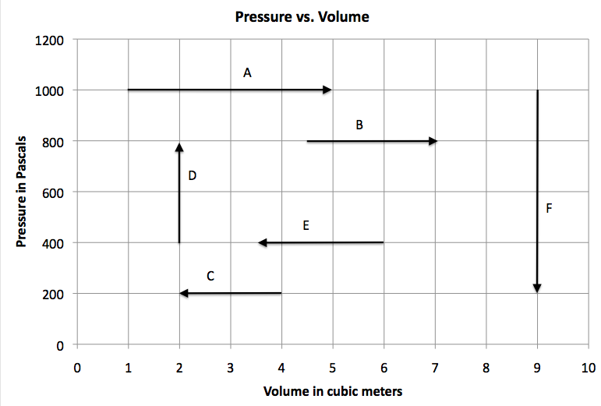

**For each process, calculate the work done, and say what happens to the pressure, volume and temperature.**

1. A Also – what is the temperature at the beginning and end of this process if this is for 2.407 mols of gas? (Use PV = nRT) (Work = 4000 J, pressure constant, volume increases, temperature rises, 50. K, 250 K)
2. B (Work = 2000 J, pressure constant, volume increases, temperature rises)
3. C (Work = -400 J, pressure constant, volume decreases, temperature falls)
4. D Also – what is the temperature at the beginning and end of this process if this is for 2.407 mols of gas? (Work = 0 J, pressure rises, volume constant, temperature rises, 40. K, 80. K)
5. E (Work = -1000 J, pressure constant, volume decreases, temperature falls)
6. F (Work = 0 J, pressure falls, volume constant, temperature falls)

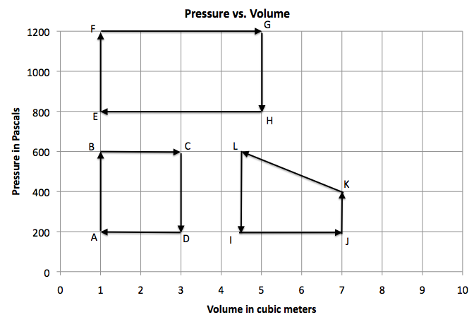

1. What is the net work done for cycle ABCD? If point A is at 60.0 K, how many mols of gas do you have, and what are the temperatures of the other vertices BCD, (+800 J, 0.401 mols, 180 K, 540 K, 180 K)
2. What is the net work done for cycle EFGH? (+1600 J)
3. What is the net work done for cycle IJKL? (-750 J)
4. Cycle MNOP is as follows: MN starts at 400 Pa and 8.0 m3 and 480 K and heats isochorically (Constant V) to 1100 Pa, NO is an isobaric (Constant P) expansion to 10.0 m3, OP is an isochoric cooling back to 400 Pa, and PM is an isobaric compression to 8.0 m3. Draw this cycle on the graph above, calculate the work done, the mols, and the temperature of the vertices NOP. (+1400 J, 0.802 mol, 1320 K, 1650 K, 600 K)

**Objective D: adiabatic, isothermal, isochoric, isobaric processes**

**Questions:**

1. In an adiabatic compression, physically how does the piston increase the temperature of the gas?
2. In an adiabatic expansion, physically how does a piston lower the temperature of the gas?

**IB Physics**

**FA 15.1 - PV Diagrams**

Name

Favorite Saying

**Show your work, and circle your answers and use sig figs to receive full credit.**

When you have finished this, go to the website and check your answers. If you got a problem wrong, cross it off on the front, and do it correctly on the back.

This is a Pressure v Volume graph for 0.280 mols of an ideal gas.



The system starts at a pressure of 175. Pa and a volume of 1.60 m3 and goes through these four processes:

1. Isobaric (constant pressure) compression to 0.400 m3
2. Isochoric (constant volume) cooling to 50.0 Pa
3. Isobaric expansion to 1.60 m3
4. Isochoric heating to 175 Pa

Draw all four processes. Use **arrows** for the processes, and **label** each process 1, 2, 3 or 4

1. Calculate the highest and lowest **temperature** (in K) **Label** these temperatures at the corners **on the graph above**.

2. Calculate the **work done by each process**, and the **net work** done by the gas in the entire cycle.

3. At what temperature in Celsius does 14.0 grams of Helium have a total internal energy of 9450 J? (He = 4.003 g/mol)

4. 32 J of heat flow into a gas, and its internal energy drops by 17 J, how much work did the gas do? Does the temperature rise or fall? (Answer both questions)

Fred does 35 J of work compressing a gas in a cylinder, and the internal energy rises by 13 J, what is the amount of heat flow into the gas? Does heat flow into or out of the gas? (Answer both questions)

5. What is the change in entropy of 1.20 kg of water boiling into vapor at 100.0 oC? (L = 22.6x105 J/kg)

**Worksheet 15B: Internal Energy, Adiabatic processes, Entropy, and Carnot**

**Objective G: Internal energy, Temperature and Mols **

**Problems:**

1. What is the internal energy of 13.0 grams of Neon gas (m = 20.1797 g/mol) that is at 45.0 oC? (2550 J)
2. How many mols of an ideal gas would have an internal energy of 8910 J at a temperature of 25.0 oC? (2.40 mols)
3. At what temperature in Celsius does 2.30 mols of an ideal gas have 34,500 J of internal energy? (930. oC)
4. What is the internal energy of 153 grams of Argon gas at STP? (m = 39.948 g/mol) (13,040 J)
5. At what temperature in Celsius does 15.0 mols of an ideal gas have 126,000 J of internal energy? (401 oC)

**Objective H: Pressures and volumes in adiabatic processes **

**Questions:**

1. Physically, how does a compressing piston heat up a gas?
2. Why does an adiabatic compression that cuts the volume in half, more than double the pressure?
3. Physically, how does an expanding piston cool a gas?
4. Why does an adiabatic expansion that doubles the volume, cut the pressure by more than a half?

**Problems:**

1. An ideal gas adiabatically expands from a pressure of 7820 Pa and volume of 4.50 liters to 6.70 liters. What is the new pressure? (4030 Pa)
2. 5.20 liters of an ideal gas is adiabatically compressed from a pressure of 12,400 Pa to 24,800 Pa. What is the volume after the compression? (3.43 Liters)
3. An ideal gas is compressed adiabatically from a pressure of 56,210 Pa and volume of 6.25 liters to 2.13 liters. What is the new pressure? (338,000 Pa)
4. 254 cubic inches of an ideal gas is adiabatically expanded from a pressure of 64.0 psi to 16.0 psi. What is the volume after the expansion? (584 cubic inches)
5. 12.0 cubic centimeters of an ideal gas is adiabatically compressed from a pressure of 242 Torr to 363 Torr. What is the volume after the compression? (9.41 cc)

**Objective I: Entropy **

**Questions:**

1. Why does the net entropy increase when a hot object comes to equilibrium with a cold?

**Problems:** (For water Lf = 3.33x105 J/kg, Lv = 22.6x105 J/kg)

1. A 145 g piece of iron (c = 450. J/kg/oC) cools from 24.0 oC to 22.0 oC. Estimate its change in entropy. (-0.441 J/K)
2. 45.0 grams of water freeze at 0 oC. What is the change in entropy? (-54.9 J/K)
3. A Carnot cycle engine has an isothermal compression that occurs at 56.0 oC in which 14.0 J of work are done on the gas. What is the change in entropy of the gas in the engine, and what is the change in entropy of the low temperature heat reservoir? (For gas: -0.0425 J/K, for reservoir: +0.0425 J/K)
4. A Carnot cycle heat engine has an isothermal expansion that occurs at 352 oC in which the gas does 63.0 J of work. What is the change in entropy of the gas in the engine, and what is the change in entropy of the low temperature heat reservoir? (For gas: +0.101 J/K, for reservoir: -0.101 J/K)
5. 450. ml of liquid water boil into vapor at 100. oC. What is the change in entropy of the water? (+2730 J/K)
6. 145 grams of water vapor condense to liquid water at 100.0 oC. What is the change in entropy? (-878 J/K)
7. An 86.0 gram ice cube melts at 0.0 oC. What is the change in entropy? (+105 J/K)
8. A Carnot cycle heat engine has an isothermal expansion that occurs at 651 oC in which the gas does 5120 J of work. What is the change in entropy of the gas in the engine, and what is the change in entropy of the low temperature heat reservoir? (For gas: +5.54 J/K, for reservoir: -5.54 J/K)
9. A Carnot cycle engine has an isothermal compression that occurs at 112 oC in which 11,400 J of work are done on the gas. What is the change in entropy of the gas in the engine, and what is the change in entropy of the low temperature heat reservoir? (For gas: -29.6 J/K, for reservoir: +29.6 J/K)

**Objective J: Carnot cycle and heat engines** 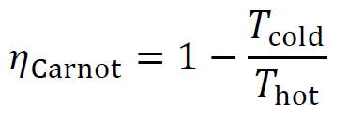 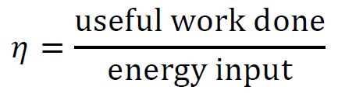

**Questions:**

1. Outline the four processes that make up a Carnot cycle. Sketch it on a PV diagram.
2. Explain why isothermal processes cause no net change in entropy.
3. Why is an isothermal process hard to pull off in a timely manner?
4. Explain why adiabatic processes cause no change in entropy.

**Problems:**

1. A heat engine does work at a rate of 735 Watts, and radiates waste heat at a rate of 137 Watts. At what (Watt) rate does it consume energy? (872 W)
2. A Carnot cycle consumes 35.0 J of heat and wastes 23.0 J of heat. If the boiler is at 197 oC, what is the exhaust **temperature**? (Answer in Celsius) (35.8 oC)
3. A power plant operates at full Carnot efficiency. It consumes heat from the boiler at a rate of 985 Watts, and wastes heat at a rate of 421 Watts. It exhausts heat at a temperature of 97.0 oC.
   1. At what (Watt) rate does this engine do **work**? (564 W)
   2. What is the **efficiency** of this engine? (0.573)
   3. What is its boiler **temperature**? (Answer in Celsius) (593 oC)
4. A heat engine consumes heat at a rate of 99.0 Watts, and wastes heat at a rate of 27.0 Watts. At what (Watt) rate does it do **work**? (72.0 W)
5. A Carnot cycle operates between 338 oC and 35.0 oC. What **heat** does it waste if it consumes 539 J? (272 J)
6. A power plant operates at full Carnot efficiency . It does useful work at a rate of 985 Watts, and wastes heat at a rate of 613 Watts. It has a boiler temperature of 572 oC.
   1. At what (Watt) rate does this engine consume heat from the boiler? (1598 W)
   2. What is the **efficiency** of this engine? (0.616)
   3. What is the exhaust **temperature**? (Answer in Celsius) (51.1 oC)
7. A heat engine consumes 96.0 J of heat and does 53.0 J of work. What **heat** does it waste? (43.0 J)
8. A Carnot cycle operates at an efficiency of 32.0 % with a cool temperature of 53.0 oC. What is its boiler **temperature**? (Answer in Celsius) (206 oC)
9. A power plant operates at full Carnot efficiency between 86.0 oC and 665 oC. It consumes heat from the boiler at a rate of 8720 Watts.
   1. What is the **efficiency** of this engine? (0.617)
   2. At what (Watt) rate is **work** done? (5380 W)
   3. At what rate is heat wasted? (3340 W)
10. A heat engine does 12.0 J of work, and wastes 25.0 J. What **heat** does it consume? (37.0 J)
11. A Carnot cycle operates between 426 oC and 91.0 oC. What is its **efficiency**? If it consumes 263 J of heat, how much **work** does it do? (0.479, 126 J)
12. A power plant operates at full Carnot efficiency between 93.0 oC and 378 oC. It wastes heat at a rate of 3610 Watts.
    1. What is the **efficiency** of this engine? (0.438)
    2. At what (Watt) rate does heat flow from the boiler? (6420 W)
    3. At what rate is **work** done? (2810 W)
13. A heat engine consumes 95.0 J of heat and wastes 78.0 J. What **work** does it do? (17.0 J)
14. A Carnot cycle operates at an efficiency of 38.0 % with a boiler temperature of 641 oC. What is its exhaust **temperature**? (Answer in Celsius) (294 oC)
15. A power plant operates at full Carnot efficiency between 49.0 oC and 295 oC. It has a power output of 7820 Watts.
    1. What is the **efficiency** of this engine? (0.433)
    2. At what (Watt) rate does heat flow from the boiler? (18,060 W)
    3. At what rate is heat wasted? (10,240 W)

**IB Physics**

**FA 15.2 - Carnot Cycle**

Name

Middle Name Do you like your middle name?

**Show your work, and circle your answers and use sig figs to receive full credit.**

When you have finished this, go to the website and check your answers. If you got a problem wrong, cross it off on the front, and do it correctly on the back.

1. If you compress 16.0 liters of an ideal gas that is at 14.0 psi adiabatically (quickly) so that the pressure doubles, what is the new volume?

2A. A heat engine consumes 57 J of heat and does 23 J of work. What heat does it waste?

2B. A heat engine is 13.5% efficient. How much heat does it waste if it does 45.0 J of work?

3. A heat engine that has a Carnot efficiency of 56.0 % and has a cold temperature of 85.0 oC, has what as its hot temperature? (Answer in Celsius)

4-5: A heat engine does useful work at a rate of 219 Watts, and operates between a temperature of 317 oC and 37.0 oC. Assume it operates at full Carnot efficiency.

4. What is its Carnot efficiency?

5A. At what (Watt) rate is heat supplied to the heat engine?

5B. At what rate is heat wasted by the heat engine?

**Worksheet 15.3 - Thermodynamics Name**

1. Consider this isobaric process for 0.9025 moles of an ideal gas.

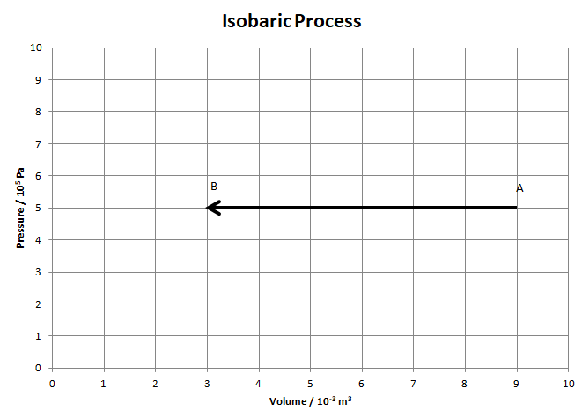a. Calculate the temperature at A and B

(A: 600 K, B: 200 K)

b. Find Q, ΔU, and W for this process.

(Q = -7500 J, ΔU = -4500 J, W = -3000 J)

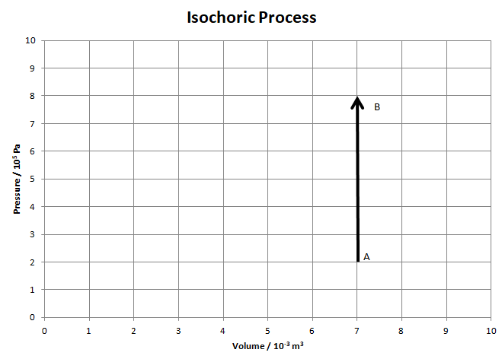2. Consider this isochoric process. The ideal gas starts at A at a temperature of 120 K.

a. How many moles of gas are there in the cylinder? (1.40 moles)

b. What is the temperature at B? (480 K)

c. Find Q, ΔU, and W for this process.

(Q = +6300 J, ΔU = +6300 J, W = 0 J)

3. Consider the isothermal expansion AB for 0.4513 moles of an ideal gas. The gas starts at A with a pressure of 6.0x105 Pa and a volume of 2.0x10-3 m3. At B the volume is 8.0x10-3 m3.

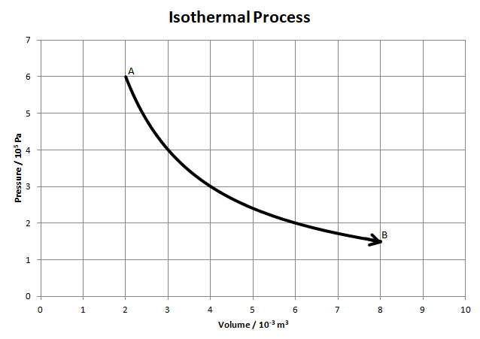a. What is the temperature at A? How could you show that the process is isothermal? (320 K)

b. What is the pressure at B? (1.5x105 Pa)

c. What is the temperature at B? (320 K)

d. The work done for this process is about +1664 J. Calculate the Q and ΔU. (Q = +1664 J, ΔU = 0)

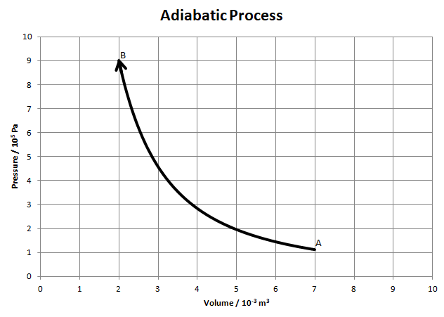4. Consider the adiabatic compression AB. At point B (at the end) the gas is at a pressure of 9.0x105 Pa, a volume of 2.0x10-3 m3, and a temperature of 850 K. It starts at a volume of 7.0x10-3 m3.

a. How many moles of gas are there?

(0.255 moles)

b. What is the pressure at point A?

(1.12x105 Pa)

c. What is the temperature at point A? (369 K)

d. Calculate the Q, ΔU and W for this process. (Calculate ΔU first) (Q = 0, ΔU = +1529 J, W = -1529 J)

5. Consider the process ABCA for 1.45 moles of gas. The work done by the gas for process AB is 3955 J.

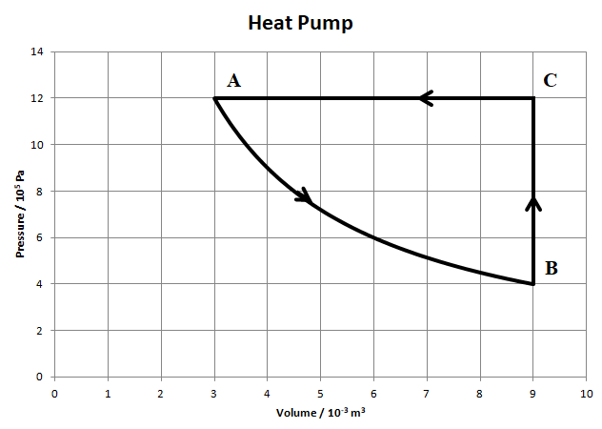 a. Show that process AB is isothermal. (Do some calculations)

b. Find the temperatures at the vertices A, B and C. (A: 299 K, B: 299 K, 896 K)

For each process calculate Q, ΔU, and W. Fill in the table:

|  |  |  |  |
| --- | --- | --- | --- |
|  | Q | ΔU | W |
| AB | +3955 J | 0 J | +3955 J |
| BC | +10,800 J | +10,800 J | 0 J |
| CA | -18,000 J | -10,800 J | -7200 J |

c. What is the net change in Q, U, and W for a complete cycle? What heat flowed in? What heat flowed out?

(Q = -3245 J, U = 0 J, W = -3245 J, Qin = 14,755 J, Qout = 18,000 J)

d. This is a heat pump. The overall “W” is provided by electrical energy, and the heat that flows in during process AB and BC comes from cooler air outside. The heat that flows out in CD heats your house. The ratio of this heat to the work we provide is called the COP (Coefficient of Performance) Calculate the COP for this heat pump (5.55)

6. Consider cycle ABCDA below. AB is an isobaric expansion, BC is adiabatic, CD is isochoric, and DA is isothermal. Point A is at a temperature of 350 K. The work done **by** the gas for BC is 1919 J. The work done **on** the gas for DA is 2707 J.

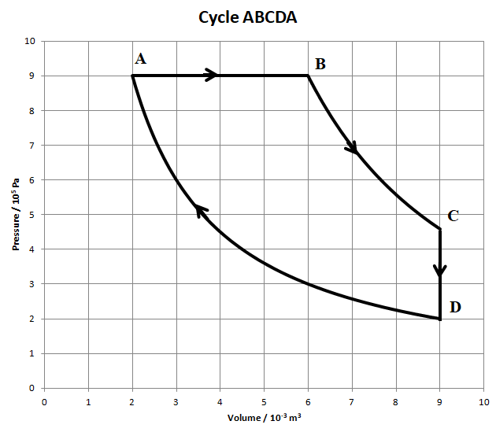a. How many moles of gas are present?

(0.619 moles)

b. What is the temperature at point B? (1050 K)

c. What is the pressure and temperature at point C? (4.58x105 Pa, 801 K)

d. State the temperature of point D. (350 K)

Fill in the table:

|  |  |  |  |
| --- | --- | --- | --- |
|  | Q | ΔU | W |
| AB | 9000 J | +5400 J | +3600 J |
| BC | 0 J | -1919 J | +1919 J |
| CD | -3481 J | -3481 J | 0 J |
| DA | -2707 J | 0 J | -2707 J |

What is the net change in Q, U, and W for a complete cycle? What heat flowed in? What heat was wasted? What is the efficiency of the cycle? (Q = +2812 J, U = 0 J, W = +2812 J, Qin = 9000 J, Qwasted = 6188 J, e = 0.312)

**IB Physics**

**FA 15.3 - Thermodynamics**

Name

Favorite Celebrity (Besides Matt Damon)   
**Show your work, and circle your answers and use sig figs to receive full credit.**

When you have finished this, go to the website and check your answers. If you got a problem wrong, cross it off on the front, and do it correctly on the back.

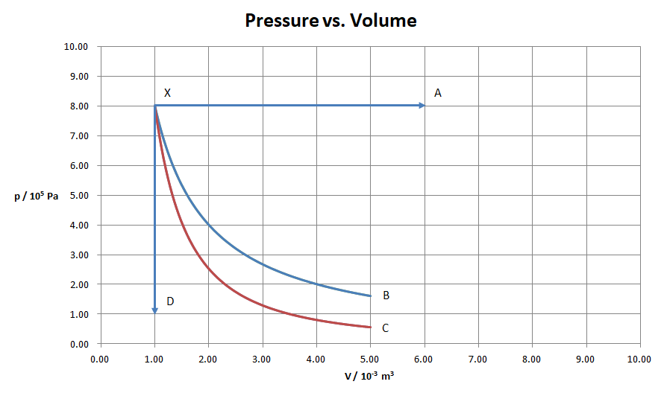

Process XB is isothermal, XC adiabatic. The temperature at X is 430. K

A. For process XA, find the temperature at A, and the W, ΔU, and Q. [3]

B. For process XC find the W, ΔU, and Q. [3]

C. For process XD find the temperature at D, and the W, ΔU, and Q. [2]

D. For process XB the work done is 1288 J. Find the pressure at B, and the W, ΔU, and Q. [2]

**Newton's Law of Cooling**

Newton’s law of cooling states that the rate of heat flow by conduction is proportional to the difference in temperature. When the difference is large, the rate of heat flow is fast, and when the difference is small, heat flows more slowly. The solution for the temperature mathematically is an exponential decay.

1. We will measure the temperature using the computer for a small beaker of boiling water as it loses heat to a well-stirred ice bath that should be at 0oC

2. The software will gather a data point every second for about 20 minutes, and we will use the analyze feature to gather data points.

3. Our hypothesis is that the temperature drops off in an exponential curve given by:

T = Toe-kt

Where

T = Temperature at a time in Celsius

To = the initial temperature (oC)

k = is some constant (s-1)

t = elapsed time (s)

If the surrounding temperature is 0oC, and the drop off is immediate.

Your goal is to find k, and show how well this equation does or doesn't work

4. Make a graph of your temperatures, and draw a nice curved line through the points.

5. To find what k has to be, look at the real data by using the examine feature in the data acquisition program. You will need the original temperature To, and then six points of data (T and t), and math skills. Show these calculations. With your six data points, you should calculate k six different times.

6. Answer these questions:

A. Why does the temperature drop off as it does? (i.e. why is it an exponential decay or nearly so?) Explain the shape of the curve. (Why is it steep at the beginning, and more gradual near the end? – use Newton’s Law of Cooling at the top of this page to explain)

B. What effect would insulating the beaker have on the graph, (i.e. would the temperature drop more quickly, or more slowly) and how would this affect the value of k? (Would k be bigger or smaller?)

C. You like your coffee hot, but you like cream in it. The phone rings just as you finish pouring yourself a cup of coffee. You know you will be on the phone for five minutes. It would be gauche to pour the coffee back into the thermos, so the question is this: Should you a) take the cream from the refrigerator and pour it into the coffee now before taking the call (The cream is cold.) or b) wait until you have finished the call and then take the cream out of the refrigerator and add it to your coffee to have the hottest cup of coffee to drink. Base your selection of one of these two options on Newton's law of cooling and give examples. Think about the time that you are on the phone, and what the temperature is of the coffee in both scenarios.

D. Evaluate the lab. (Discuss the validity of the model, sources of error and ways to mitigate the errors)

**IB2 Mock Thermo Test**

1. (a) 0.164 moles of an ideal monatomic gas is in a container of volume 1.30x10-3 m3,

with a pressure of 9.20x105 Pa.

(i) Calculate the temperature of the gas [878 K]

(ii) Calculate in J the internal energy of the gas [1794 J]

(b) The gas is expanded very rapidly so that the pressure is 3.20x105 Pa

(i) Explain why this process would be adiabatic [???]

(ii) Calculate the new volume of the gas [2.45x10-3 m3]

(iii) Calculate the new temperature of the gas [575 K]

2. The pressure volume (pV) diagram shows a cycle ABCA of a heat engine. The working substance is 0.850 moles of an ideal gas. At A the pressure of the gas is 12.0x105 Pa, and the volume is 1.00x10-3 m3.

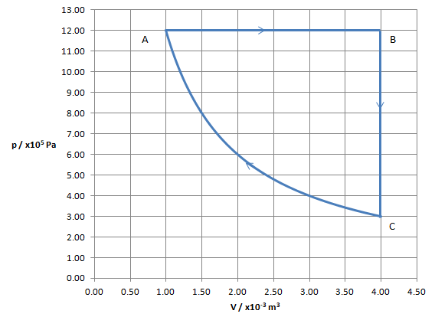

(a) For the isobaric expansion AB

(i) Calculate the temperature at A and B [170. K, 680. K]

(ii) Calculate the work by the gas [+3600 J]

(iii) Calculate the change in internal energy of the gas [+5400 J]

(iv) Calculate the thermal energy that flows into the gas [+9000 J]

(b) Calculate the thermal energy that leaves the gas for process BC [-5400]

(c) The work done on the gas during the isothermal compression CA is 1664 J

(i) Show using data from the graph that process CA is isothermal [pV = pV...]

(ii) Justify why the thermal energy lost during the compression CA is 1664 J [Q=ΔU+W]

(iii) Calculate the change in entropy of the gas for the isothermal compression CA [-9.79 J/K]

(d) Calculate the efficiency of the engine [0.215]

3. The P-V diagram of the Carnot cycle ABCDA for a monatomic ideal gas operating with a Carnot efficiency of 0.370

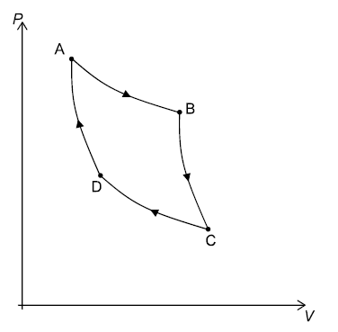

(a) On the diagram label each process either ("Isothermal" or Adiabatic") and either [???]

("Expansion" or "Compression")

(b) The low temperature is 345 K. Calculate the high temperature. Label these temperatures

on the graph above. Label also the processes where no heat flows, and those there heat either

flows into or out of the gas [548 K]

(c) During process CD, 1280 J of heat flow out of the gas.

(i) Calculate the useful work done by the entire cycle [752 J]

(ii) Calculate the heat that must flow into the gas in process AB [2032 J]

4. A planet with an atmosphere is 1.80x1011 m from a star with a radius of 9.50x108 m and a surface

temperature of 6250 K. The atmosphere of the planet has an albedo of 0.210.

(a) Show that the intensity of the radiation incident on the upper atmosphere is 2410 Wm-2 [2409.9 Wm-2]

(b) Calculate the average intensity spread out over the entire surface of the planet [476 Wm-2]

(c) Calculate the radiative equilibrium temperature assuming that the atmosphere were

transparent to IR wavelengths of light [303 K]

(d) Calculate the peak black body wavelength radiated by the planet and the star. Also

state which part of the electromagnetic spectrum each wavelength belongs to. [9.58 μm, 464 nm]

(e) With reference to the wavelengths of the incident and radiated energy, explain how the [???]

surface of the planet could be warmer than the value you calculated in (c)