**Videos 14A – Rumford and Joule Name**

**Count Rumford:**

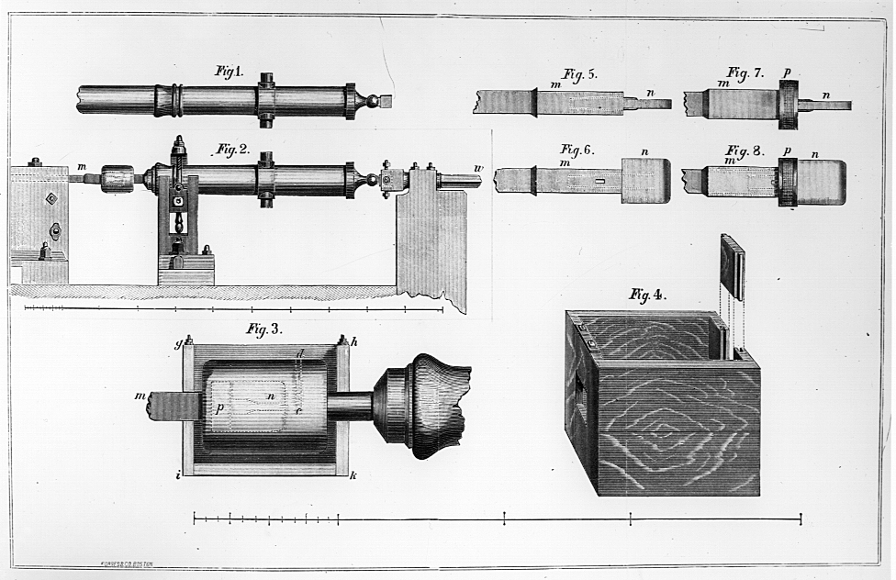Caloric Model

Rumford’s discovery:

**Joule:**

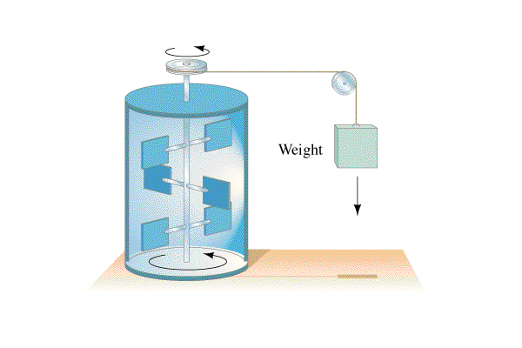 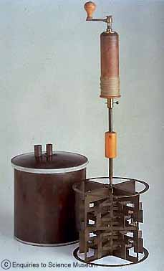

Joule’s heat-energy equivalence:

**Videos 14B – Specific Heat Name**

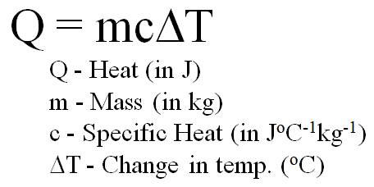 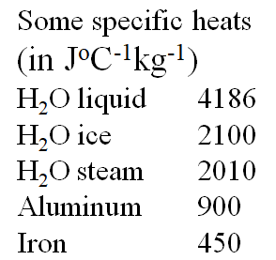 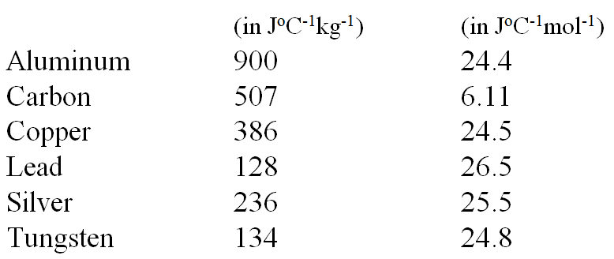

Example: A. Nicholas Cheep wants to calculate what heat is needed to raise 1.5 liters (1 liter = 1 kg) of water by 5.0 oC. Can you help him? (c = 4186 J oC-1kg-1) (31,000 J)

Whiteboards: (These are solved on the website in the videos linked after the main one)

|  |  |
| --- | --- |
| 1. Adella Kutessen notices what change in temperature if 512 g of iron absorbs 817 J of heat  (c = 450. J oC-1kg-1) (3.55 oC) | 2. Anita Break notices that a chunk of Aluminium absorbs 12,000 J of heat while raising its temperature a mere 3.45 oC Of what mass is this chunk?  (c = 900. J oC-1kg-1) (3.9 kg) |
| 3. Anne Sodafone does an experiment where 5.412 kg of a mystery substance absorbs 12,510 J of heat while raising its temperature 2.19 oC What is the specific heat? (1060 J oC-1kg-1) | Draw a picture of a turtle here please: |

**Videos 14C – Latent Heat Name**

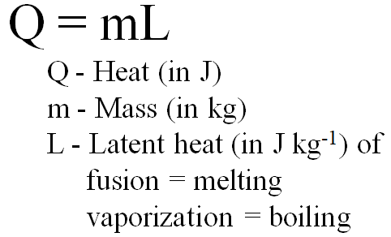 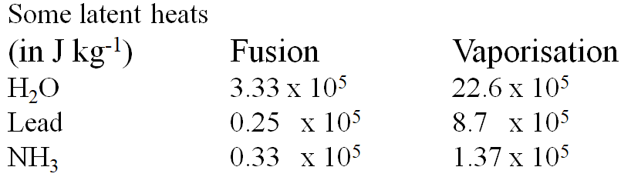

Example: Dewey Cheatham melts 4.51 kg of lead. What heat is needed? (1.1 x 105 J)

Whiteboards: (These are solved on the website in the videos linked after the main one)

Take the time to go through #3 – those are the questions that are on the test!!!

|  |  |
| --- | --- |
| 1. Helen Highwater pumps 45 MJ (45 x 106 J) of heat into some water at 100 oC. How much boils away?  (20. kg) | 2. Aaron Alysis has a 1500. Watt heater. What time will it take him to melt 12.0 kg of ice, assuming all of the heat goes into the water at 0 oC  (2660 seconds) |
| 3. Eileen Dover takes 1.42 kg of ice ( c = 2100 J oC-1kg-1) from -40.0 oC to water ( c = 4186 J oC-1kg-1) at 20.0 oC. What TOTAL heat is needed? (7.11 x 105 J) | |

**Videos 14D – Phase Change Graphs Name**

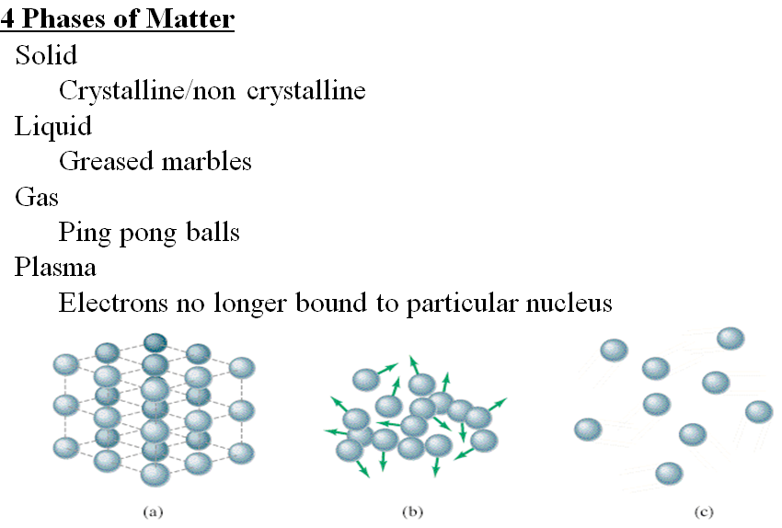

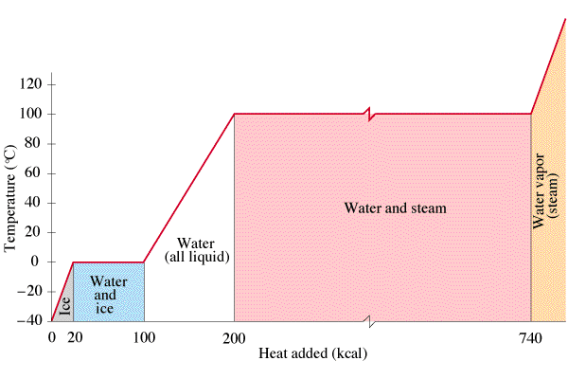

Example

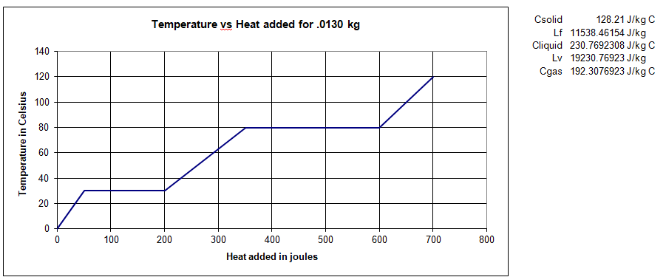



Whiteboards: (These are solved on the website in the videos linked after the main one)

|  |  |
| --- | --- |
| 1. What is the melting point and boiling point?  (25oC, 75oC) | 2. What is specific heat of the solid phase?  (440 J oC-1 kg-1) |
| 3. What is specific heat of the liquid phase?  (890 J oC-1 kg-1) | 4. What is specific heat of the gaseous phase?  (1480 J oC-1 kg-1)` |
| 5. What is the latent heat of fusion?  (22,000 J kg-1) | 6. What is the latent heat of vaporisation?  (56,000 J kg-1) |

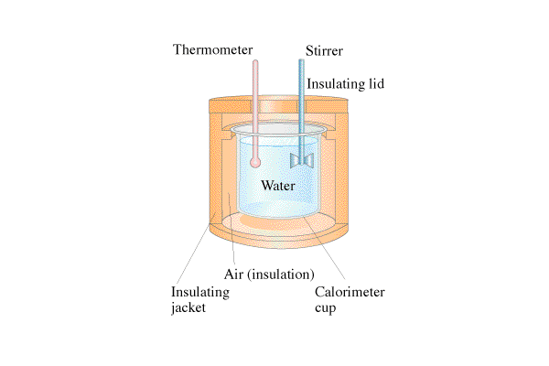**Videos 14E-Calorimetry Name**

Heat lost by hot stuff = heat gained by cold stuff

Example 1: A 0.231 kg piece of unknown substance at 98 oC is dropped into 0.481 kg of water at 18 oC. The final temperature of the water is 32 oC. What is the specific heat of the substance? (neglect the calorimeter cup, and assume no heat is lost to the surroundings) (cwater = 4186 JoC-1kg-1) (1800 JoC-1kg-1 )

Example 2: A 0.250 kg piece of iron at 95.0 oC is dropped into 0.512 kg of water at 18.0 oC. What is the final equilibrium temperature? (neglect the calorimeter cup, and assume no heat is lost to the surroundings)

(cwater = 4186 JoC-1kg-1,cFe = 450. JoC-1kg-1) (21.8 oC )

Whiteboards: (These are solved on the website in the videos linked after the main one)

|  |  |
| --- | --- |
| 1. 0.112 kg of a mystery substance at 85.45 oC is dropped into 0.873 kg of water at 18.05 oC in an insulated Styrofoam container. The water and substance come to equilibrium at 23.12 oC. What is the c of the substance? (cwater = 4186 JoC-1kg-1) (2650 JoC-1kg-1) | 2. A chunk of Mippsalipsium at 68.1 oC is dropped into 0.625 kg of water at 21.1 oC in a .257 kg Aluminum calorimeter. The water, Aluminum, and Mippsalipsium come to equilibrium at 25.2 oC. What is the mass of the Mippsalipsium? (0.125 kg)  (cwater = 4186 JoC-1kg-1, cAl = 900. JoC-1kg-1, cMi = 2174 JoC-1kg-1) |
| 3. 52 grams of glass at 91.1 oC is dropped into 154 g of water at 25.1 oC in an insulated Styrofoam container. What will be the final equilibrium temperature if no heat is lost to the surroundings? (29 oC)  (cwater = 4186 JoC-1kg-1, cglass = 840 JoC-1kg-1) | 4. 127 grams of copper at 99.5 oC is dropped into 325 g of water at 23.6 oC in a 562 g glass beaker. What will be the final equilibrium temperature if no heat is lost to the surroundings? (25.6 oC )  (cwater = 4186 JoC-1kg-1, cglass = 840 JoC-1kg-1, cCu = 390 JoC-1kg-1) |

**Videos 13AB – Kinetic Theory and Temperature Name**

**13A – Kinetic Theory:**

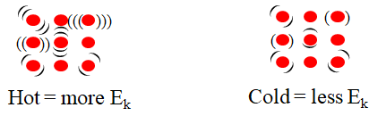

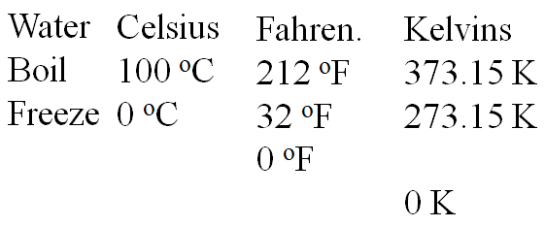**13B – Temperature Scales**

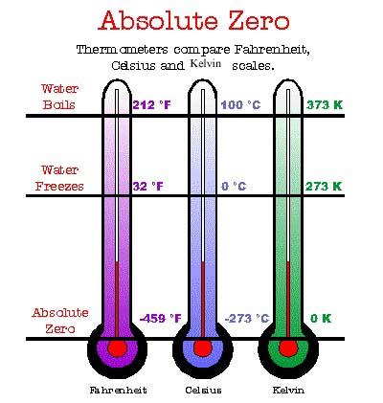

Write down the formula for converting:

Whiteboards: (These are solved on the website in the videos linked after the main one)

|  |  |
| --- | --- |
| 1. What is 37 oC in Kelvins? (310 K) | 2. What is 77.35 K in oC (-195.80 oC) |
| 3. What is 128 oC in Kelvins? (401 K) | 4. What is 38 oF in oC (3.3 oC) |

**Videos 13F – Ideal Gas Law Name**

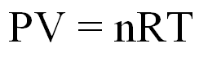

P = pressure in Pa (Absolute, not gauge)

V = volume in m3

n = moles of gas molecules

n = mass/molar mass

careful of: N O F Cl Br I H

R = 8.31 JK-1 (for these units)

T = ABSOLUTE TEMPERATURE (in K)

Example – Nitrogen cylinder is at a (gauge) pressure of 90.1 psi. It has a volume of 378 liters at a temperature of 37.0 oC. What is the mass of Nitrogen in the tank? (N is 14.007 amu) (2967 g = 2.97 kg)

Whiteboards: (These are solved on the website in the videos linked after the main one)

|  |  |
| --- | --- |
| 1. What is the volume in liters of 1.00 mol of N2 at 0.00 oC, and 1.00 atm? (1 atm = 1.013 x 105 Pa)  (22.4 liters) | 2. We have 34 g of O2 in 18.3 liters @ 23 oC. What pressure? (1.43 x 105 Pa) |
| 3. What is the temperature if 52.0 g of He occupies 212 liters at a pressure of 2.15 x 105 Pa? (422 K, 149 oC) | Draw a picture of a pretty pony here please if you haven’t anything better to do |

**Videos 13G – Combined Gas Law Name**

Re writing the ideal gas law: $\frac{P_{1}V_{1}}{n_{1}T_{1}}= \frac{P_{2}V_{2}}{n_{2}T_{2}}$

What must be true about Temperature and Pressure (and volume too):

Example – A nitrogen cylinder contains 3.42 kg of nitrogen at 2000. psi absolute and 20.0 oC. What is the pressure if the temperature is 150. oC, but you have released 0.20 kg of nitrogen? (2718 psi ≈ 2720 psi)

Whiteboards: (These are solved on the website in the videos linked after the main one)

|  |  |
| --- | --- |
| 1. An airtight drum at 1.00 atm and 10.0 oC is heated until it reaches a pressure of 1.15 atm. What is the new temperature in oC? (52.5 oC) | 2. An airtight cylinder has a pressure of 162 Jukkalas when the piston is 14.5 cm from the bottom. What is the pressure if the piston is moved to 17.2 cm from the bottom of the cylinder? (Assume that the temperature is the same) (137 Jukkalas ) |
| 3. A tyre is at 82 kPa gauge pressure when the temperature is 10.0 oC . What is the gauge pressure if the temperature is 52 oC (assume the volume remains constant, and that the tyre does not leak)  (211 kPa Absolute, 109 kPa Gauge) | Draw a very happy timberwolf eating with knife and fork in this space: |

**Videos 13C - Boltzmann's Equation Name**

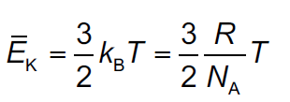 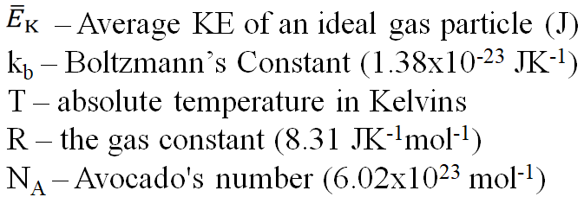 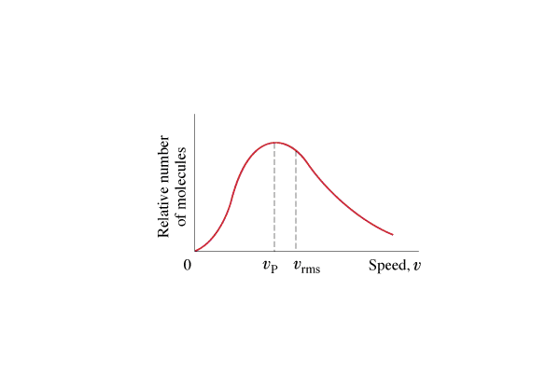

Example #1 – What is the RMS velocity of a helium atom in the thermosphere that is at 1800 oC?

(The mass of a Helium atom is (4.003 u)x(1.661x10-27 kg/u) = 6.649x10-27 kg)

Whiteboards: (These are solved on the website in the videos linked after the main one)

|  |  |
| --- | --- |
| 1. What is the average KE of an ideal gas molecule at 37.0 oC? (6.42x10-21 J) | 2. At what temperature is the average KE of an ideal gas molecule 1.20x10-20 J? (580. K) |
| 3. What is the RMS speed of an atom of Neon-20 at room temperature?  (Ne-20 = 19.992 u, 1 u= 1.661x10-27 kg, T = 20.0 oC)  (605m/s) | 4. At what temperature is the RMS velocity of Helium the same as Usain Bolt’s PR average in the 100 m? (100 m in 9.58 s)  (He =4.00 u, 1 u= 1.661x10-27 kg)  (0.0175 K) |

**Videos 13D – Maxwellian Velocity Distribution Name**

 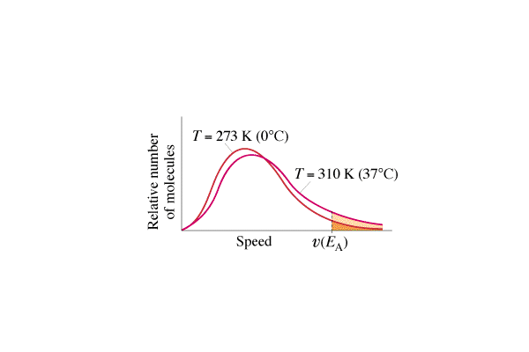

What vp and vrms mean:

What are the limitations of the ideal gas law? (i.e. when does it break down?)

In general:

Examples:

**Videos 15F - Energy Sources Name**

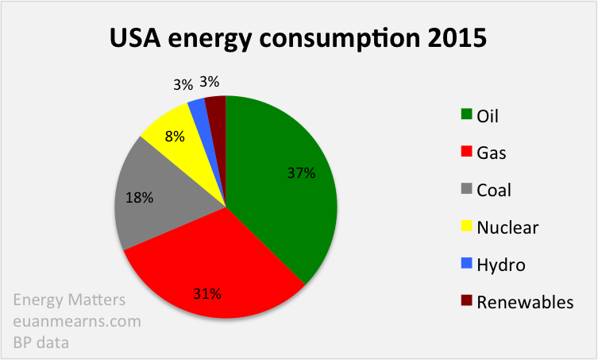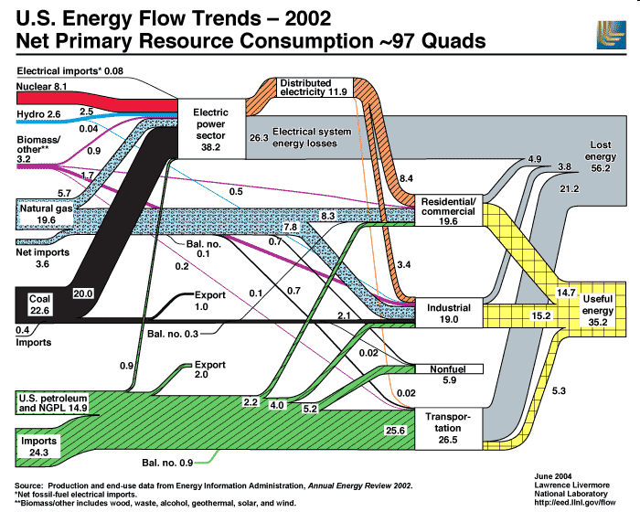

|  |  |  |  |
| --- | --- | --- | --- |
|  | Energy Transformations | Pros | Cons |
| Oil |  |  |  |
| Natural Gas |  |  |  |
| Coal |  |  |  |
| Hydroelectric |  |  |  |
| Pumped Hydro |  |  |  |
| Nuclear |  |  |  |
| Wind |  |  |  |
| Solar PV |  |  |  |
| Solar Heating |  |  |  |
| Geothermal |  |  |  |
| Biomass |  |  |  |

**Videos 15F1 – Energy Production Name**

**Energy Density:**

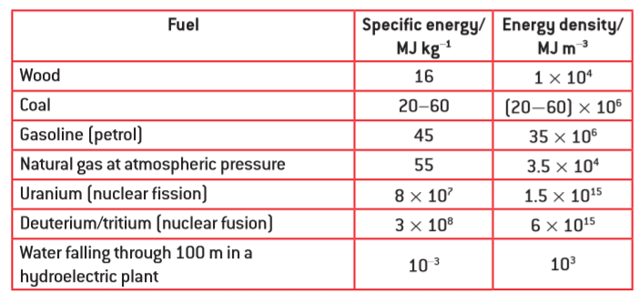**0. Energy Density:** How many grams of petrol must you burn to release 100 kJ of energy?

(2.22 grams)

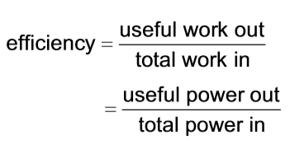

**1. Heating Water:** A water heater uses natural gas to heat 195 liters of water from 15.0 oC to 59.0 oC. What mass of natural gas would this take for a 100% efficient heater? What if the efficiency is 56.0%

(cwater = 4186 J kg-1 oC-1) (0.653 kg, 1.17 kg)

**2. Thermal Power Stations:**

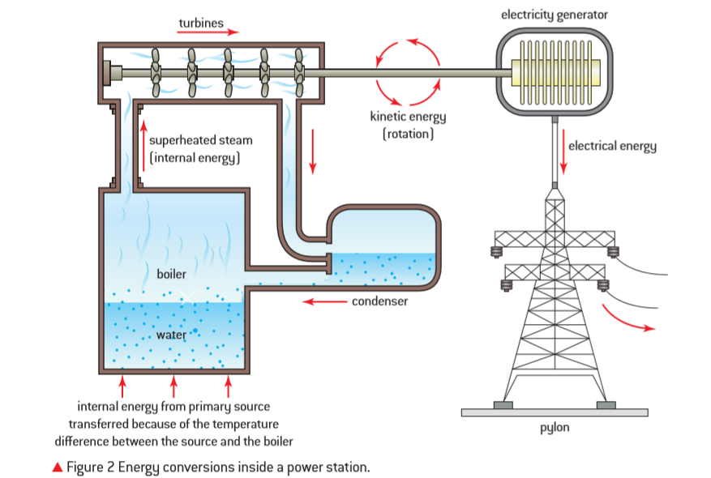

A coal fired electrical generation plant has an overall efficiency of 34.0% and generates an average of 180. MW of electrical power. What quantity of a coal with a specific energy of 47.0 MJ kg-1 would this plant use in one week? (6.81x106 kg)

Whiteboard 1: A water heater uses natural gas to heat 180. liters of water initially at 20.0 oC. If the heater has an efficiency of 54.0%, what is the final temperature of the water after it has burned 0.500 kg of natural gas?

(cwater = 4186 J kg-1 oC-1) (39.7 oC)

Whiteboard 2: A natural gas electrical generation plant puts out an average of 312 MW of power for a year, and in the process, uses 4.36x108 kg of natural gas. What is its overall efficiency? (41.0%)

**3. Wind Turbines:**

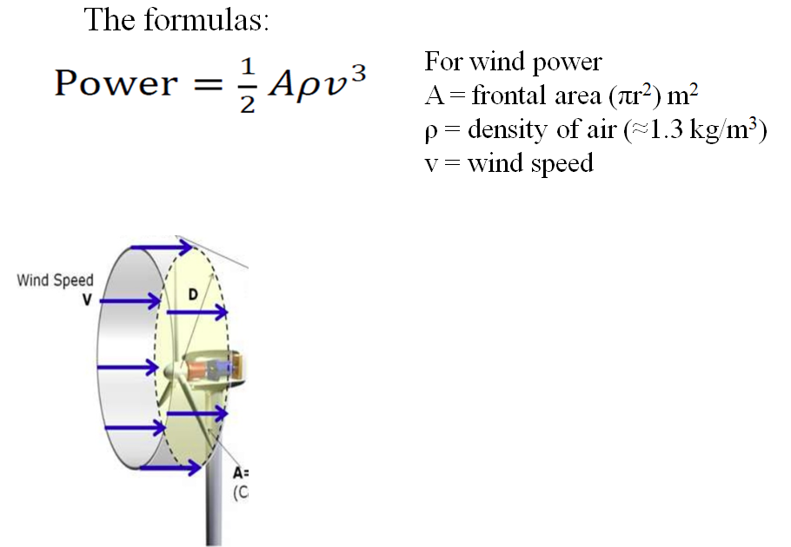

Ex1 – What max power can you get from a wind turbine with 8.2 m long blades when the wind speed is about 5.4 m/s on the average? Use the density of air to be 1.2 kg/m3 (2.0x104 W)

Ex2 – What max power can you get from a wind turbine with 8.5 m long blades when the wind speed is about 7.3 m/s incident on the front of the blades, and is slowed to 6.5 m/s after the blades. Use the density of air to be 1.3 kg/m3 (1.7x104 W)

Whiteboard: Your wind turbines have a radius of 9.70 m. They operate where the wind speed is 8.50 m/s, and they slow the wind to 7.60 m/s on their downwind side. Use the density of air to be 1.3 kgm-3

* What is the power output per turbine?
* How many turbines do you need to generate a megawatt of power? (1.00x106 W)

(33652.26963 W ≈ 3.37x104 W, 30 turbines)

**4. Pumped Energy Storage:**

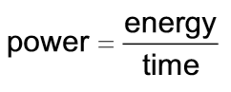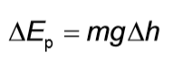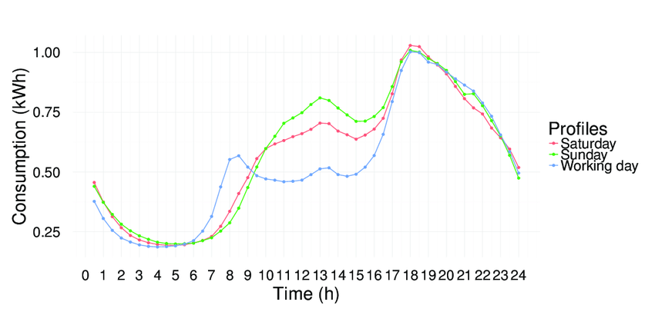 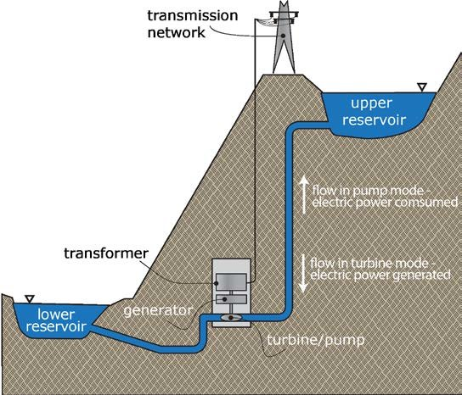

Example: A 65.0% efficient pumped storage plant uses a reservoir that is 196 m higher than the generation site. What is its electrical power output if it is draining water from the reservoir a a rate of 1250 kg s-1? (1.56 MW)

Whiteboard: A pumped electrical storage facility generates 1.66 MW of power. It has a reservoir height of 130. m, and releases 2240 kg of water per second. What is its overall efficiency? (58.1%)

**5. Solar:**

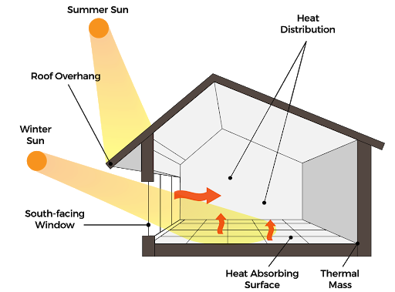 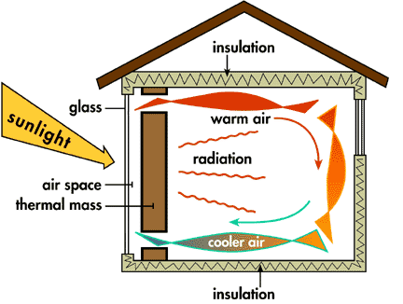

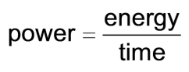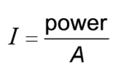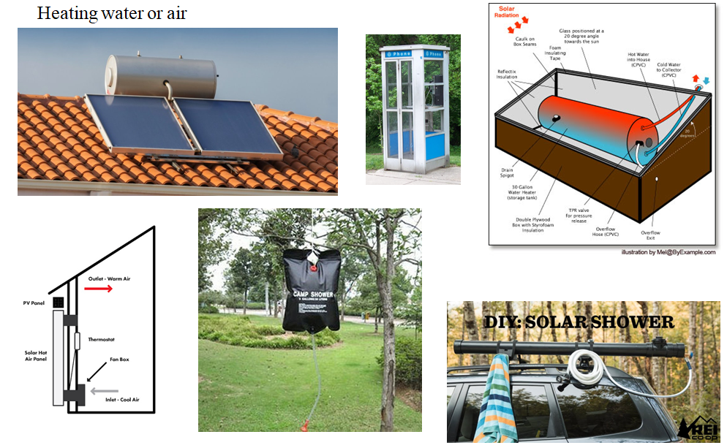

Example: A photovoltaic panel measures 1.75 m by 1.10 m, and is 23.0% efficient. How much total electrical power can it put out if the solar intensity is 890 W m-2? How many Joules of electrical energy can it produce in a 6.00 hour period when the sun is hitting the panels? How many kWh of electricity? (394 W, 8.51x106 J, 2.36 kWh)

Whiteboard: A house has a total of 12.8 m2 of solar panels that generate a power of 2045 Watts when the solar intensity is 750. W m-2. What is the efficiency of the panels? (21.3 %)

**Videos 14F - Heat Transfer Name**

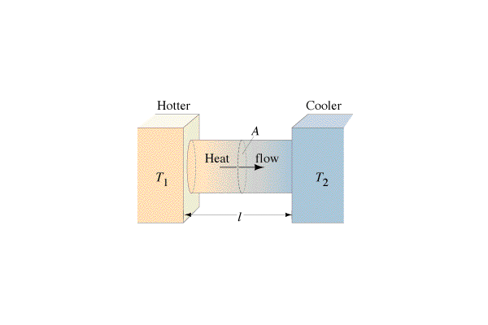Conduction -

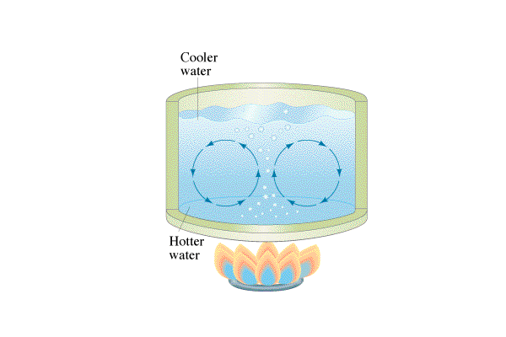Convection -

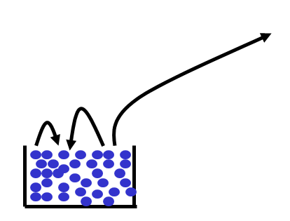

Evaporation -

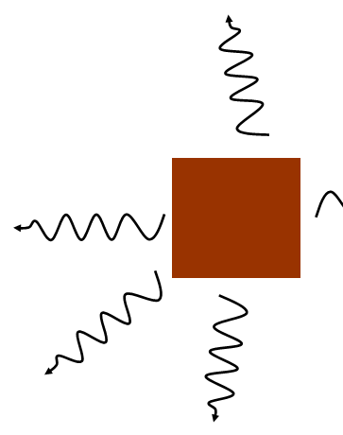

Radiation -

**Videos 14I - Wien Displacement and Black Body Radiation Name**

Black Body Radiation – electromagnetic waves emitted by all objects

(Radio, Micro, IR Light, UV, X-Ray, Gamma Ray)

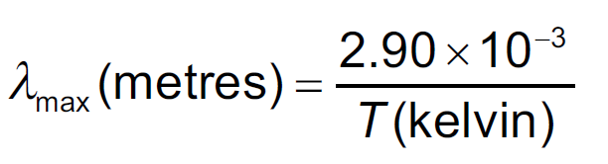

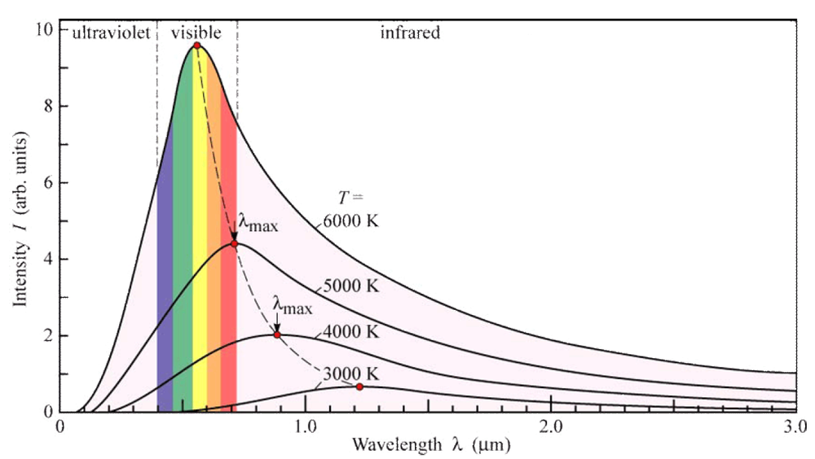

**Ex:** A star has a peak black body wavelength of 501 nm. What is its temperature? (5790 K)

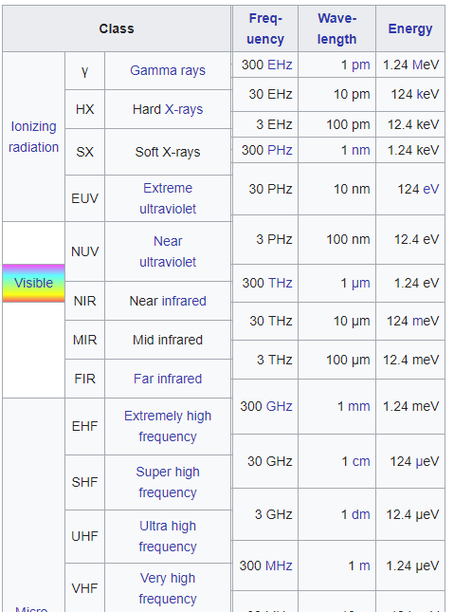

What is the peak radiation of the surface of ocean water

that is at 21.0 oC? (9.86 μm)

**Videos 14J - Radiative Heat Transfer Name**

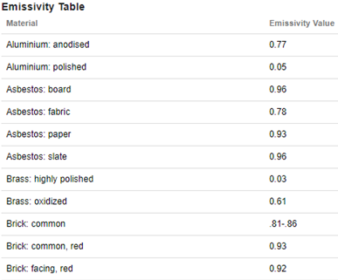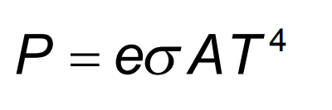

P - Rate of heat transfer in Watts

e - emissivity of object

σ - Stefan-Boltzmann constant - 5.67x10-8 Wm-2K-4

A - Radiative area in m2

T - Temperature in K

Ex1: A brick wall that has been warmed by the sun is at a temperature of 313 K, and measures 13 m long by 3.0 m high. At what rate does it radiate heat to the surroundings?

Ex2: An anodized aluminum sphere 20. cm in radius is used to radiate waste heat into space. What temperature does it need to be to radiate 800. W of heat?

Ex3: A transformer box has a surface area of 3.2 m2 and is at a temperature of 39 oC in a room where the surroundings are at a temperature of 20. oC. What is the net rate of heat transfer from the box if its emissivity is 0.82?

**Videos 14K - Albedo Name**

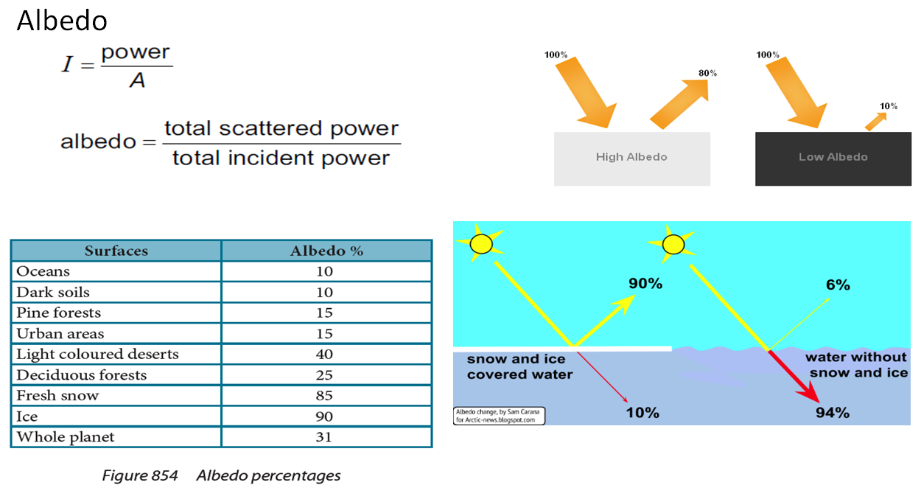

Ex – Sunlight of intensity 1030 Wm-2 shines on a solar heater with an albedo of 6.20 % (0.0620)

What is the reflected intensity? What is the absorbed intensity?

What is the power absorbed if the heater has a surface area of 16 m2?

Try these:

On a day when the solar radiation is 980. W/m2, how much power per square meter is reflected off into space from the **oceans**? How much is absorbed?

98.0 Wm-2 reflected, 882 Wm-2 absorbed

Do the same calculation for **fresh snow**. 833 Wm-2 reflected, 147 Wm-2 absorbed

**Videos 14L - Greenhouse Effect Name**

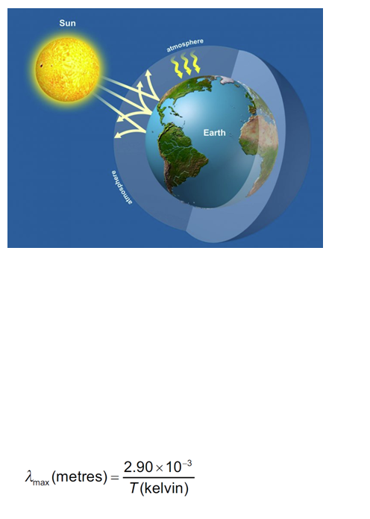

Ex 1: A star with a surface temperature of 5200 K has a radius of 6.5x108 m, and is 1.7x1011 m from a planet. Assume the star is a perfect black body. Calculate the intensity of the radiation in Wm-2 incident on the planet’s upper atmosphere.

Ex 2: 606 Wm-2 is incident on the upper atmosphere of a planet. If the planet’s upper atmosphere has an albedo of 0.23,

a) What portion of the light makes it to the surface?

b) What is the average intensity of light over the whole surface of the planet?

c) What would be the equilibrium temperature of the planet in space if there were no greenhouse effect?