Videos 15F - Energy Sources Name
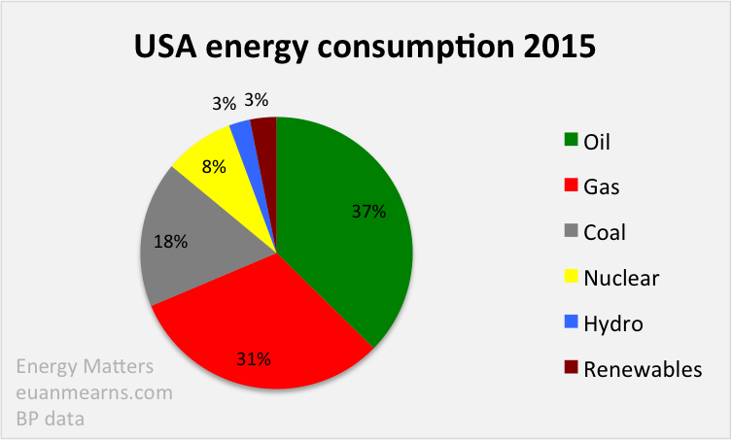
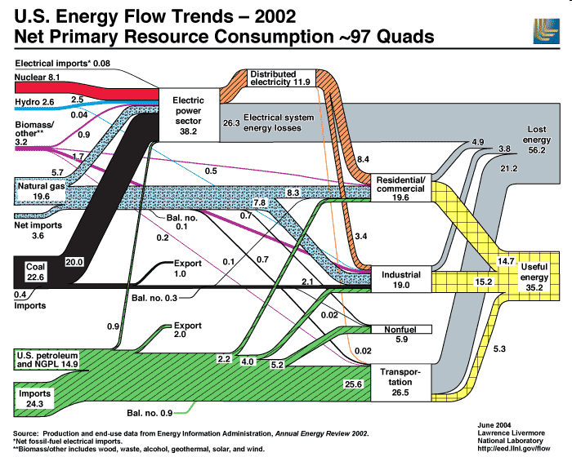
 | Energy Transformations | Pros | Cons
Oil

Natural Gas

Coal

Hydroelectric

Pumped Hydro

Nuclear

Wind

Solar PV

Solar Heating

Geothermal

Biomass

