Videos 14B – Specific Heat Name
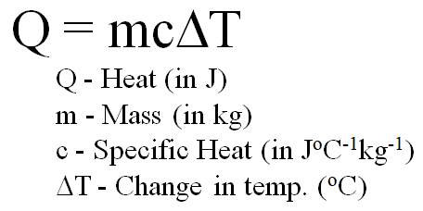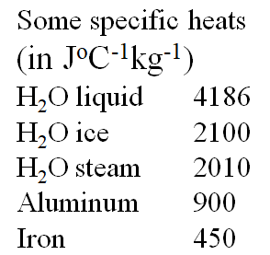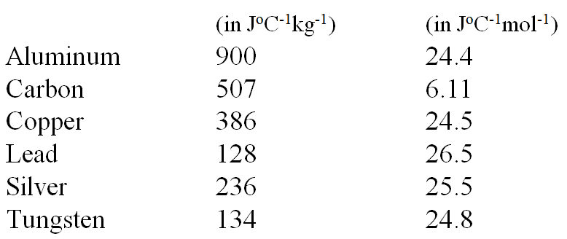
Example: A. Nicholas Cheep wants to calculate what heat is needed to raise 1.5 liters (1 liter = 1 kg) of water by 5.0 ºC. Can you help him? (c = 4186 J ºC⁻¹kg⁻¹) (31,000 J )

Whiteboards: (These are solved on the website in the videos linked after the main one)
1. Adella Kutessen notices what change in temperature if 512 g of iron absorbs 817 J of heat  (c = 450. J ºC⁻¹kg⁻¹) (3.55 ºC ) | 2. Anita Break notices that a chunk of Aluminium absorbs 12,000 J of heat while raising its temperature a mere 3.45 ºC Of what mass is this chunk?  (c = 900. J ºC⁻¹kg⁻¹) (3.9 kg )
3. Anne Sodafone does an experiment where 5.412 kg of a mystery substance absorbs 12,510 J of heat while raising its temperature 2.19 ºC What is the specific heat? (1060 J ºC⁻¹kg⁻¹) | Draw a picture of a turtle here please:

