Videos 14A – Rumford and Joule Name

Count Rumford:

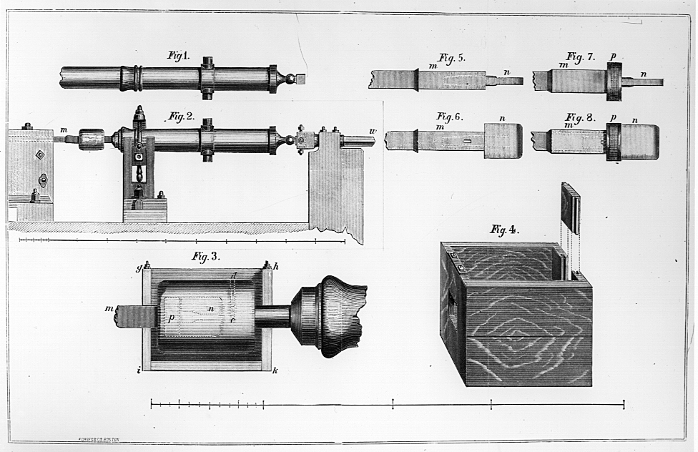
Caloric Model

Rumford’s discovery:

Joule:
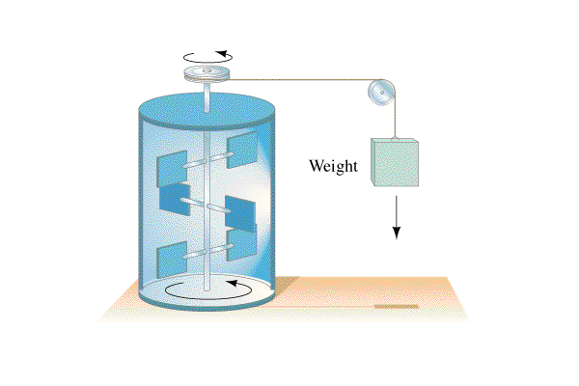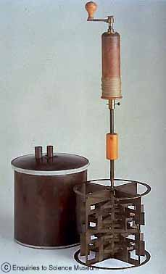

Joule’s heat-energy equivalence:

