Videos 13C - Boltzmann's Equation Name
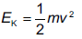
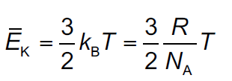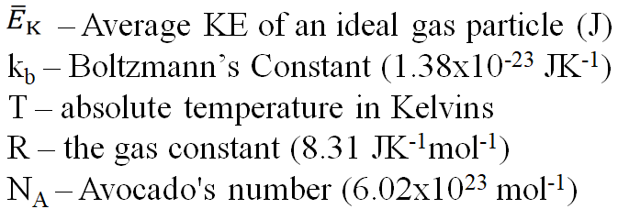

Example #1 – What is the RMS velocity of a helium atom in the thermosphere that is at 1800 ºC?
(The mass of a Helium atom is (4.003 u)x(1.661x10⁻²⁷ kg/u) = 6.649x10⁻²⁷ kg)

Whiteboards: (These are solved on the website in the videos linked after the main one)
1. What is the average KE of an ideal gas molecule at 37.0 ºC? (6.42x10⁻²¹ J) | 2. At what temperature is the average KE of an ideal gas molecule 1.20x10⁻²⁰ J? (580. K)
3. What is the RMS speed of an atom of Neon-20 at room temperature?  (Ne-20 = 19.992 u, 1 u= 1.661x10⁻²⁷ kg, T = 20.0 ºC)  (605m/s) | 4. At what temperature is the RMS velocity of Helium the same as Usain Bolt’s PR average in the 100 m? (100 m in 9.58 s)  (He =4.00 u, 1 u= 1.661x10⁻²⁷ kg)  (0.0175 K)

