Practice 11.2 – Resonant Systems

A. Damping and energy
This is the amplitude graph for an oscillator with damping being driven at its resonant frequency. It starts at rest.
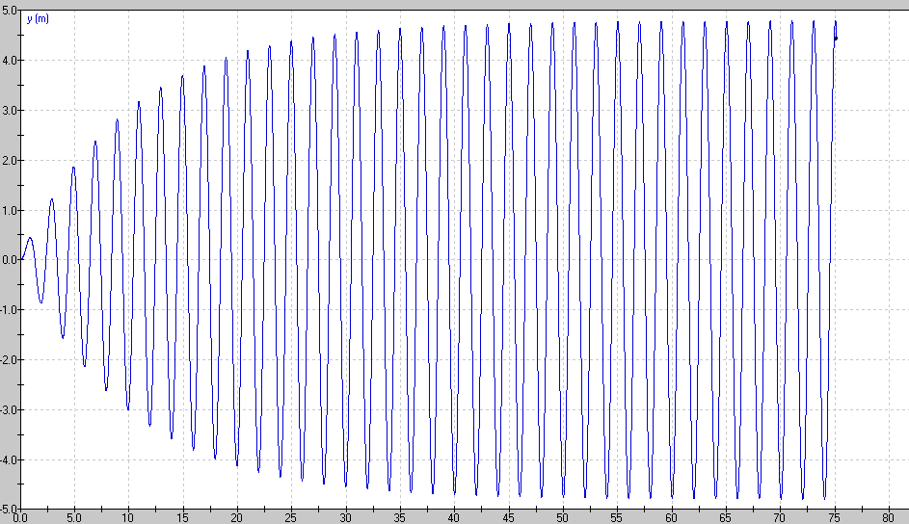
1. When does the system reach equilibrium? (Power input = Power dissipated)

2. How does the Power input compare to the Power dissipated at 10 seconds?

3. How does the Power input compare to the Power dissipated at 45 seconds?

4. How would decreasing the Q factor change the equilibrium amplitude of the oscillator?

5. How would increasing the Power input change the equilibrium amplitude?

(1. About 35 seconds, 2. Input > Dissipated, 3. Input = Dissipated, 4. Decreasing Q increases damping, so the amplitude would be lower, 5. Increase the amplitude)

B. Amplitude vs. Frequency curves

A car’s suspension has this variation of amplitude of vibration vs. driving frequency with a moderate amount of damping:
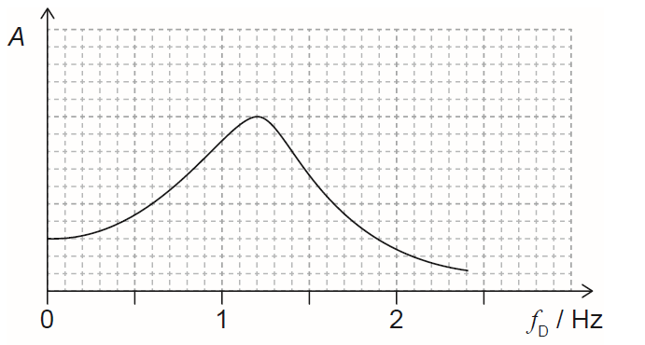
10
5
1. What is the resonant frequency of the system?

2. Draw a curve for a slightly higher Q factor.

3. Draw a curve for a slightly lower Q factor.

4. Some washboard bumps on a gravel road are 1.85 m apart. At what speed will the car hit the bumps at the resonant frequency of the car’s suspension?

5. Another set of washboard bumps seems to make the car go crazy when it is going 15.0 m/s. How far apart are they?

6. Is it better (as far as the amplitude of the suspension) to drive much faster or much slower than the resonant frequency of the suspension on a washboard road?

(1. 6.0 Hz, 2. Higher Q means less damping, so the curve in general higher, with a narrower peak that is slightly to the right, and largely the same at the extreme left and right of the graph, 3. Lower Q factor means more damping, so the curve is in general lower, with a broader peak that is slightly to the left, but is largely the same at the extremes, 4. 11.1 m/s would be the speed for resonance, 5. These bumps are 2.50 m apart, 6. Other safety considerations aside, faster produces less resonance.)
C. Resonance and Phase lag
1. An oscillator has a natural resonant frequency of 256 Hz and it is lightly damped. We can drive it at a variety of frequencies.
a. What is its relative amplitude and phase relative to the driver when it is being driven with a frequency of 100 Hz?

b. What is its relative amplitude and phase relative to the driver when it is being driven with a frequency of 256 Hz?

c. What is its relative amplitude and phase relative to the driver when it is being driven with a frequency of 1000 Hz

(1a. small amp./in phase, b. large amp./90º behind driver, c. small amp./180º behind driver)
2. An oscillator has a natural resonant period of 4.00 seconds and it is lightly damped. We can drive it at a variety of periods.
a. What is its relative amplitude and phase relative to the driver when it is being driven with a period of 0.500 seconds?

b. What is its relative amplitude and phase relative to the driver when it is being driven with a period of 20.0 seconds?

c. What is its relative amplitude and phase relative to the driver when it is being driven with a period of 4.00 seconds?

(2a. small amp./180º behind driver, b. small amp./in phase, c. large amp./90º behind driver)
3. Consider this position vs. time graph for a driven oscillator:
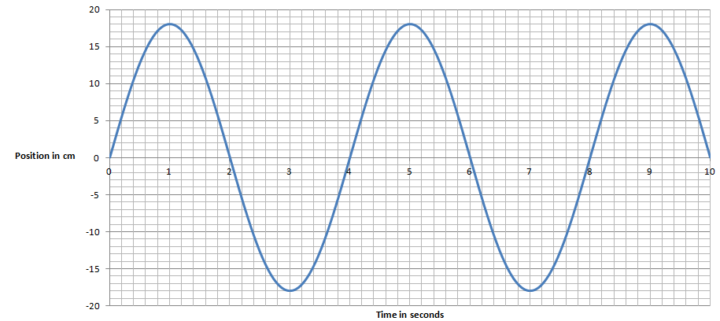
a. Suppose it is being driven with a period of 4.0 seconds, where is the driver with respect to equilibrium
(+x_{o}, -x_{o},or 0) at 1, 2, 3 and 4 seconds? What direction is the driver going?

b. Suppose it is being driven with a period of 1.0 seconds, where is the driver with respect to equilibrium
(+x_{o}, -x_{o},or 0) at 1, 2, 3 and 4 seconds? What direction is the driver going?

c. Suppose it is being driven with a period of 30 seconds, where is the driver with respect to equilibrium
(+x_{o}, -x_{o},or 0) at 1, 2, 3 and 4 seconds? What direction is the driver going?

(3a. x: 0/-x_{o}/0/+x_{o}, v: -/0/+/0 b. x: -x_{o} /0/+x_{o} /0, v: 0/+/0/- c. x: +x_{o} /0/-x_{o} /0, v: 0/-/0/+)

D. Q Factor calculations:
1. Estimate the Q factor: (Count the cycles before it dies down)
a.  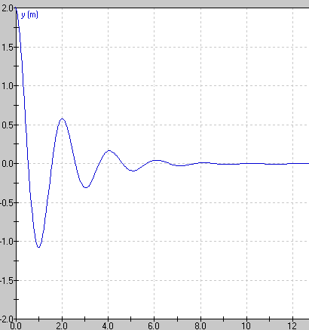 | b.  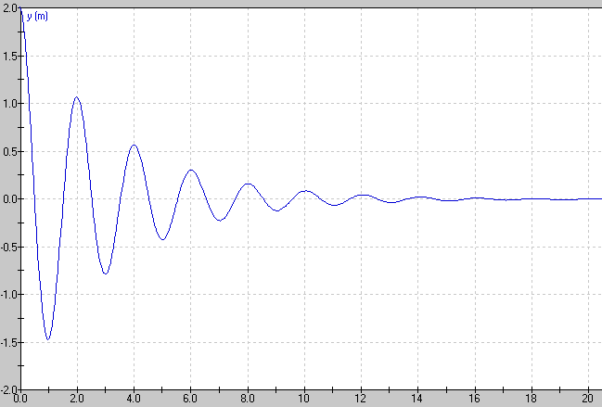

2. Calculate the Q Factor: $Q=2π\frac{energy stored}{energy dissipated per cycle}$ and $E_{T}= \frac{1}{2}mω^{2}x_{o}^{2}$
a. 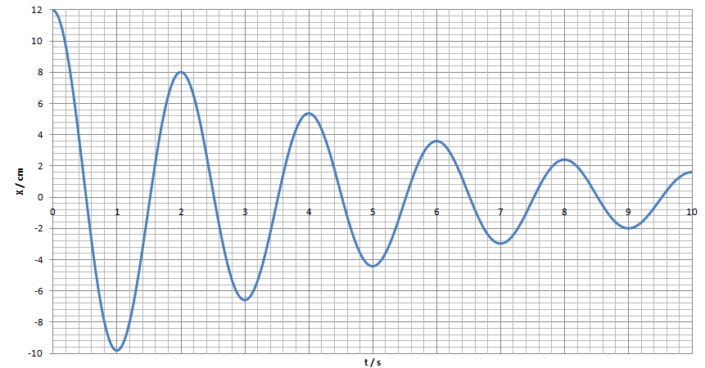 | b. 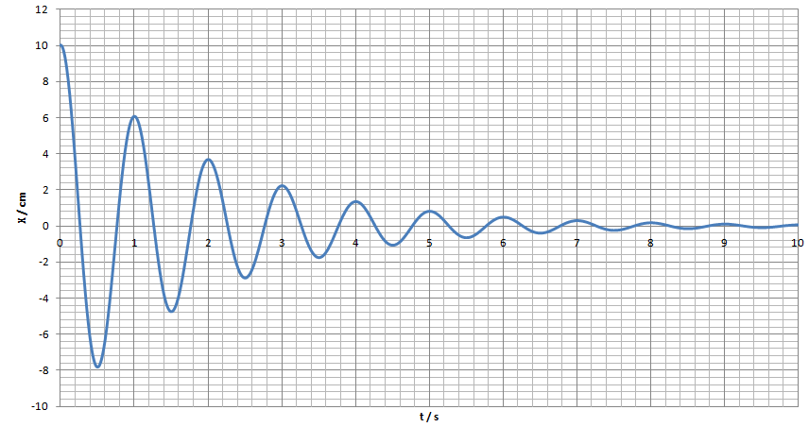

(1 a. 3?, b. 7?, 2a. 12.0 cm → 8.0 cm gives Q =11, b. 10.0 cm → 6.0 cm gives Q = 9.8 These will vary highly as it is sensitive to your reading of the graph)

Calculations of X and X_{o}:
3. An oscillator has a Q factor of 24 and starts with an amplitude of 16 cm. What is the amplitude of the oscillator after one complete cycle? (13.7 cm ≈ 14 cm)
4. An oscillator has a Q factor of 9.2. After one complete cycle, it has an amplitude of 31 cm. What was its original amplitude? (55 cm)

5. Declining energy graph:
a.  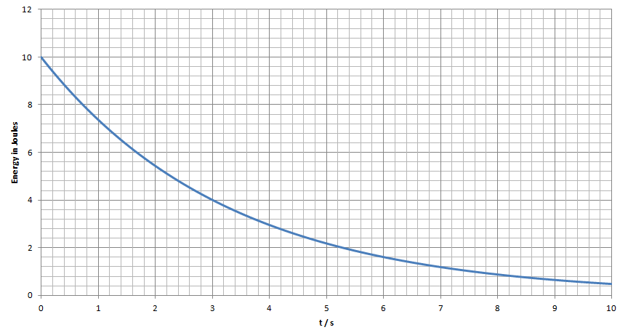  Given this graph of energy stored in an oscillator, and that its period is 3.00 s, calculate its Q factor. (10.0 J → 4.00 J gives Q = 10.5) | b.  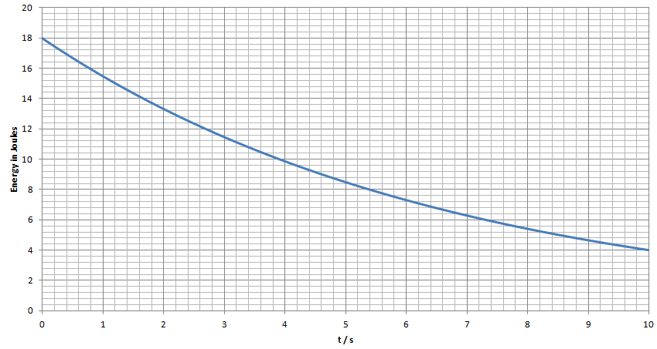  The Q factor of this system is 14.3. Determine the period.  (after 1 cycle, E = 10 J, so T = 3.9 s reading the graph)

Calculations of $Q=2π x resonant frequency x \frac{energy stored}{power loss}$
6. An oscillator has an initial amplitude of 1.30 m, a mass of 2.80 kg, and a period of 8.40 s. What is its initial stored energy? If it loses power initially at a rate of 0.275 W, what is its Q value? (1.32 J, 3.6)
7. An oscillator has a Q factor of 34.0 and a period of 0.800 s. Calculate the ratio $\frac{energy stored}{power loss}$ of the oscillator. If the system has a mass of 3.20 kg, and an initial amplitude of 16.0 cm, what is the initial energy of the system, and what is the initial rate of power loss for the system? (4.33 J/W or 4.33 s, 2.53 J, 0.584 W)

