Practice 11.0 – Interpreting graphs of Simple Harmonic Motion Name

Position Graphs
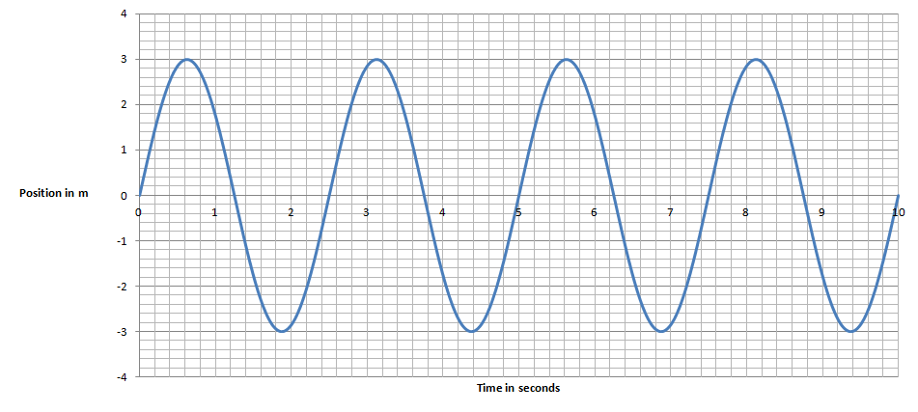 | 1. For this graph of position vs. time for an oscillator:  a. x_{o} = T = v_{o} = .  b. Write an equation for its motion: (x = ?)  c. Write an equation for its velocity: (v = ?)
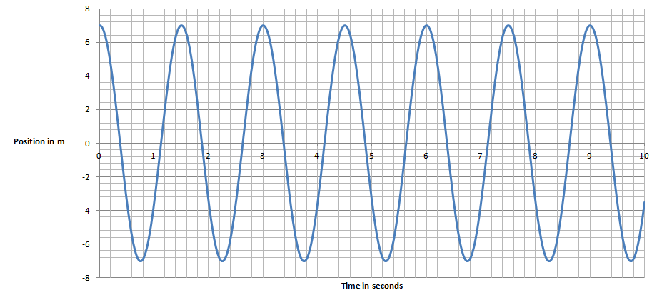 | 2. For this graph of position vs. time for an oscillator:  a. x_{o} = T = v_{o} = .  b. Write an equation for its motion: (x = ?)  c. Write an equation for its velocity: (v = ?)
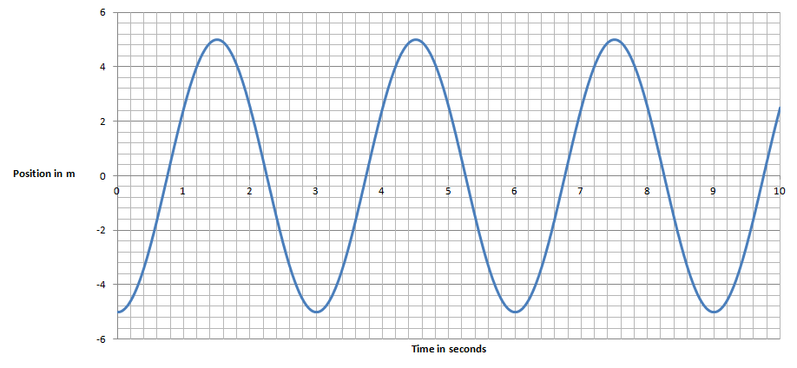 | 3. For this graph of position vs. time for an oscillator:  a. x_{o} = T = v_{o} = .  b. Write an equation for its motion: (x = ?)  c. Write an equation for its velocity: (v = ?)
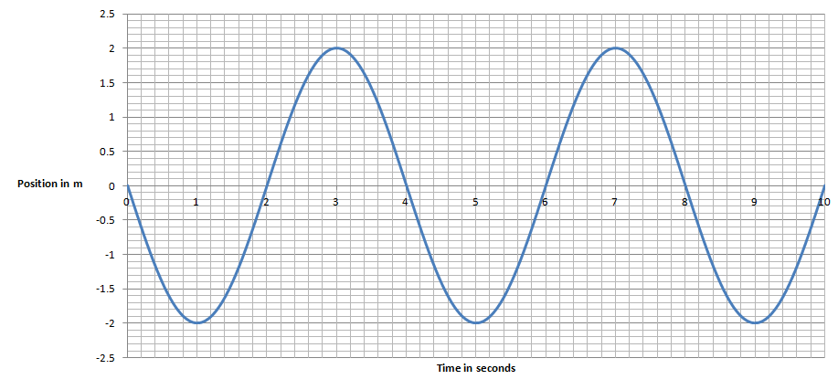  d. What is the position, velocity and acceleration of the object at 3.00 s, 4.00 s, and 6.50 s? | 4. For this graph of position vs. time for an oscillator:  a. x_{o} = T = v_{o} = .  b. Write an equation for its motion: (x = ?)  c. Write an equation for its velocity: (v = ?)

Velocity Graphs:
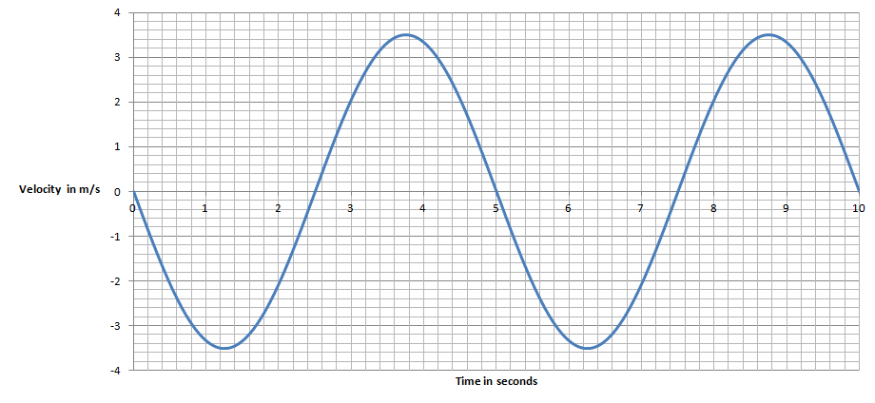 | 5. For this graph of velocity vs. time for an oscillator:  a. v_{o} = T = x_{o} = .  b. Write an equation for its velocity: (v = ?)  c. Write an equation for its position: (x = ?)
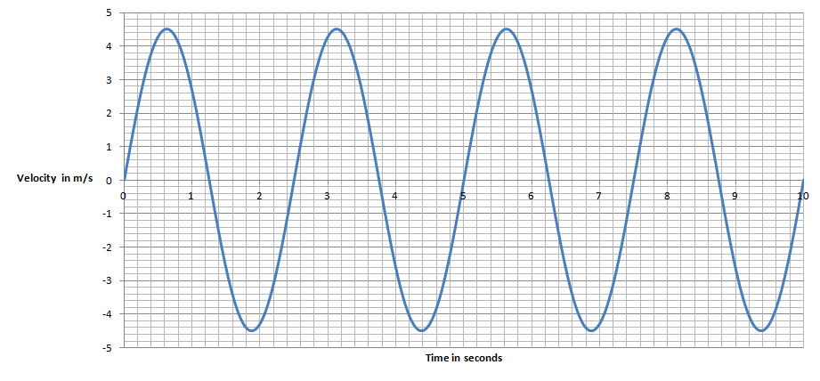 | 6. For this graph of velocity vs. time for an oscillator:  a. v_{o} = T = x_{o} = .  b. Write an equation for its velocity: (v = ?)  c. Write an equation for its position: (x = ?)
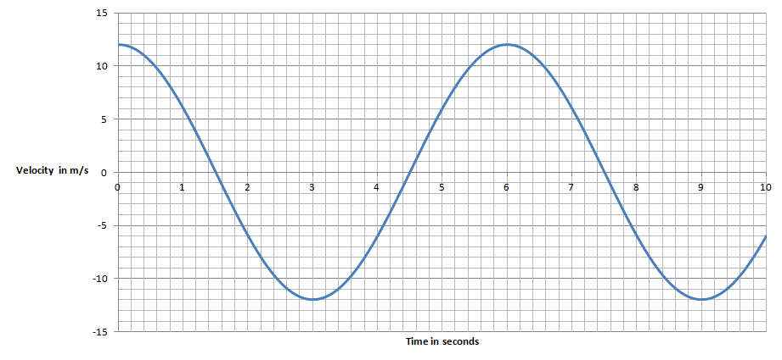 | 7. For this graph of velocity vs. time for an oscillator:  a. v_{o} = T = x_{o} = .  b. Write an equation for its velocity: (v = ?)  c. Write an equation for its position: (x = ?)
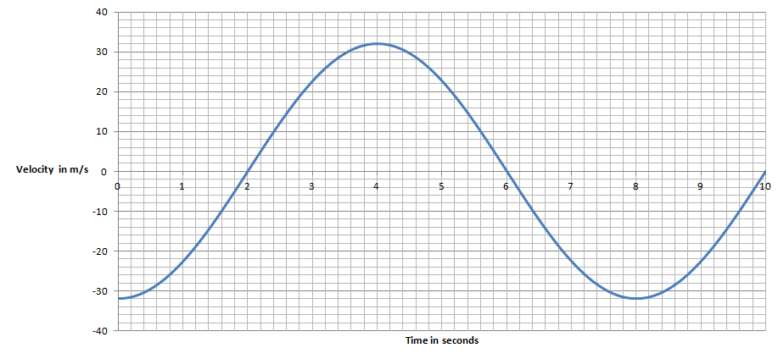 | 8. For this graph of velocity vs. time for an oscillator:  a. v_{o} = T = x_{o} = .  b. Write an equation for its velocity: (v = ?)  c. Write an equation for its position: (x = ?)
d. What is the position, velocity and acceleration of the mass at 2.00 s? at 5.00 s?

9. For this graph of Position vs. Time:
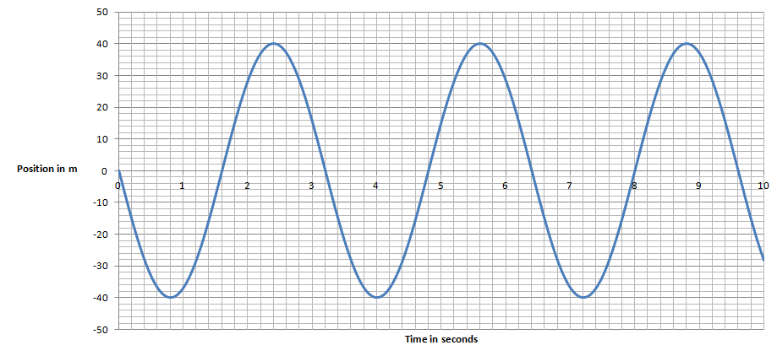

Fill in the table qualitatively: (+ or - or 0)
Time | x | v | a
2.4 s
7.2 s
1.6 s
3.0 s
7.6 s
6.5 s
5.0 s
3.2 s

10. For this graph of Velocity vs. Time:
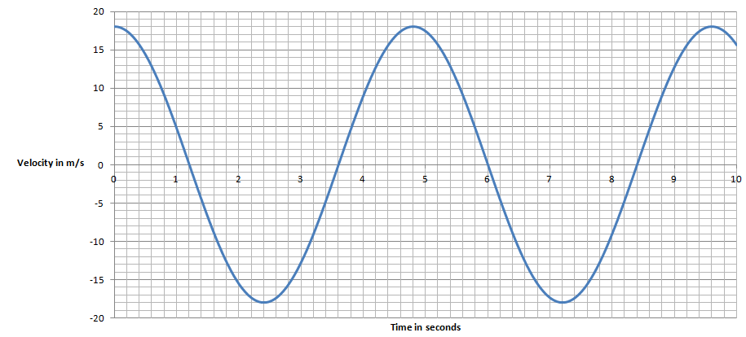

Fill in the table qualitatively: (+ or - or 0)
Time | x | v | a
3.2 s
0.8 s
1.6 s
4.8 s
6.0 s
7.2 s
8.4 s
4.0 s

