Noteguide for Rayleigh Criterion (Videos 12N) Name

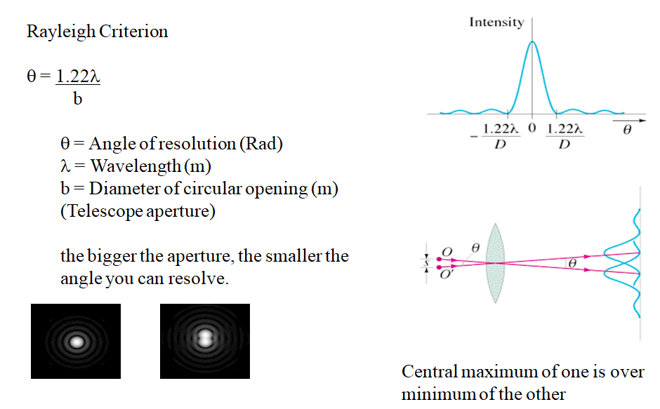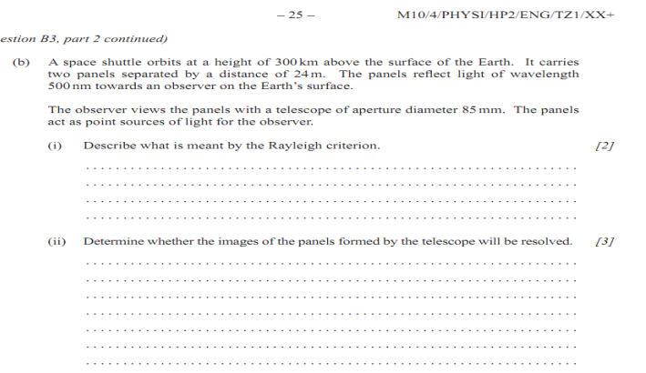

Whiteboards:
1. What is the angular resolution of the 100 inch (2.54 m) diameter telescope on the top of Mt Wilson? (use 550 nm as the wavelength, 550 nm = 550 x 10⁻⁹ m) (2.6 x 10⁻⁷ radians)

2. What diameter telescope do you need to resolve two stars that are separated by 1.8 x 10¹¹ m, but are 3.0 × 10¹⁷ m (32 LY) from us? (use 550 nm as the wavelength)
hint λ = s/r = (1.8 x 10¹¹ m)/(3.0 × 10¹⁷ m)

