Noteguide for Diffraction (Videos 12M) Name
Diffraction in general:
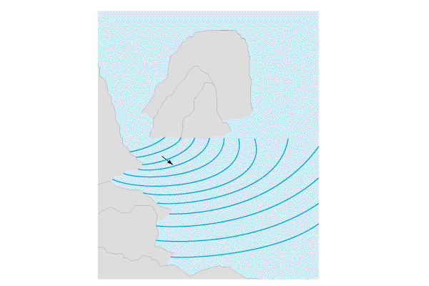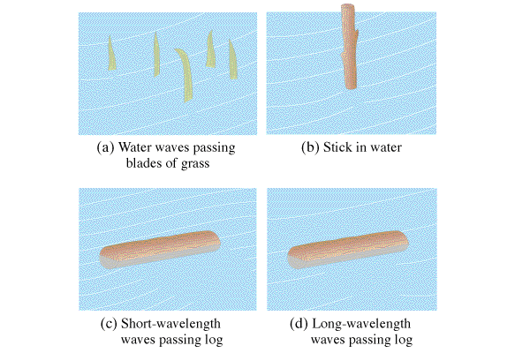

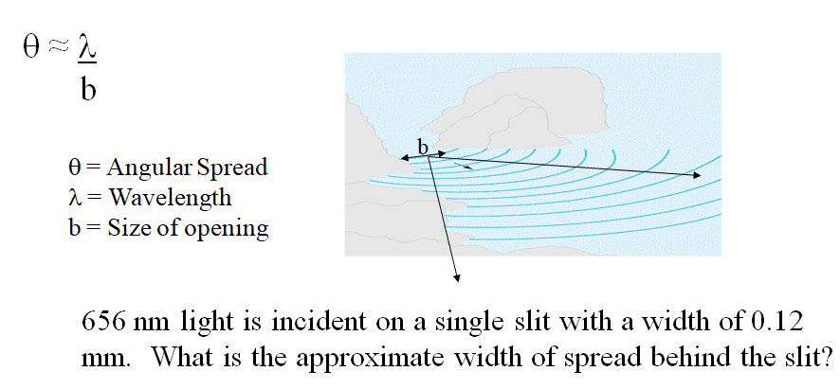

Try this problem: Sound waves with a frequency of 256 Hz come through a doorway that is 0.92 m wide. What is the approximate angle of diffraction into the room? Use 343 m/s as the speed of sound.
(1.5 rad)

Try this one too: A subwoofer needs to have an angle of diffraction of 2π at 425. Hz. What should be the width of the port? (Use the speed of sound to be 343 m/s) (0.13 m)

