Noteguide for Snell's Law (Videos 12K) Name
Hitting Straight on: Hitting at an angle:
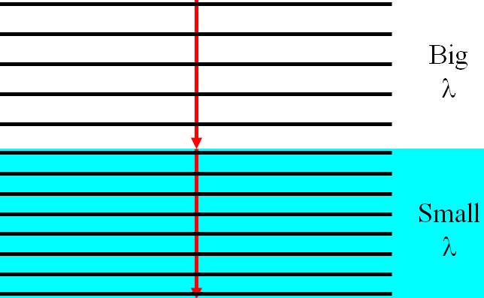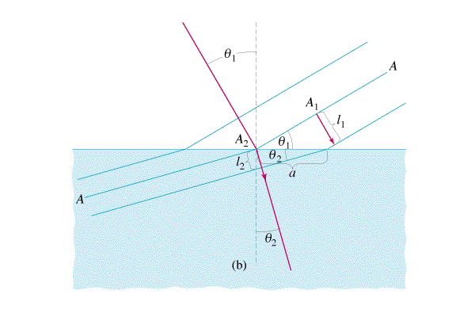

The data packet: Derivation:
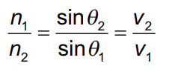

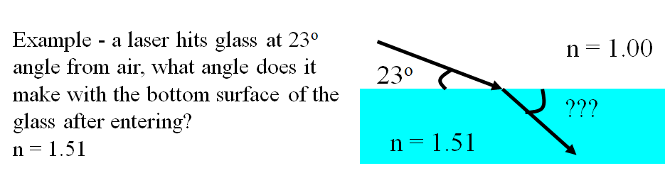

Whiteboards:
1. A beam of light makes an angle of 25º with the perpendicular on the air side of a liquid, and 17º below the liquid. What is the substance’s index of refraction? (1.45) | 2. A ray of light has an incident angle of 12º with the underside of an air-water interface, what is the refracted angle in the air? (n = 1.33 for water, 1.00 for air) (16º)

