Noteguide for Thin Film Interference (Videos 12J1) Name

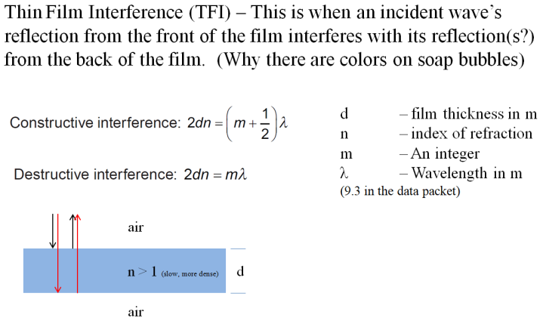
Example: A film of oil with an index of refraction of 1.48 floats on water with an index of refraction of 1.33. A region looks blue because it is constructively interfering at 450. nm. What is the minimum thickness the oil layer could have to effect this constructive interference? What are the next two thicknesses that would effect this same color? (76.0 nm, 228 nm, 380. nm)

Whiteboards
1. A thin film of glass has an index of refraction of 1.53 and creates constructive interference at 575 nm. What is the minimum thickness it could have? What is the next greatest thickness it could have? (94.0 nm, 282 nm, 470. nm ) | 2. What is the smallest thickness of a thin soap film with n = 1.37 that would appear black of illuminated by 520. nm light?  (190. nm )
3. A soap bubble is 82.5 nm thick where it is creating a bright band of color at 463 nm light. Where it is thinner than that, it creates no visible bands. What is the index of refraction of the soap bubble?  (1.40 ) | 4. A soap bubble has an n = 1.42, and is 231 nm thick. What is the biggest wavelength that would appear black at this location?  (656 nm )
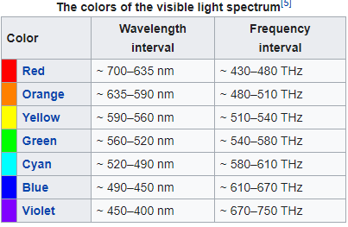
5. A soap bubble has an index of refraction of 1.34 and is 504 nm thick. What wavelengths have constructive interference? What color is it? (2701 nm, 900. nm, 540. nm, 386 nm, 300. nm, so Green )

