Noteguide for Doppler Effect (Videos 12H) Name
Part 1 - Moving Source
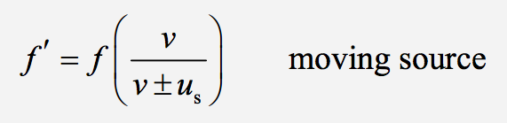
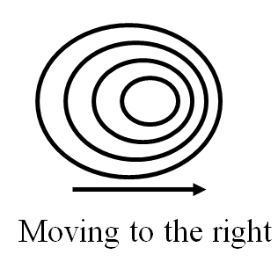
Derivation:

Example: A car with a 256 Hz horn approaches you at 40.0 m/s. What frequency do you hear?
(use v sound = 343 m/s)

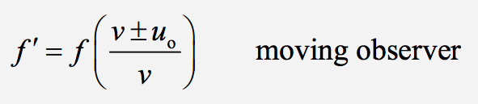
Part 2 - Moving Observer

Derivation

Example: You run at 8.50 m/s toward a violinist playing 660. Hz. What frequency do you hear? (Use 343 m/s as the speed of sound)

Whiteboards: (For all of these use the speed of sound (v) to be 343 m/s)
1. A car with a 256 Hz horn approaches you at 27.0 m/s. What frequency do you hear? (278 Hz)

2. What speed in what direction is the same car (f = 256 Hz) moving if you hear 213 Hz
(69.2 m/s away)

3. You drive at 23.0 m/s toward a singer singing at 212. Hz. What frequency do you hear? (226 Hz)

4. A running person who is late for a concert hears the concertmaster who is playing an A 440. Hz. How fast and in what direction are they running if they hear a frequency of 463 Hz (17.9 m/s toward)

Double Shift:
5. You are driving on a road, and a car coming the other way has a horn with a frequency of 256 Hz. The oncoming car is going 20.0 m/s toward you, and you are going 60.0 m/s toward them. What frequency do you hear? (319.4 Hz)

6. You are overtaking a car on a road. You have a car horn with a frequency of 100.0 Hz, and you are going 48.00 m/s, behind a car going 23.00 m/s. When you honk your horn, what frequency does the the person in the other car hear? (108.5 Hz)

7. You are driving down a road at 12.0 m/s toward a wall. You honk your horn that has a frequency of 148 Hz. What frequency do you hear the reflection off the wall? Use 343 m/s as the speed of sound.
(159 Hz)

