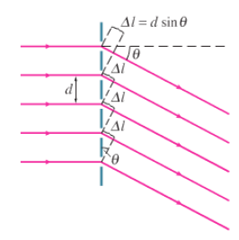
Noteguide for Diffraction Gratings (Videos 12F3) Name
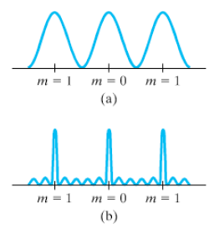

Maxima: d sinϴ = nλ

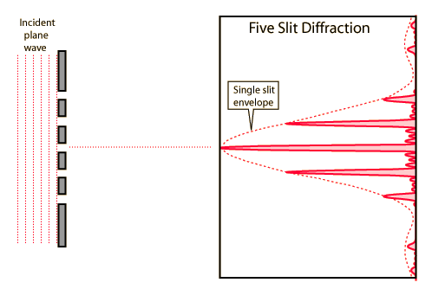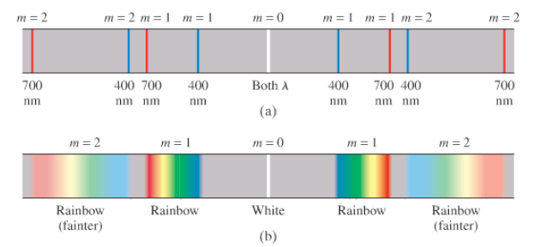

Example 1: At what angle will 719 nm light produce a second order maximum when falling on a grating whose slits are 1.24x10⁻³ cm apart?

B. What distance is this maximum from the center on a screen that is 4.30 m away?

Example 2: A 3600-line/cm grating produces a third order fringe at 23.0º.
A. What is the wavelength of the light?

B. How many orders are possible with this wavelength?

Whiteboards:
Whiteboard 1: A diffraction grating produces a third order spectral line at 19.0º for 632.8 nm light. (5.83x10⁻⁶ m, 1714 lines per cm)
A. What is the distance between the slits or lines?

B. How many lines are there per cm?

Whiteboard 2: White light containing wavelengths from 410. nm to 750. nm falls on a grating with 8600 lines/cm. What distance separates the first order of the red end of the spectrum from the blue end on a screen that is 2.50 m away? (410 nm: 20.646º, 0.942 m, 750 nm: 40.166º, 2.11 m, So the y would be 1.17 m apart.)

