Noteguide for Superposition and Interference (Videos 12DE) Name
12D: Superposition: (Overlapping waves add)
Examples:

12E: Interference:
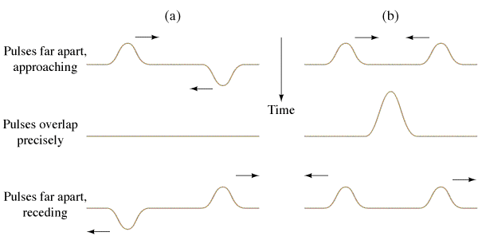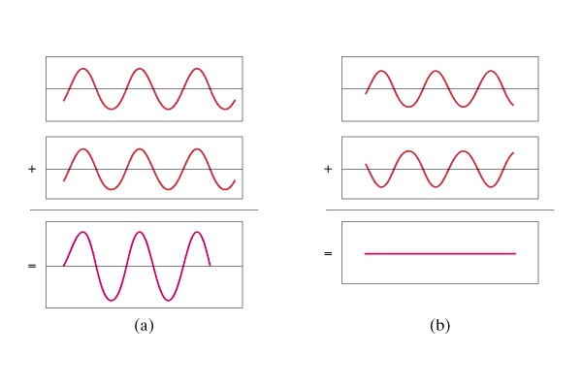

Wavelength rule for constructive interference: | Wavelength rule for destructive interference:

Other Examples:

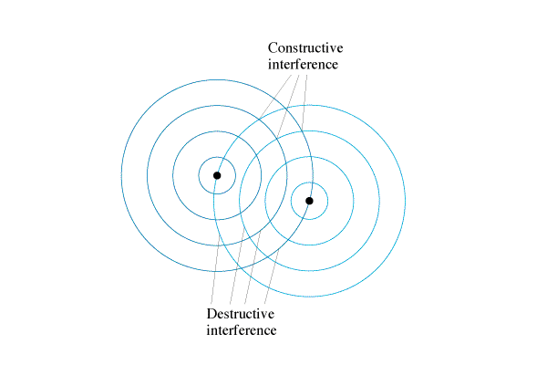

Example Problem:
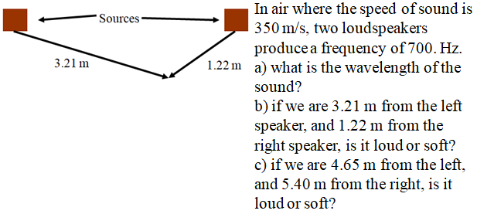

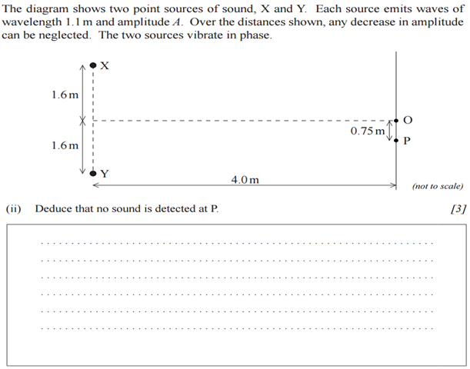
Whiteboards:
1. Two speakers 3.0 m apart are making sound with a wavelength of 48.0 cm.
A. What is the frequency of this sound if v = 343 m/s? | B. If I am 2.12 m from one speaker, and 3.80 m from the other, is it loud, or quiet, and how many wavelengths difference in distance is there?
C. If I am 5.17 m from one speaker, and 8.05 m from the other, is it loud, or quiet, and how many wavelengths difference in distance is there?

