Noteguide for Types, Reflections (Videos 12BC) Name
12B
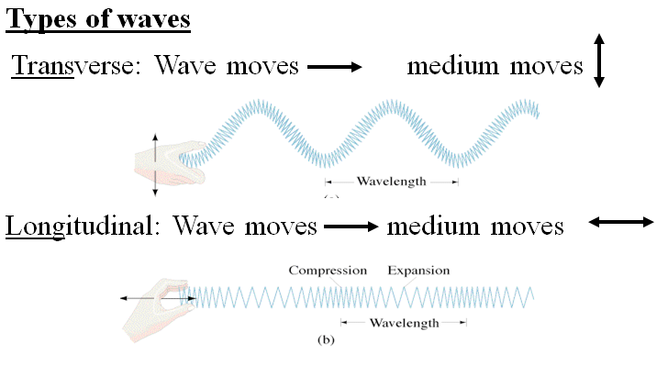

Electromagnetic Waves:

Types of waves:
 | Mechanical | Electromagnetic
Transverse
Longitudinal

12C Reflections:

Occur when:

Examples of reflections:

How to prevent reflections:

Fixed vs. Free ends:

Mirrors:

