Noteguide for Pendulums (Videos 11C) Name
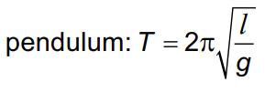
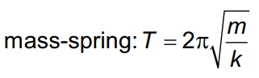
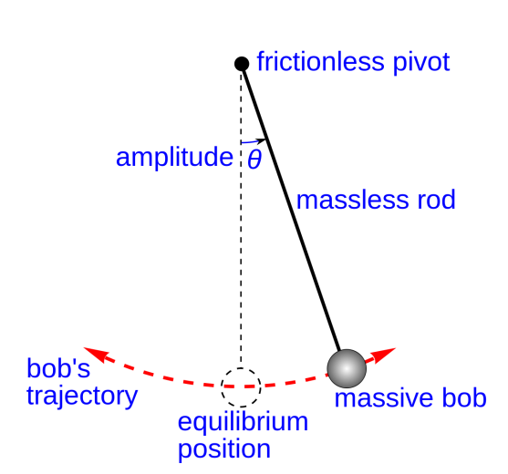

Example: What is the period of a pendulum that is 12 cm long? (0.69 s)
What is its frequency? (1.4 Hz)

Whiteboards:
1. A Foucault pendulum is 25.0 m long. What is its period? (10.0 s)

2. A pendulum has a period of 2.00 s. What is its length? (0.994 m)

3. A pendulum on the moon that is 50 cm long, has a period of 3.5 seconds. What is the acceleration of gravity on the moon? (1.6 m/s/s)

