Noteguide for Simple Harmonic Motion Graphs (Video 11A2) Name
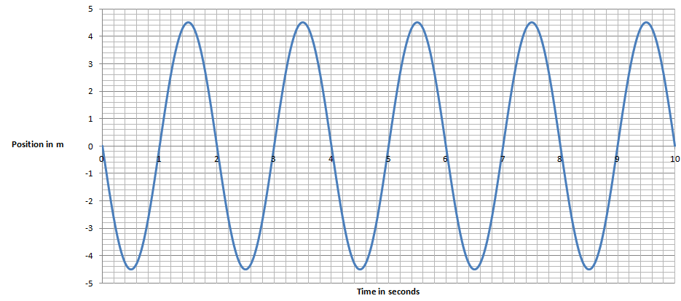
Given this graph of position vs. time for a SHO, determine:
Period = Amplitude =

2. Write an equation for its position:

3. Write an equation for its velocity: (EC - write one for its acceleration)

4. At 1.80 seconds, what is the position, velocity, and acceleration?

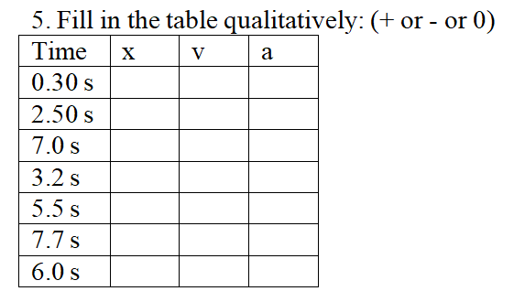

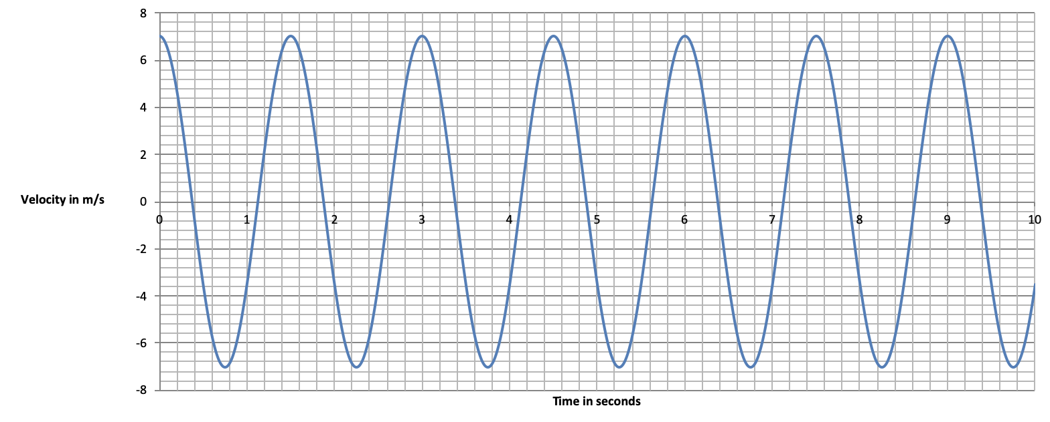

What is the period? Can you draw the position vs time graph?

