Noteguide for Frequency, Wavelength and Velocity (Videos 12A) Name
Define these terms:
Medium
Amplitude
Wavelength
Wave speed
Period
Frequency

Basic Formulas:

Example 1: What is the frequency of a wave that takes 0.12 s for the whole wave to pass by?

Example 2: What is the wavelength of an A 440.0 Hz if the speed of sound is 343 m/s?

Whiteboards:
1. What is the period of a 60. Hz wave? (0.017 s) | 2. What is the frequency of a wave with a period of 0.003906 s (256.0 Hz)
3. What is the velocity of a 1.12 m wave with a frequency of 32 Hz? (36 m/s) | 4. What is the wavelength of a 89.1 MHz FM radio signal? 1 MHz = 10⁶ Hz v = c = 3.00 x 10⁸ m/s (Speed of light) (3.37 m)
5. What is the frequency of a sound wave that has a wavelength of 45 cm, where the speed of sound is 335 m/s (740 Hz) | 6. What is the period of a 12.0 m long radio wave?  v = c = 3.00 x 10⁸ m/s (Speed of light)  (4.00 x 10⁻⁸ s)

Noteguide for Types, Reflections (Videos 12BC) Name
12B
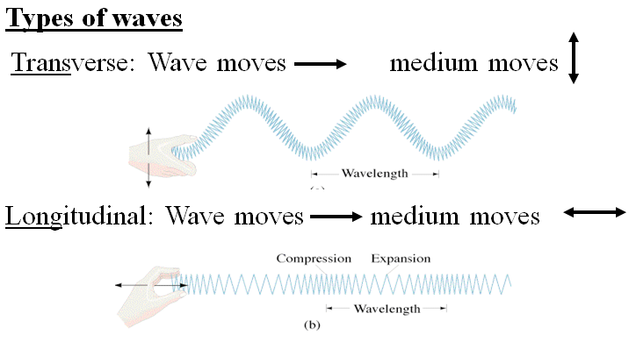

Electromagnetic Waves:

Types of waves:
 | Mechanical | Electromagnetic
Transverse
Longitudinal

12C Reflections:

Occur when:

Examples of reflections:

How to prevent reflections:

Fixed vs. Free ends:

Mirrors:

Noteguide for Intensity and Inverse Square (Videos 12C1) Name
Concept 0: The Definition of Intensity:

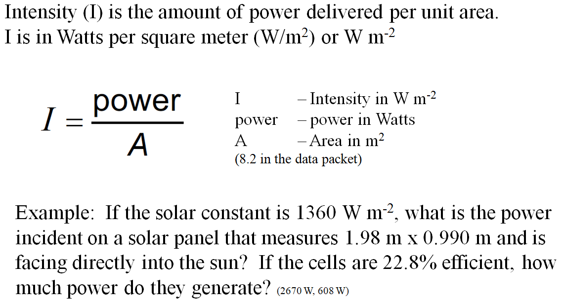

Whiteboards
1. A sunlamp projects 45.0 Watts of power onto a piece of metal that measures 34.0 cm x 67.0 cm. What is the intensity of the light?  (198 Wm⁻²) | 2. On a winter day in Oregon, the solar flux is 365 Wm-2. What is the total power incident on a roof that measures 12.5 m by 45.5 m and is angled cleverly so that it is perpendicular to the sun’s rays!!? (208 kW)
3. You are designing a solar array for your house. You want to generate 5000. W of electricity on a sunny 980. W m⁻² day, but since your solar panels are only 22.8% efficient, you will need to capture 21,930 Watts of solar flux. What area is required to capture this amount of solar flux?
(22.4 m²)

Concept 1: The Inverse Square Law:

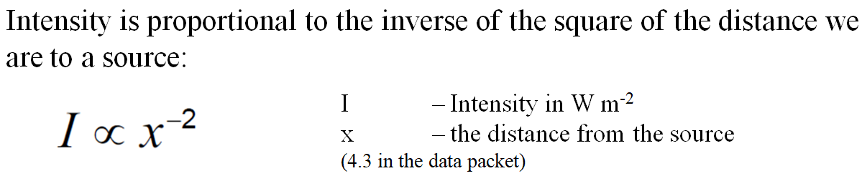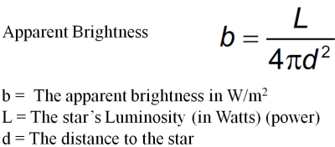

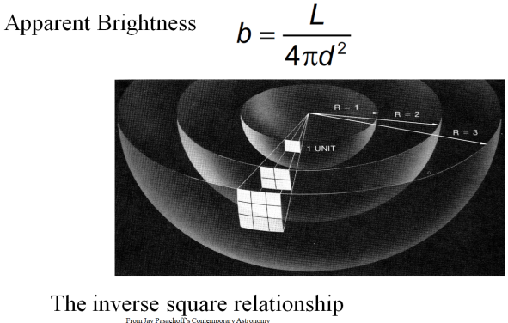
Example: If we are 204 cm from a source our intensity is 12.0 W m⁻². What would be our intensity if we were to move to 68.0 cm from the same source? (108 W m⁻²)

Whiteboards:
1. A sound source that is 4.50 m from us is hitting us with 3.40 mW m⁻² of power. What is the intensity if we were 6.70 m from it?  (1.53 mW m⁻²) | 2. The intensity from a bright light is 260. W m⁻² when we are 3.85 m from it. At what distance would it be 450. W m⁻²?  (2.93 m)
3. What distance from a 60.0 W light source is the intensity 12.0 mW m⁻²? (19.9 m)

Noteguide for Intensity and Amplitude (Videos 12D1) Name

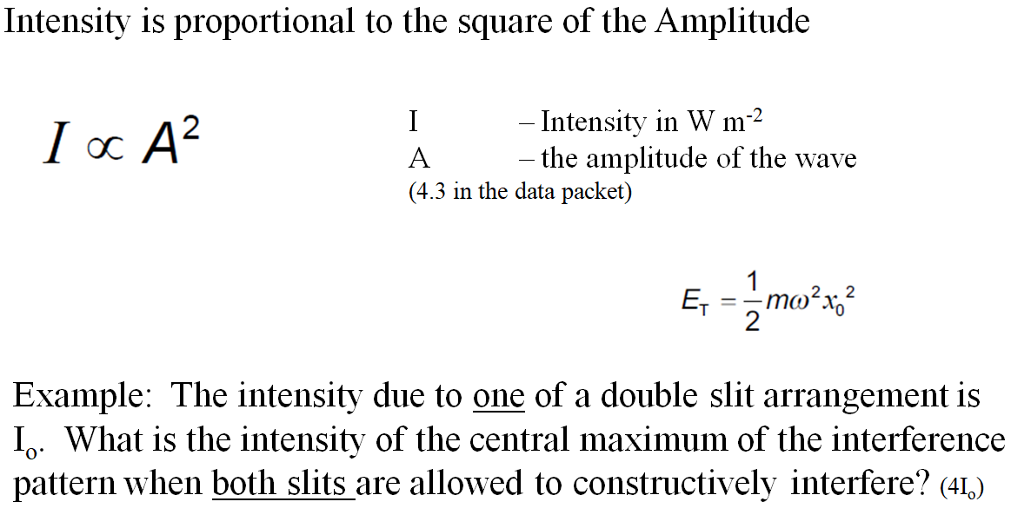

Whiteboards
1. Three narrow slits close together are illuminated by light. The intensity at the center of the three on a distant screen is  23.8 μW m⁻² due to the light from one of the slits. What is the intensity if all three constructively interfere at the center?  (2.14x10⁻⁴ W m⁻²) | 2. A number of narrow slits close together are illuminated by light. When only one of the slits illuminates the screen, the central bright spot has an intensity of I_{o}. When all of the slits illuminate the screen, the intensity is 25I_{o} in the center.. How many slits are there?  (5)
3. Light from a heat lamp has an intensity of 467 W m⁻². If we were to double the amplitude of the light wave, what would be its intensity?
(1868 W m⁻²)

Noteguide for Superposition and Interference (Videos 12DE) Name
12D: Superposition: (Overlapping waves add)
Examples:

12E: Interference:
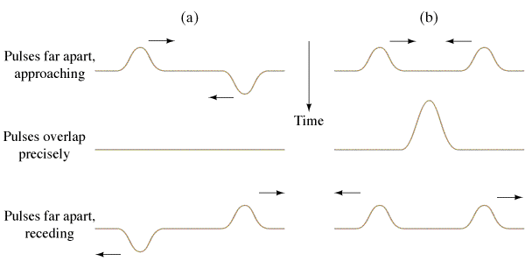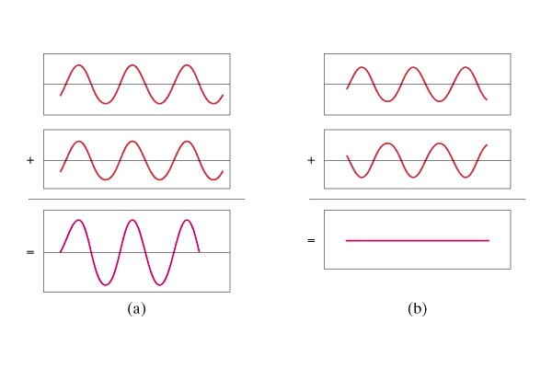

Wavelength rule for constructive interference: | Wavelength rule for destructive interference:

Other Examples:

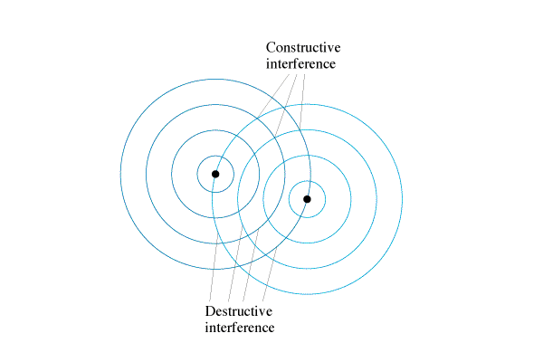

Example Problem:
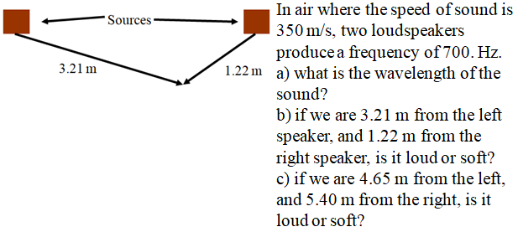

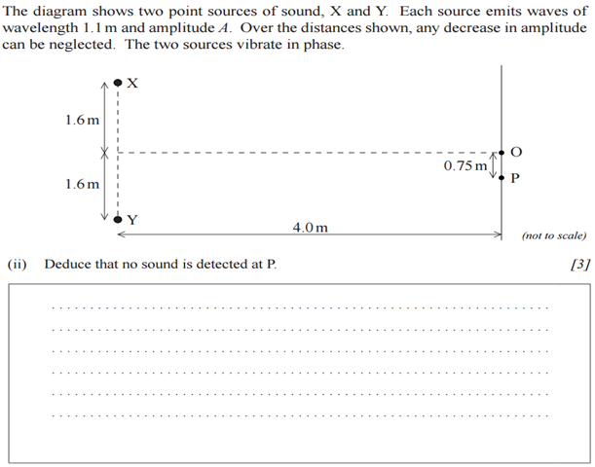
Whiteboards:
1. Two speakers 3.0 m apart are making sound with a wavelength of 48.0 cm.
A. What is the frequency of this sound if v = 343 m/s? | B. If I am 2.12 m from one speaker, and 3.80 m from the other, is it loud, or quiet, and how many wavelengths difference in distance is there?
C. If I am 5.17 m from one speaker, and 8.05 m from the other, is it loud, or quiet, and how many wavelengths difference in distance is there?

Noteguide for Double Slit Interference Patterns (Videos 12F1) Name
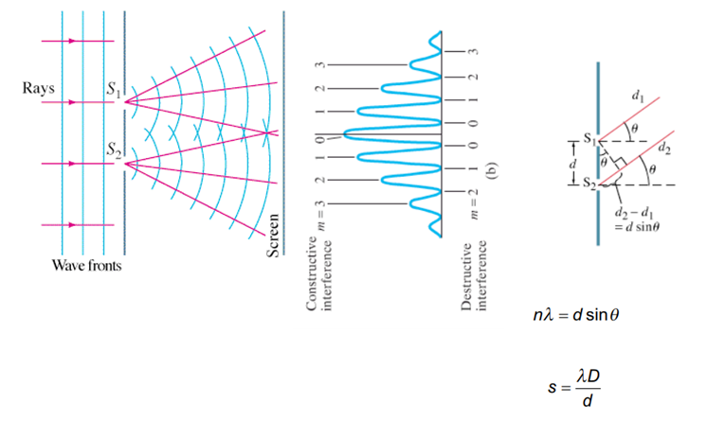
Write down what all the variables are:

Example 1: A Parallel beam of light from a laser with a wavelength of 638 nm falls on two very narrow slits 0.0550 mm apart.
A. How far apart are the fringes on the center of a screen 4.30 m away?

B. What angle separates the central fringe, and the fifth order fringe? What distance is this on the screen?

C. What distance separates the central fringe and the and the first minimum (destructive) location?

Example 2: The third order fringe of 620. nm light is observed at an angle of 21.0º when the light falls on two narrow slits.
A. What distance separates the slits?

B. What angle does the second order fringe make with the central fringe? What distance separates the central bright spot and the second order fringe on a screen 5.00 m away?

Whiteboard 1: Monochromatic light falls on two very narrow slits 0.0450 mm apart. Successive fringes on a screen 6.00 m away are 7.20 cm apart. Determine the wavelength and the frequency of the light.

Whiteboard 2: Two narrow slits are separated by 1.00 mm are illuminated by 544 nm light. Find the distance between adjacent bright fringes on a screen 3.40 m away.

What angle separates the central bright spot and the 4th order fringe?

Noteguide for Single Slit Interference Patterns (Videos 12F2) Name
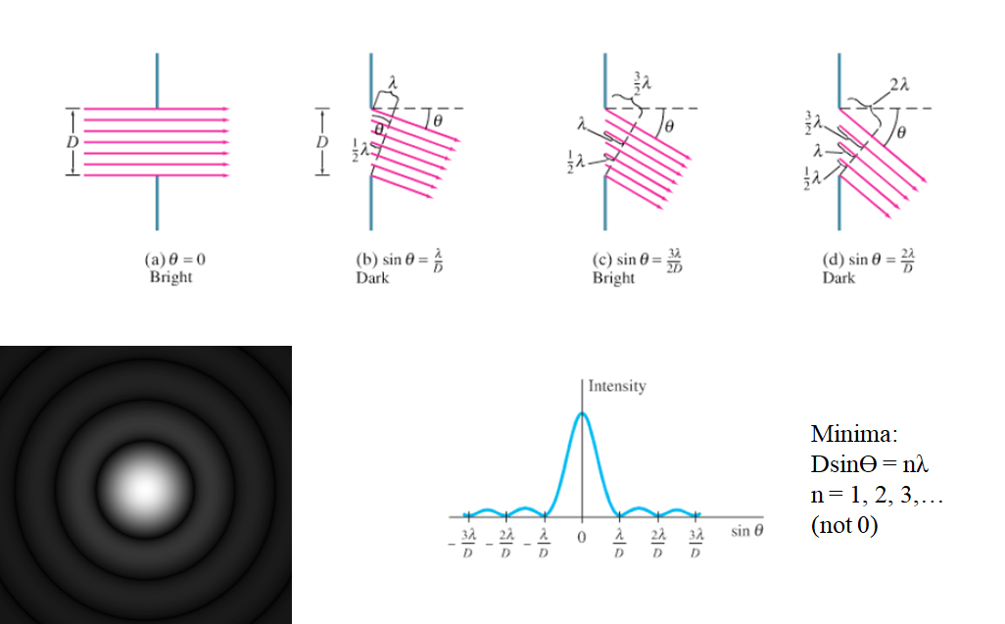

Write down what all the variables are:

Example: If 644 nm light falls on a slit 0.0560 mm wide,
A. What is the full angular width of the central diffraction peak?

B. What is its width on a screen that is 4.50 m away?

C. What distance separates the central maximum from the third minimum on the screen 4.50 m away?

Whiteboard 1: Monochromatic light falls on a slit that is 0.00320 mm wide. The angle between the central maximum and the second dark fringe on one side is 18.0º. What is the wavelength of light used? (4.94x10⁻⁷ m (494 nm) )

Whiteboard 2: When blue light of wavelength 462 nm falls on a single slit, the first dark bands on either side are separated by 43.0º. Determine the width of the slit. (1.26x10⁻⁶ m (1.26 μm) )

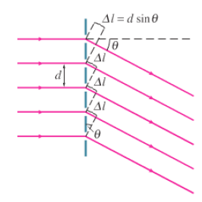
Noteguide for Diffraction Gratings (Videos 12F3) Name
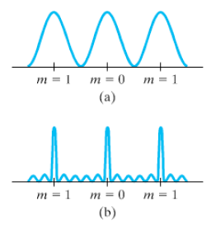

Maxima: d sinϴ = nλ

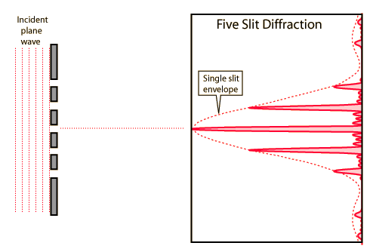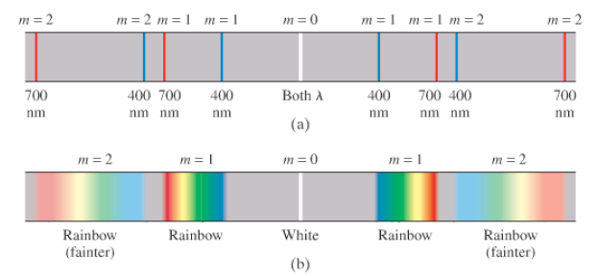

Example 1: At what angle will 719 nm light produce a second order maximum when falling on a grating whose slits are 1.24x10⁻³ cm apart?

B. What distance is this maximum from the center on a screen that is 4.30 m away?

Example 2: A 3600-line/cm grating produces a third order fringe at 23.0º.
A. What is the wavelength of the light?

B. How many orders are possible with this wavelength?

Whiteboards:
Whiteboard 1: A diffraction grating produces a third order spectral line at 19.0º for 632.8 nm light. (5.83x10⁻⁶ m, 1714 lines per cm)
A. What is the distance between the slits or lines?

B. How many lines are there per cm?

Whiteboard 2: White light containing wavelengths from 410. nm to 750. nm falls on a grating with 8600 lines/cm. What distance separates the first order of the red end of the spectrum from the blue end on a screen that is 2.50 m away? (410 nm: 20.646º, 0.942 m, 750 nm: 40.166º, 2.11 m, So the y would be 1.17 m apart.)

Noteguide for Standing Waves (Videos G, Part 1) Name
Watch the demos of all three kinds first

Intro to standing waves -
Draw the next two modes: (from the video)
Harmonic | Both ends fixed | Both ends free | One end fixed
1
2
3
Haha - we will talk in class why they happen. (I try to explain it on the video)

Calculations with standing waves

One whole wavelength: 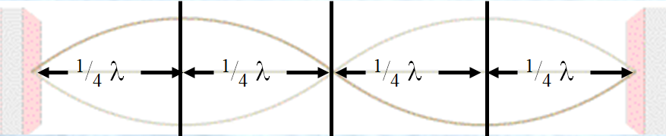

So a quarter wavelength is either:

OR Formulas:

So count the quarter wavelengths:

Formulas:
Example: This waveform is 8.45 m long. What is the wavelength of the standing wave? If it has a frequency of 30.4 Hz, what is the wave speed?

What is meant by the waveform: What is meant by the wavelength:

Do all of the examples
This waveform is 45 cm long. What is the wavelength? | The wavelength is 0.80 m long. What is the length of the standing wave? (The waveform)
This waveform is 2.42 m long. What is the wavelength? If it is a sound wave (v = 343 m/s), what is the frequency? | The wavelength is 124 cm long. What is the length of the waveform?  If it is a sound wave (v = 343 m/s), what is its frequency

Noteguide for Standing Waves (Videos 12G, Part 2) Name
Video G Part 2 - First three modes of vibration
This string is 32.0 cm long, and has a wave speed of 281.6 m/s. Find the wavelength and frequency for each mode:
 | Wavelength | Frequency
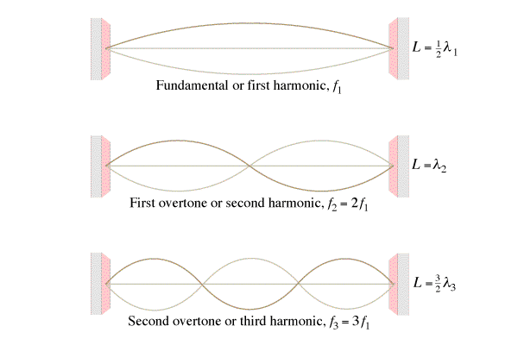
What is the pattern of frequencies:

This pipe is 1.715 m long, sound travels at 343 m/s along the pipe. Find the wavelength and frequency for each mode:
 | Wavelength | Frequency
What is the pattern of frequencies:

This pipe is 1.715 m long, sound travels at 343 m/s along the pipe. Find the wavelength and frequency for each mode:
 | Wavelength | Frequency
What is the pattern of frequencies:

Whiteboards:
1. The third harmonic on a flute (both ends open pipe) has a frequency of 480. Hz. How long is the waveform if the speed of sound inside the flute is 335 m/s?  (1.05 m) | 2. What is the frequency of the 2nd harmonic on a 0.31 m long pan pipe (One end open, one end closed) where the speed of sound is 343 m/s (829.8 Hz)
3. What is the wave speed on a 0.34m long violin string if the first harmonic has a frequency of 440 Hz?  (299.2 m/s) | 4. What is the frequency of the 3rd harmonic on a violin string that is 0.34 m long where the wave speed is 299.2 m/s (1320 Hz)

Noteguide for Doppler Effect (Videos 12H) Name
Part 1 - Moving Source
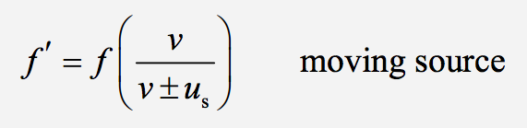
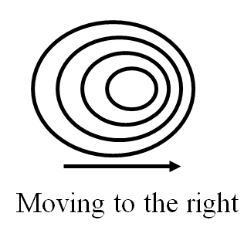
Derivation:

Example: A car with a 256 Hz horn approaches you at 40.0 m/s. What frequency do you hear?
(use v sound = 343 m/s)

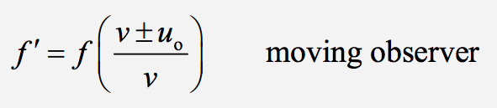
Part 2 - Moving Observer

Derivation

Example: You run at 8.50 m/s toward a violinist playing 660. Hz. What frequency do you hear? (Use 343 m/s as the speed of sound)

Whiteboards: (For all of these use the speed of sound (v) to be 343 m/s)
1. A car with a 256 Hz horn approaches you at 27.0 m/s. What frequency do you hear? (278 Hz)

2. What speed in what direction is the same car (f = 256 Hz) moving if you hear 213 Hz
(69.2 m/s away)

3. You drive at 23.0 m/s toward a singer singing at 212. Hz. What frequency do you hear? (226 Hz)

4. A running person who is late for a concert hears the concertmaster who is playing an A 440. Hz. How fast and in what direction are they running if they hear a frequency of 463 Hz (17.9 m/s toward)

Double Shift:
5. You are driving on a road, and a car coming the other way has a horn with a frequency of 256 Hz. The oncoming car is going 20.0 m/s toward you, and you are going 60.0 m/s toward them. What frequency do you hear? (319.4 Hz)

6. You are overtaking a car on a road. You have a car horn with a frequency of 100.0 Hz, and you are going 48.00 m/s, behind a car going 23.00 m/s. When you honk your horn, what frequency does the the person in the other car hear? (108.5 Hz)

7. You are driving down a road at 12.0 m/s toward a wall. You honk your horn that has a frequency of 148 Hz. What frequency do you hear the reflection off the wall? Use 343 m/s as the speed of sound.
(159 Hz)

Noteguide for Sound (Videos 12I1) Name
What type of wave is sound:

Range of human hearing:

Most sound is:

v = (331 + 0.60T) m/s, T = temperature in ºC

Example 1 – What is the speed of sound at 20 ºC? 42 ºC?

Whiteboards:
1. What is the speed of sound in air at 80 ºC?  (379 m/s) | 2. At what temperature in Celsius is the speed of sound 318 m/s? (-21.7 ºC)

Noteguide for Beats (Videos 12I2) Name
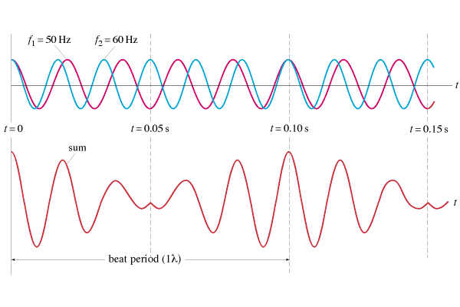

f_{beat} = |f₁ - f₂|

Examples:
1. I play a pitch of 256 Hz (C) on my Pennywhistle, and you play a pitch of 384 Hz (G) on your whistle. What is the beat frequency?

2. If I am playing a pitch of 384 Hz, and I hear a beat frequency of 10.0 Hz, what are the possible other frequencies that are playing?

Whiteboards:
1. What beats do you hear if you play an e 640 Hz with a c 1024 Hz?  (384 Hz, G in octave below the E ) | 2. If you are playing an A 440 Hz, and you hear a beat frequency of 20 Hz, what are the other possible frequencies that could be playing?  (460 Hz or 420 Hz )
3. The concertmaster is playing an A 440.0 Hz. Another violin hears a beat every 0.20 seconds. What frequency are they playing?
(445.0 Hz or 435.0 Hz )

Noteguide for Index of Refraction (Videos 12J) Name
c = 3.00 x 10⁸ m/s in a vacuum Light is slower in other materials
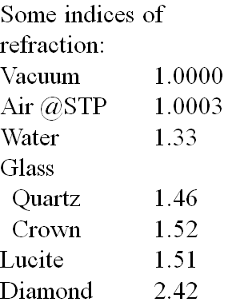
Index of refraction:

n = c/v

c = 3.00 x 10⁸ m/s
v = speed in particular medium (m/s)
n = index of refraction (no units!!!)

The bigger n is, the slower light travels

Example:
What is the speed of light in water? n = 1.33

Whiteboards:
1. What is the index of refraction of a substance where the speed of light is 2.3 x 10⁸ m/s? (1.30) | 2. What is the speed of light in diamond? n = 2.42  (1.24x10⁸ m/s)
3. What is the wavelength of 720. nm light in a diamond? n = 2.42 (720. nm is its wavelength in a vacuum, the frequency remains the same) Find the frequency in a vacuum (v = fλ), find the velocity in diamond (See #2), find the wavelength in the diamond (v = fλ). Then, after doing all that, multiply 720 by 1.00/2.42 (the ratio of the indices)
(298 nm)

Noteguide for Thin Film Interference (Videos 12J1) Name

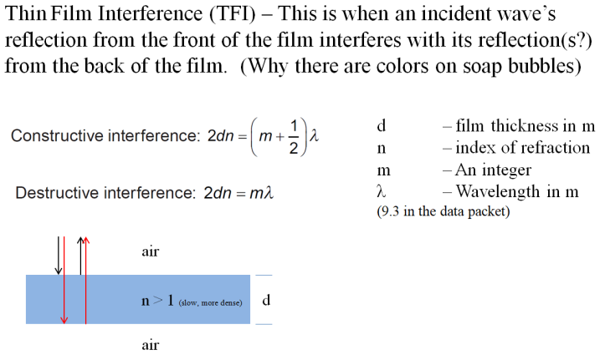
Example: A film of oil with an index of refraction of 1.48 floats on water with an index of refraction of 1.33. A region looks blue because it is constructively interfering at 450. nm. What is the minimum thickness the oil layer could have to effect this constructive interference? What are the next two thicknesses that would effect this same color? (76.0 nm, 228 nm, 380. nm)

Whiteboards
1. A thin film of glass has an index of refraction of 1.53 and creates constructive interference at 575 nm. What is the minimum thickness it could have? What is the next greatest thickness it could have? (94.0 nm, 282 nm, 470. nm ) | 2. What is the smallest thickness of a thin soap film with n = 1.37 that would appear black of illuminated by 520. nm light?  (190. nm )
3. A soap bubble is 82.5 nm thick where it is creating a bright band of color at 463 nm light. Where it is thinner than that, it creates no visible bands. What is the index of refraction of the soap bubble?  (1.40 ) | 4. A soap bubble has an n = 1.42, and is 231 nm thick. What is the biggest wavelength that would appear black at this location?  (656 nm )
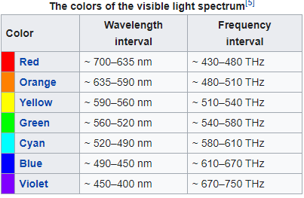
5. A soap bubble has an index of refraction of 1.34 and is 504 nm thick. What wavelengths have constructive interference? What color is it? (2701 nm, 900. nm, 540. nm, 386 nm, 300. nm, so Green )

Noteguide for Snell's Law (Videos 12K) Name
Hitting Straight on: Hitting at an angle:
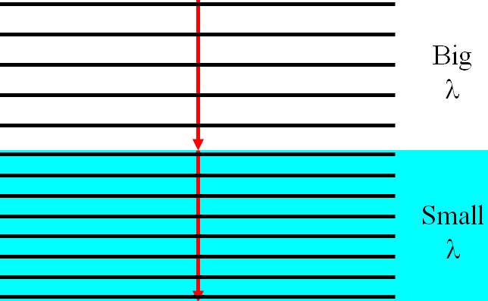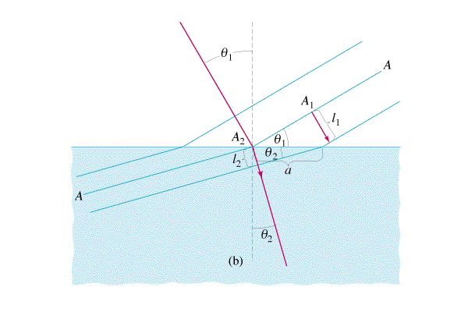

The data packet: Derivation:
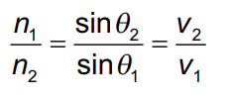

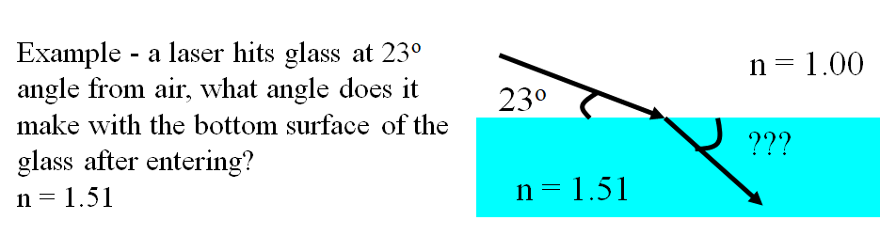

Whiteboards:
1. A beam of light makes an angle of 25º with the perpendicular on the air side of a liquid, and 17º below the liquid. What is the substance’s index of refraction? (1.45) | 2. A ray of light has an incident angle of 12º with the underside of an air-water interface, what is the refracted angle in the air? (n = 1.33 for water, 1.00 for air) (16º)

Noteguide for Critical Angle (Videos 12L) Name
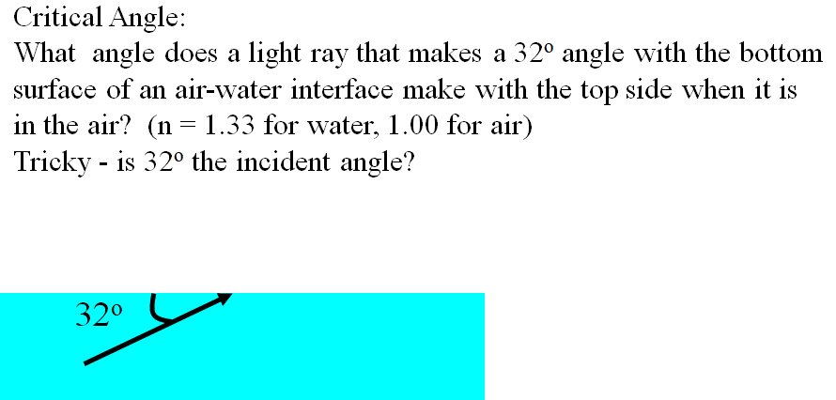

From slow to fast
Light bends over. When ϴ_{fast} = 90º, light does not leave water - total internal reflection
Example: What is the Critical angle for an air-water interface?

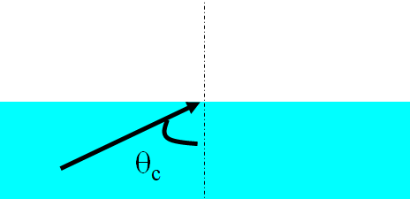

Whiteboard:
What is the Critical angle for an water-diamond interface? Where does the critical angle occur?
n_{water} = 1.33, n_{diamond} = 2.42
(33.3º - in the diamond)

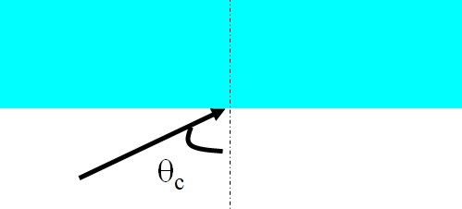

Noteguide for Diffraction (Videos 12M) Name
Diffraction in general:
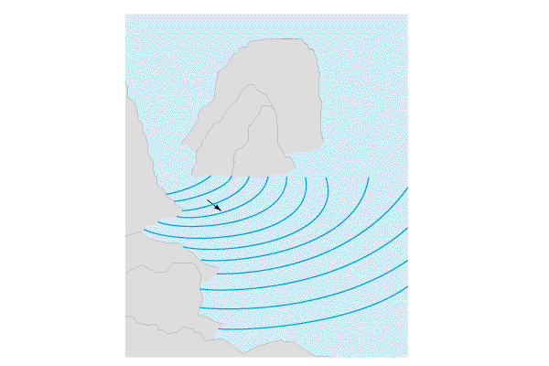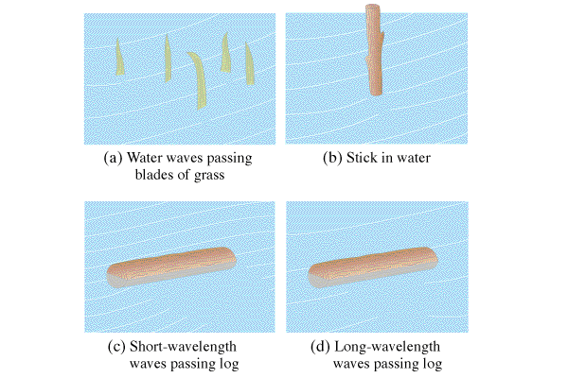

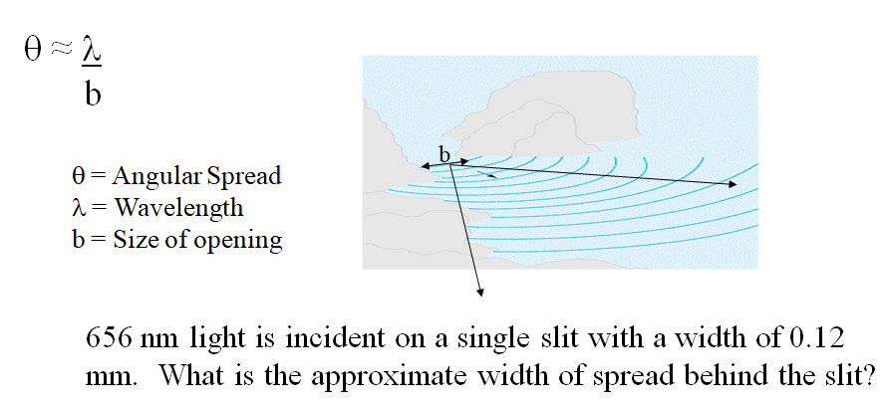

Try this problem: Sound waves with a frequency of 256 Hz come through a doorway that is 0.92 m wide. What is the approximate angle of diffraction into the room? Use 343 m/s as the speed of sound.
(1.5 rad)

Try this one too: A subwoofer needs to have an angle of diffraction of 2π at 425. Hz. What should be the width of the port? (Use the speed of sound to be 343 m/s) (0.13 m)

Noteguide for Rayleigh Criterion (Videos 12N) Name

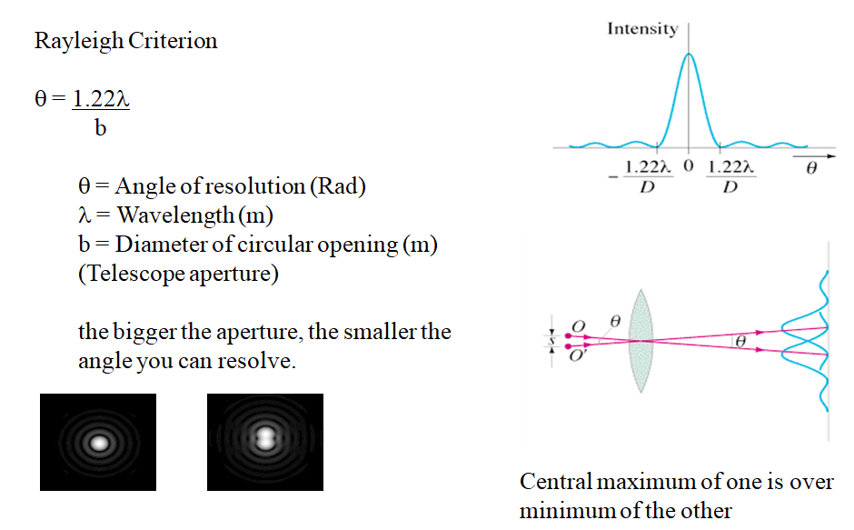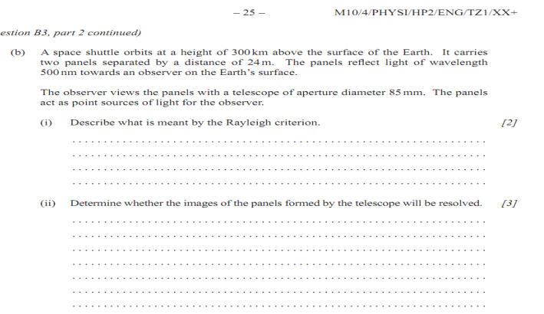

Whiteboards:
1. What is the angular resolution of the 100 inch (2.54 m) diameter telescope on the top of Mt Wilson? (use 550 nm as the wavelength, 550 nm = 550 x 10⁻⁹ m) (2.6 x 10⁻⁷ radians)

2. What diameter telescope do you need to resolve two stars that are separated by 1.8 x 10¹¹ m, but are 3.0 × 10¹⁷ m (32 LY) from us? (use 550 nm as the wavelength)
hint λ = s/r = (1.8 x 10¹¹ m)/(3.0 × 10¹⁷ m)

Noteguide for Diffraction Grating Resolution (Videos 12O) Name

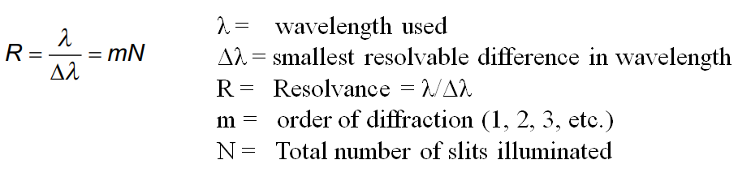

Example:
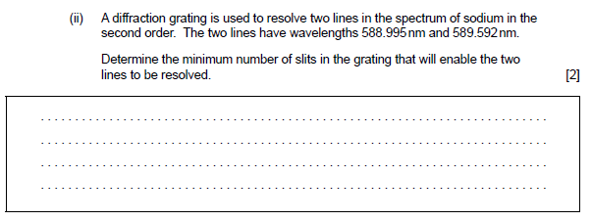

Whiteboards:
1. 632.8 nm light illuminates 742 slits in a diffraction grating. What is the smallest difference in wavelength difference from this wavelength that the grating can resolve in the first order? (0.853 nm)

2. 985 slits in a diffraction grating can resolve in its second order a wavelength difference of 0.350 nm. What must be the wavelength of the light? (689.5 nm)

Noteguide for Polarization (Videos 12P) Name

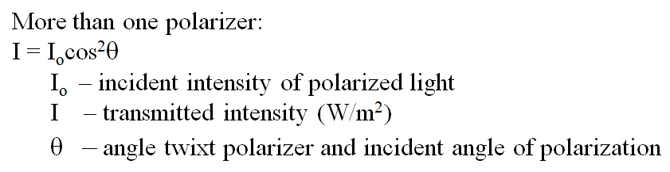
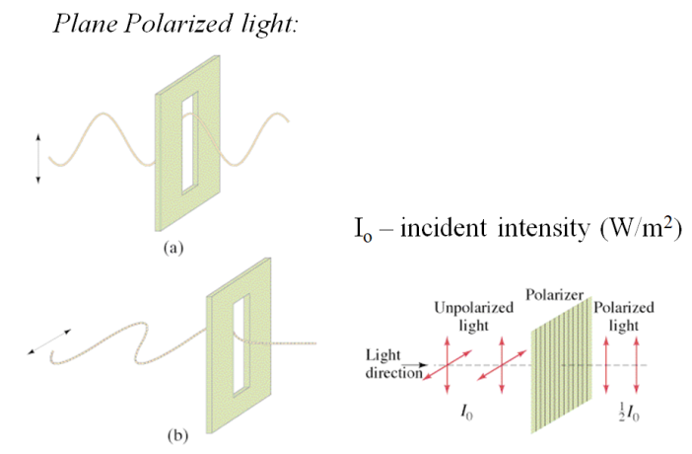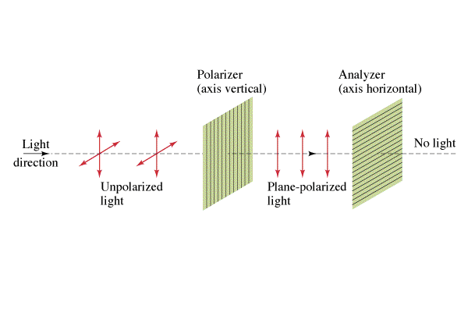

Two polarizers are at an angle of 37º with each other. If there is a 235 W/m² beam of light incident on the first filter, what is the intensity between the filters, and after the second?

Whiteboards:
1. 120. W/m² of vertically polarized light goes through a filter that makes an angle of 21.0º with the vertical. What is the transmitted intensity? (105 W/m²) | 2. 120. W/m² of vertically polarized light goes through a filter that makes some angle with the vertical such that only 80.0 W/m² are transmitted. What angle does the filter make with the vertical? (35.3º)
3. 500. W/m² of UNpolarized light goes through a vertically polarized filter, and then through one the makes an angle of 68.0º with the vertical. What is the transmitted intensity?

