IB Physics
FA11.1 - Simple Harmonic Motion

Name

Nickname
1. An SHO with an amplitude of 0.470 m has a speed of 2.15 m/s when it is 0.230 m from equilibrium. What is its period? What is its position when it has a velocity of 1.10 m/s? What is its acceleration when it is at x = -0.370 m?

2. An SHO has an equation of position (in m) of x = 7.20sin(5.10t) What is its maximum velocity? What is its acceleration when it is at x = +4.20 m?

3. Write the equation of position for an SHO that has an equation of velocity of v = 24.0cos(6.00t). What is its position and velocity at t = 11.2 s?

4. An SHO has a mass of 3.61 kg, a period of 4.17 s, and a total energy of 15.7 J. What is its amplitude?

5. An SHO has a mass of 1.83 kg, a frequency of 10.0 Hz, and amplitude of 0.180 m. What is its potential energy when it is 0.130 m from equilibrium?

SHM Problems from 11.1:

Speed, Amplitude, and Position:
- An SHO has a period of 0.234 s and amplitude of 0.470 m. What is its speed and acceleration when it is at x = +0.118 m? (12.2 m/s, -85.1 m/s/s)
- An SHO has a period of 3.45 s, and amplitude of 0.676 m. What is its distance from equilibrium when it has a speed of 0.645 m/s? (0.576 m)
- An SHO has a speed of 0.627 m/s when it is 0.870 m from equilibrium. What is its period if its amplitude is 1.08 m? (6.41 s)
- An SHO has a speed of 3.34 m/s when it is 0.540 m from equilibrium. What is its amplitude if its angular velocity is 7.50 rad/s? (0.700 m)
- An SHO with an amplitude of 2.12 m has a speed of 5.86 m/s when it is at x = -1.80 m. What is its acceleration at this point? (+49.3 m/s/s)
Simple equations of motion:
- An SHO has an equation of position (in m) of x = 14.0sin(6.50t) What is its acceleration at x = -8.00 m? (338 m/s/s) What is its position, velocity and acceleration at t = 3.20 s? (+13.0 m, -33.7 m/s, -549 m/s/s)
- An SHO has an equation of position (in m) of x = 43.2sin(12.0t) What is its amplitude and angular velocity? (two questions) (43.2 m, 12.0 rad/s)
- An SHO has an equation of position (in m) of x = 8.50sin(4.00t) What is its amplitude and maximum velocity? (8.50 m, 34.0 m/s)
- An SHO has an equation of position (in m) of x = 9.50sin(1.62t) What is its position, velocity and acceleration at t = 9.25 s? (+6.29 m, -11.5 m/s, -16.5 m/s/s)
- An SHO has an equation of velocity (in m/s) of v = 1.25cos(5.60t) What is its period? (1.12 s) What is its position, velocity, and acceleration at t = 4.60 s (+0.131 m , +1.01 m/s, -4.11 m/s/s)
Advanced Equations of motion:
- An SHO has an equation of position (in m) of x = 5.10sin(6.35t). What is its acceleration when it is at x = +3.40 m? (-137 m/s/s)
- An SHO has an equation of position (in m) of x = 3.50sin(11.0t) What is its velocity at t = 2.32 seconds? (+35.6 m/s)
- An SHO that has an equation of position (in m) of x = 6.50sin(5.00t). What is its speed when it is 2.13 m from equilibrium? (30.7 m/s)
- An SHO with a mass of 3.91 kg and an equation of velocity (in m/s) of v = 12.0cos(17.0t). What is its kinetic energy at t = 16.3 s? (181 J) What is its amplitude, and what is its acceleration at x = +0.600 m? (0.706 m, -173 m/s/s)
- What is the amplitude of an SHO that has an equation of velocity (in m/s) of v = 14.0cos(5.70t). (2.46 m) What is the position at t = 16.9 s? (+2.14 m)
Energy
- An SHO has a mass of 3.14 kg, a period of 4.32 s, and amplitude of 0.521 m. What is its total energy? (0.902 J)
- An SHO has a mass of 2.61 kg, a period of 0.657 s, and a total energy of 843 J. What is its amplitude? (2.66 m)
- An SHO has a mass of 6.67 kg, amplitude of 0.870 m, and a total energy of 18.3 J. What is its period? (2.33 s)
- An SHO has a period of 3.41 s, and a total energy of 32.7 J, and amplitude of 5.43 m. What is its mass? (0.653 kg)
- What is the period of a SHO that has a total energy of 24.2 J, a mass of 3.23 kg, and amplitude of 0.312 m? (0.506 s)
- An SHO has a mass of 1.63 kg, a total energy of 45.7 J, amplitude of 0.148 m. What is its kinetic energy when it is 0.115 m from equilibrium? (18.1 J)
- An SHO has a mass of 2.93 kg, a frequency of 12.0 Hz, and amplitude of 0.194 m. What is its potential energy when it is 0.120 m from equilibrium? (120. J)
- An SHO has a mass of 4.20 kg, a total energy of 16.8 J, and amplitude of 0.840 m. What distance is it from equilibrium when it has a potential energy of 11.3 J? (0.689 m)
- An SHO has a total energy of 436 J, a mass of 0.895 kg, and amplitude of 2.42 m. What is its speed when it is 1.21 m from equilibrium? (27.0 m/s)
- An SHO has a total energy of 10.2 J, amplitude of 0.830 m, and a mass of 1.81 kg. What is its potential energy when its velocity is 2.28 m/s? (5.50 J)

Practice 11.0 – Interpreting graphs of Simple Harmonic Motion Name

Position Graphs
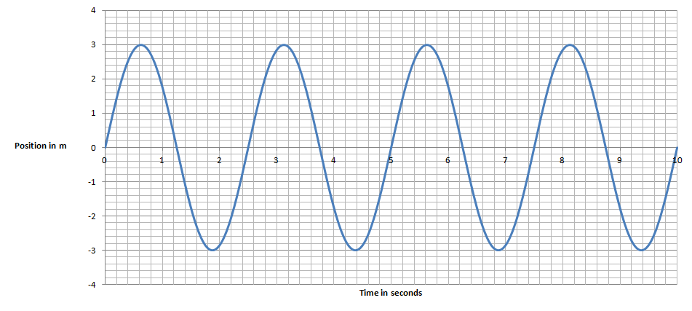 | 1. For this graph of position vs. time for an oscillator:  a. x_{o} = T = v_{o} = .  b. Write an equation for its motion: (x = ?)  c. Write an equation for its velocity: (v = ?)
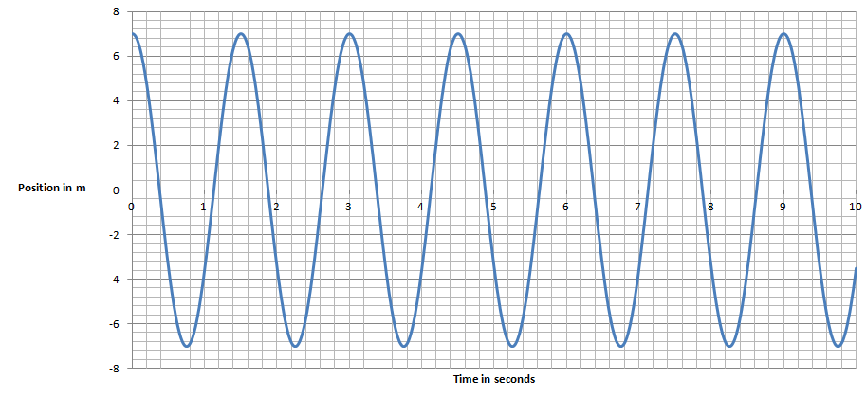 | 2. For this graph of position vs. time for an oscillator:  a. x_{o} = T = v_{o} = .  b. Write an equation for its motion: (x = ?)  c. Write an equation for its velocity: (v = ?)
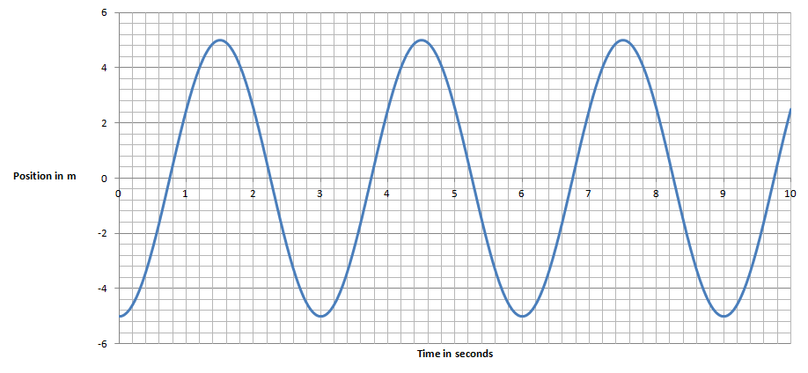 | 3. For this graph of position vs. time for an oscillator:  a. x_{o} = T = v_{o} = .  b. Write an equation for its motion: (x = ?)  c. Write an equation for its velocity: (v = ?)
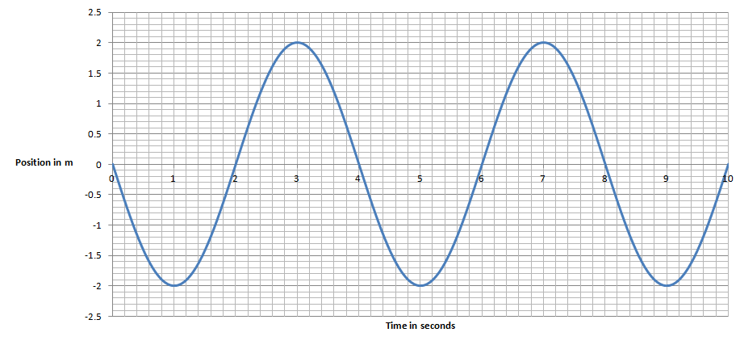  d. What is the position, velocity and acceleration of the object at 3.00 s, 4.00 s, and 6.50 s? | 4. For this graph of position vs. time for an oscillator:  a. x_{o} = T = v_{o} = .  b. Write an equation for its motion: (x = ?)  c. Write an equation for its velocity: (v = ?)

Practice 11.0 – Interpreting graphs of Simple Harmonic Motion - p2
Velocity Graphs:
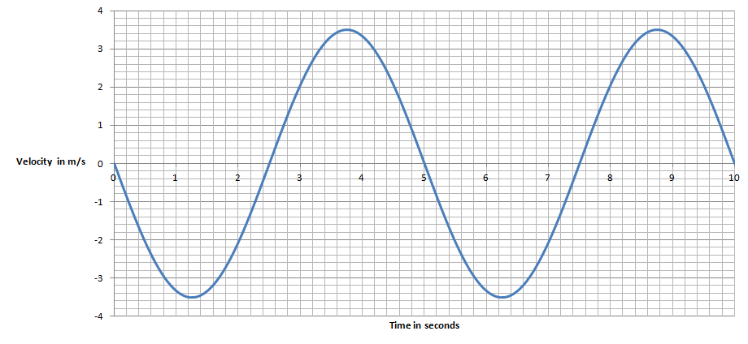 | 5. For this graph of velocity vs. time for an oscillator:  a. v_{o} = T = x_{o} = .  b. Write an equation for its velocity: (v = ?)  c. Write an equation for its position: (x = ?)
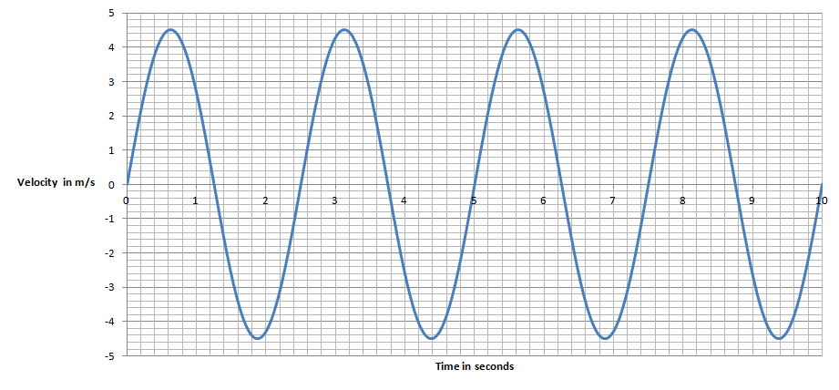 | 6. For this graph of velocity vs. time for an oscillator:  a. v_{o} = T = x_{o} = .  b. Write an equation for its velocity: (v = ?)  c. Write an equation for its position: (x = ?)
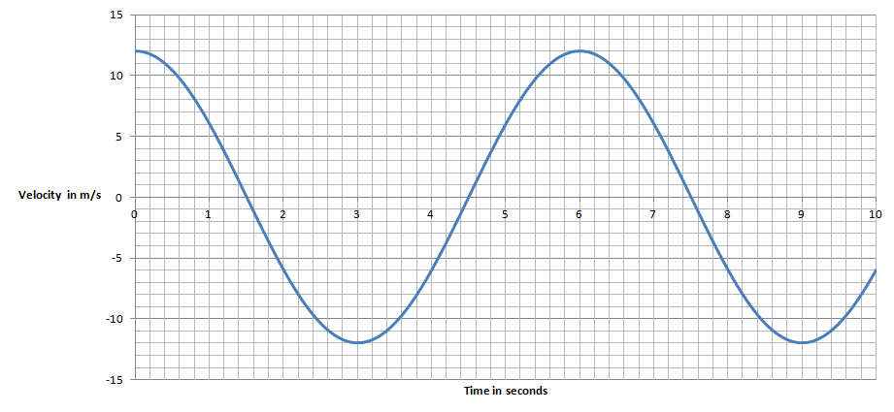 | 7. For this graph of velocity vs. time for an oscillator:  a. v_{o} = T = x_{o} = .  b. Write an equation for its velocity: (v = ?)  c. Write an equation for its position: (x = ?)
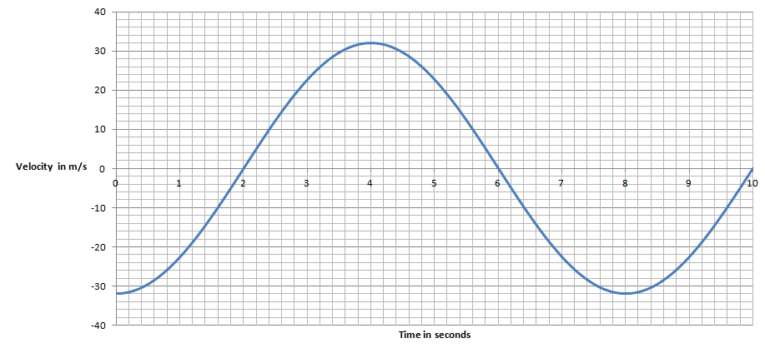 | 8. For this graph of velocity vs. time for an oscillator:  a. v_{o} = T = x_{o} = .  b. Write an equation for its velocity: (v = ?)  c. Write an equation for its position: (x = ?)
d. What is the position, velocity and acceleration of the mass at 2.00 s? at 5.00 s?

Practice 11.0 – Interpreting graphs of Simple Harmonic Motion - p3
9. For this graph of Position vs. Time:
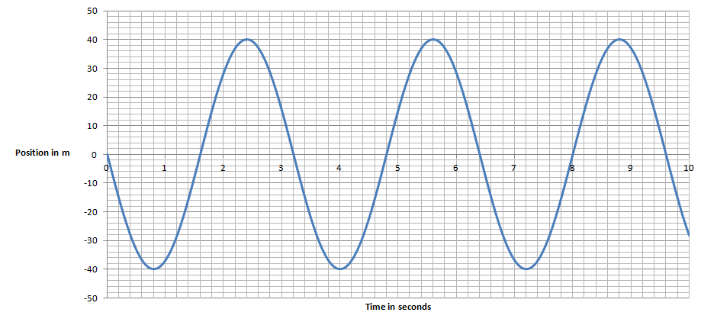

Fill in the table qualitatively: (+ or - or 0)
Time | x | v | a
2.4 s
7.2 s
1.6 s
3.0 s
7.6 s
6.5 s
5.0 s
3.2 s

10. For this graph of Velocity vs. Time:
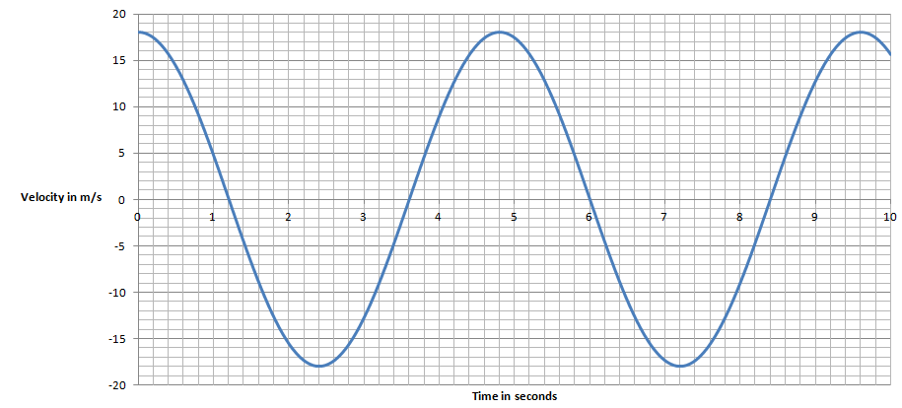

Fill in the table qualitatively: (+ or - or 0)
Time | x | v | a
3.2 s
0.8 s
1.6 s
4.8 s
6.0 s
7.2 s
8.4 s
4.0 s

IB Physics
FA11.0 - Simple Harmonic Motion Graphs

Name

What your parents call you when they are cheesed off
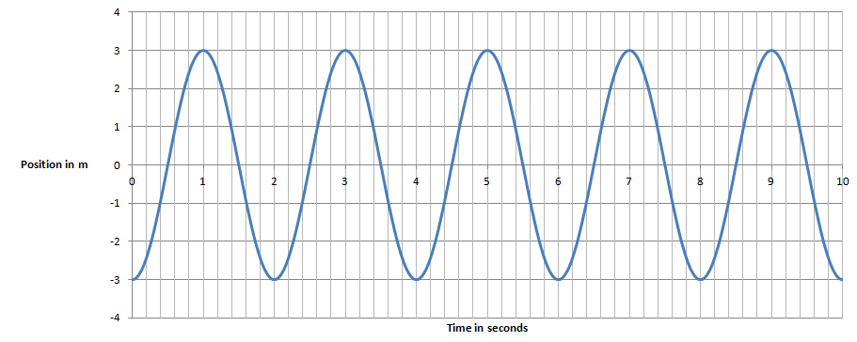

Given this graph of position vs. time for a SHO, determine:

1. Period = Amplitude =

2. Write an equation for its position:

3. Write an equation for its velocity: (EC - write one for its acceleration)

4. At 4.2 seconds what is its position, velocity and acceleration?

5. Fill in the table qualitatively: (+ or - or 0)
Time | x | v | a
3.0 s
1.5 s
2.4 s
3.8 s
4.5 s
4.0 s

Resonant Systems Lab Name

Concept 0 - Basic Resonant Systems
Part 1
- Run the ResonanceVPeriod.IP simulation in Interactive Physics and set the driving amplitude to 2.00, and the damping to 0.20
- Try different driving periods (1.60, 1.80, 2.00, 2.20, 2.40) and see what happens to the ultimate amplitude of the system. You will have to let it run for some time. Notice that it eventually settles on an equilibrium where the oscillator is receiving and dissipating energy at the same rate, so the energy (amplitude) levels off.
- The system has a resonant period of 2.00 s. What is the relationship between the driving period and the ultimate amplitude of the system?? Which driving period achieves the highest amplitude?

- The damping is a frictional force that is proportional to the velocity. For a driving period of 2.00 seconds, change the damping. What is the relationship between the damping and the ultimate amplitude of the system?

Part 2
- Run the ResonanceVPeriod.IP simulation in Interactive Physics and set the driving amplitude to 2.00, and the damping to 0.20
- Set the period to the resonant period (2.00 s) and let it run for 100 seconds, then hit Stop.
- Notice that at around 40 seconds on the graph the system goes into equilibrium.
- The damping force is proportional to the velocity of the mass:
  - What is happening to the velocity of the oscillator as the amplitude increases? (Why?)

  - What is happening to the damping force as the amplitude increases? (Why?)

  - What is happening to the rate at which the system dissipates energy as the amplitude increases?

  - Compare the rate that the system receives energy to the rate at which it dissipates energy:
    - from 0 - 40 seconds?

    - from 40-100 seconds?

Concept 1 - Q factor is related the degree of damping.
Systems with a high Q factor are lightly damped, and those with a low Q factor are heavily damped.
Part 1
- Run the QFactor.IP simulation in Interactive Physics and set the Period to 2.00 seconds, and the Q factor to 10
- About how many cycles does it go though before it stops?
- Try some different values of Q factor (1-15?), and notice what happens.
- What is the relationship between the Q factor and the number of cycles it goes through before it stops?

Part 2
- Run the QFactor.IP simulation in Interactive Physics and set the Period to 2.00 seconds.
- A system is critically damped when it returns to equilibrium with a velocity of zero in the fastest time possible. Try several Q factors that are less than 1.00 (0.90, 0.80, 0.70...)
- What is the Q factor that corresponds to critical damping? Does this make sense in terms of what you determined in part 1?

Concept 2 - The relationship between oscillator phase and Driving Phase in resonant systems
Part 1
- Run the BartonsPendulums-fewer.IP simulation in Interactive Physics and set the Driving Amplitude to 2.00, and the Damping to 0.10
- Set the Driving Period to 1.20, 1.40, 1.60, 1.80, 2.00, 2.20s and watch the different oscillators that are tuned to these periods go nuts. (You don't have to try all those periods, just get the general idea)
Part 2
- Run the BartonsPendulums-fewer.IP simulation in Interactive Physics and set the Driving Amplitude to 2.00, and the Damping to 0.10, and the Driving Period to 1.60 (This is the middle oscillator)
- Let it go until the 1.60 oscillator reaches equilibrium, and then hit stop. (at around counter 2500 in the lower right corner)
- Notice that there is a bar that moves around that is labeled driving phase. When this bar is above zero, there is an upward force, and below, a downward force. When the bar and the oscillator are at the top and bottom together, they are in phase.
  - What is the relationship between the Driving Phase and the Phase of the faster oscillators? (1.0, 1.2, 1.4)

  - What is the relationship between the Driving Phase and the Phase of the slower oscillators? (1.8, 2.0, 2.2)

  - What is the relationship between the Driving Phase and the Phase of the resonant oscillator? (1.60)

It is hard to see this with the simulation running, so with it stopped, use the frame by frame buttons at the bottom right to freeze the phase bar at 0, 90, 180, 270, 360 degrees (like a trig circle)

Practice 11.2 – Resonant Systems - p1

A. Damping and energy
This is the amplitude graph for an oscillator with damping being driven at its resonant frequency. It starts at rest.
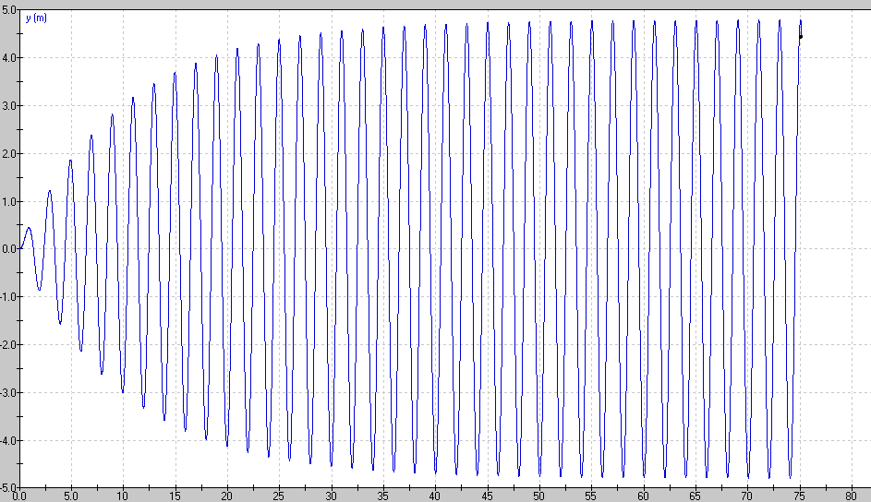
1. When does the system reach equilibrium? (Power input = Power dissipated)

2. How does the Power input compare to the Power dissipated at 10 seconds?

3. How does the Power input compare to the Power dissipated at 45 seconds?

4. How would decreasing the Q factor change the equilibrium amplitude of the oscillator?

5. How would increasing the Power input change the equilibrium amplitude?

(1. About 35 seconds, 2. Input > Dissipated, 3. Input = Dissipated, 4. Decreasing Q increases damping, so the amplitude would be lower, 5. Increase the amplitude)

Practice 11.2 – Resonant Systems - p2
B. Amplitude vs. Frequency curves

A car’s suspension has this variation of amplitude of vibration vs. driving frequency with a moderate amount of damping:
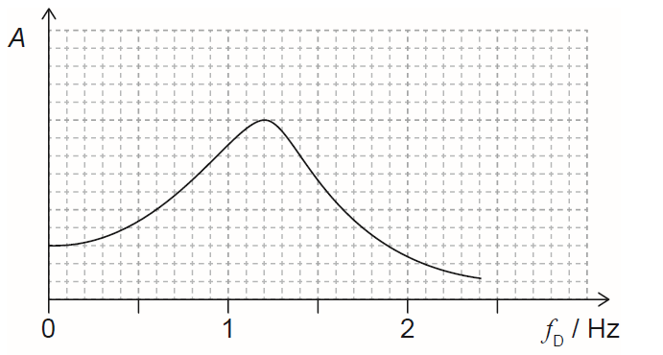
10
5
1. What is the resonant frequency of the system?

2. Draw a curve for a slightly higher Q factor.

3. Draw a curve for a slightly lower Q factor.

4. Some washboard bumps on a gravel road are 1.85 m apart. At what speed will the car hit the bumps at the resonant frequency of the car’s suspension?

5. Another set of washboard bumps seems to make the car go crazy when it is going 15.0 m/s. How far apart are they?

6. Is it better (as far as the amplitude of the suspension) to drive much faster or much slower than the resonant frequency of the suspension on a washboard road?

(1. 6.0 Hz, 2. Higher Q means less damping, so the curve in general higher, with a narrower peak that is slightly to the right, and largely the same at the extreme left and right of the graph, 3. Lower Q factor means more damping, so the curve is in general lower, with a broader peak that is slightly to the left, but is largely the same at the extremes, 4. 11.1 m/s would be the speed for resonance, 5. These bumps are 2.50 m apart, 6. Other safety considerations aside, faster produces less resonance.)
Practice 11.2 – Resonant Systems - p3
C. Resonance and Phase lag
1. An oscillator has a natural resonant frequency of 256 Hz and it is lightly damped. We can drive it at a variety of frequencies.
a. What is its relative amplitude and phase relative to the driver when it is being driven with a frequency of 100 Hz?

b. What is its relative amplitude and phase relative to the driver when it is being driven with a frequency of 256 Hz?

c. What is its relative amplitude and phase relative to the driver when it is being driven with a frequency of 1000 Hz

(1a. small amp./in phase, b. large amp./90º behind driver, c. small amp./180º behind driver)
2. An oscillator has a natural resonant period of 4.00 seconds and it is lightly damped. We can drive it at a variety of periods.
a. What is its relative amplitude and phase relative to the driver when it is being driven with a period of 0.500 seconds?

b. What is its relative amplitude and phase relative to the driver when it is being driven with a period of 20.0 seconds?

c. What is its relative amplitude and phase relative to the driver when it is being driven with a period of 4.00 seconds?

(2a. small amp./180º behind driver, b. small amp./in phase, c. large amp./90º behind driver)
3. Consider this position vs. time graph for a driven oscillator:
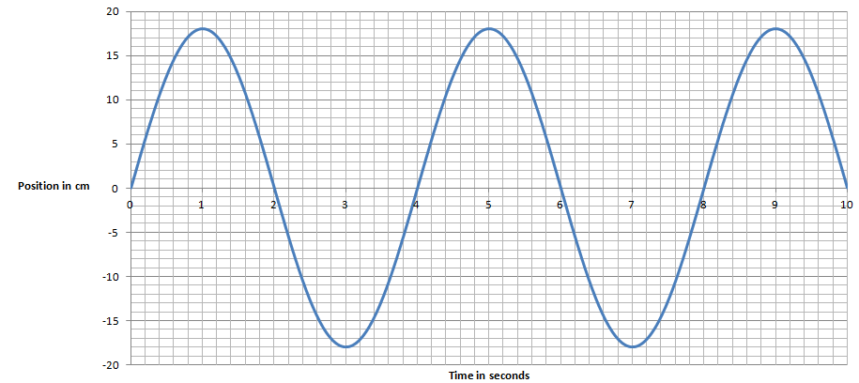
a. Suppose it is being driven with a period of 4.0 seconds, where is the driver with respect to equilibrium
(+x_{o}, -x_{o},or 0) at 1, 2, 3 and 4 seconds? What direction is the driver going?

b. Suppose it is being driven with a period of 1.0 seconds, where is the driver with respect to equilibrium
(+x_{o}, -x_{o},or 0) at 1, 2, 3 and 4 seconds? What direction is the driver going?

c. Suppose it is being driven with a period of 30 seconds, where is the driver with respect to equilibrium
(+x_{o}, -x_{o},or 0) at 1, 2, 3 and 4 seconds? What direction is the driver going?

(3a. x: 0/-x_{o}/0/+x_{o}, v: -/0/+/0 b. x: -x_{o} /0/+x_{o} /0, v: 0/+/0/- c. x: +x_{o} /0/-x_{o} /0, v: 0/-/0/+)

Practice 11.2 – Resonant Systems - p4
D. Q Factor calculations:
1. Estimate the Q factor: (Count the cycles before it dies down)
a.  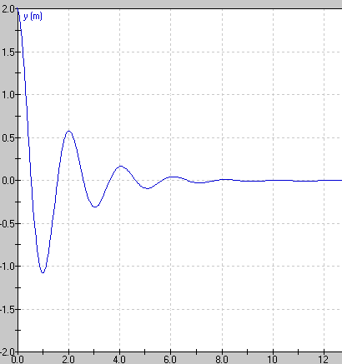 | b.  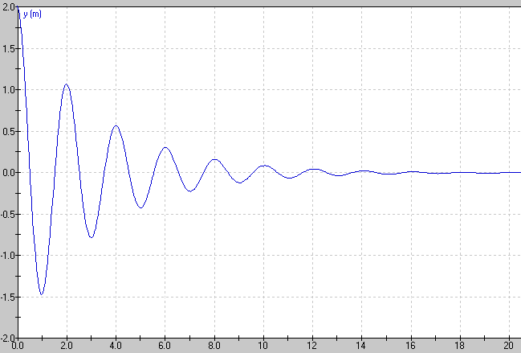

2. Calculate the Q Factor: $Q=2π\frac{energy stored}{energy dissipated per cycle}$ and $E_{T}= \frac{1}{2}mω^{2}x_{o}^{2}$
a. 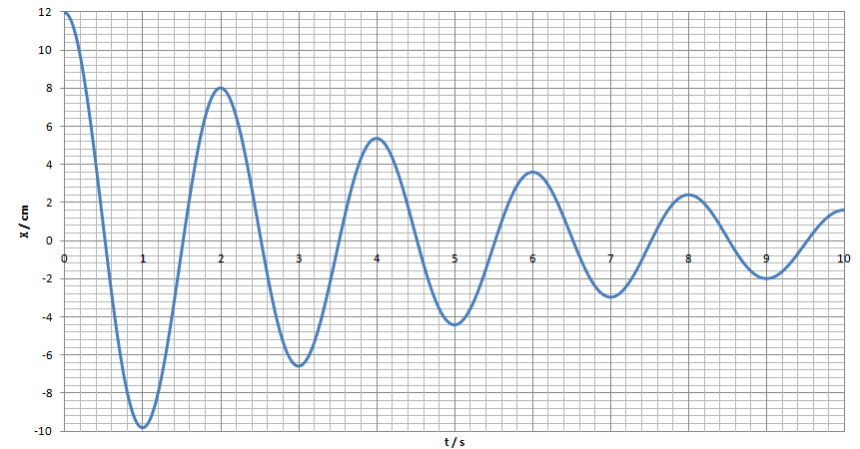 | b. 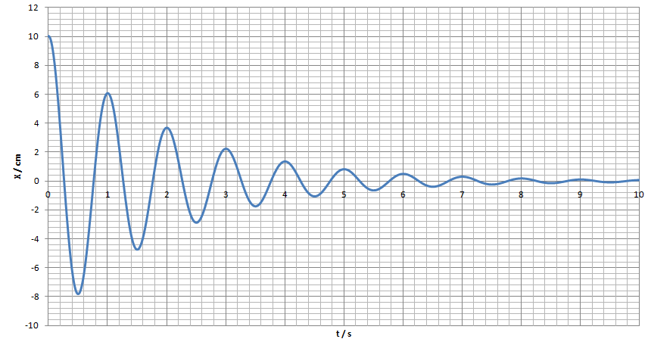

(1 a. 3?, b. 7?, 2a. 12.0 cm → 8.0 cm gives Q =11, b. 10.0 cm → 6.0 cm gives Q = 9.8 These will vary highly as it is sensitive to your reading of the graph)

Calculations of X and X_{o}:
3. An oscillator has a Q factor of 24 and starts with an amplitude of 16 cm. What is the amplitude of the oscillator after one complete cycle? (13.7 cm ≈ 14 cm)
4. An oscillator has a Q factor of 9.2. After one complete cycle, it has an amplitude of 31 cm. What was its original amplitude? (55 cm)

5. Declining energy graph:
a.  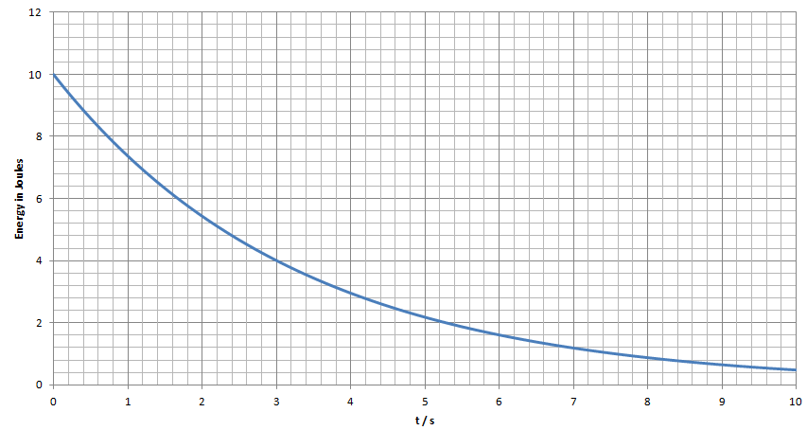  Given this graph of energy stored in an oscillator, and that its period is 3.00 s, calculate its Q factor. (10.0 J → 4.00 J gives Q = 10.5) | b.  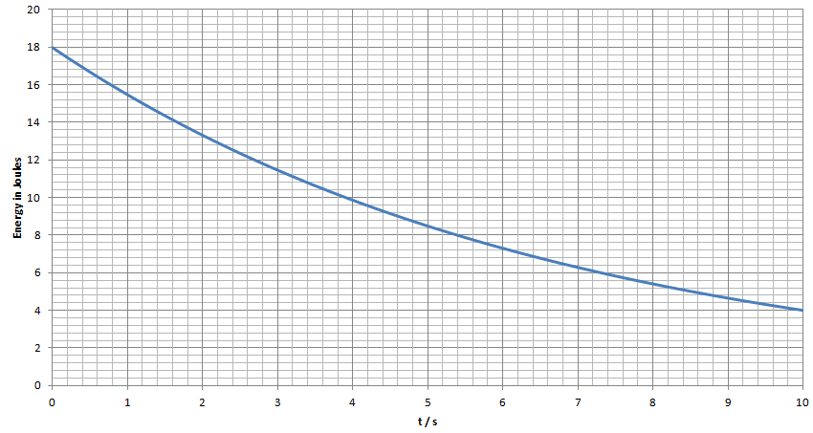  The Q factor of this system is 14.3. Determine the period.  (after 1 cycle, E = 10 J, so T = 3.9 s reading the graph)

Calculations of $Q=2π x resonant frequency x \frac{energy stored}{power loss}$
6. An oscillator has an initial amplitude of 1.30 m, a mass of 2.80 kg, and a period of 8.40 s. What is its initial stored energy? If it loses power initially at a rate of 0.275 W, what is its Q value? (1.32 J, 3.6)
7. An oscillator has a Q factor of 34.0 and a period of 0.800 s. Calculate the ratio $\frac{energy stored}{power loss}$ of the oscillator. If the system has a mass of 3.20 kg, and an initial amplitude of 16.0 cm, what is the initial energy of the system, and what is the initial rate of power loss for the system? (4.33 J/W or 4.33 s, 2.53 J, 0.584 W)

IB Physics
FA11.2 – Resonant Systems

Name

Childhood Nickname

1. A critical mechanical component of a truck has this variation of amplitude of vibration vs. driving frequency with a moderate amount of damping:

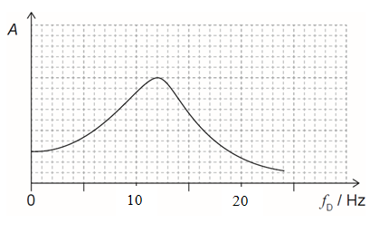
a. What is the resonant frequency of the component?

b. On the graph to the left, draw the curve if the damping is slightly increased. Would the Q factor be more or less?
c. On the graph to the left, draw the curve if the damping is slightly decreased. Would the Q factor be more or less?

d. A rumble strip has bumps across the road that are spaced out 0.820 m from each other. At what speed would this component resonate?

e. For each of these driving frequencies, outline what would be true about the amplitude, and the phase of the component relative to the driver
f_{D} = 2.0 Hz  Amplitude: Phase: | f_{D} = 12.0 Hz  Amplitude: Phase: | f_{D} = 30.0 Hz  Amplitude: Phase:

2. Given this graph of the motion of a damped oscillator, calculate the Q factor:
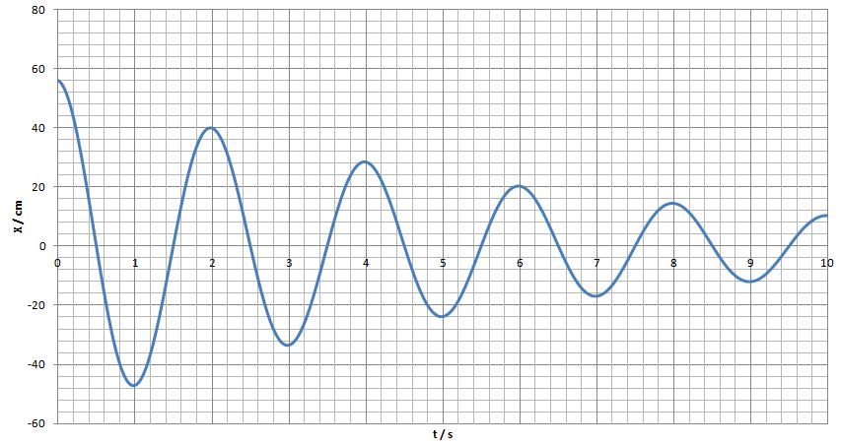

3. An oscillator has a Q factor of 54 and starts with an amplitude of 86.0 cm. What is the amplitude of the oscillator after one complete cycle?

4-5: An oscillator has an initial amplitude of 23.0 cm m, a mass of 412 g, and a period of 1.30 s.
4. What is its initial stored energy? 5. If it loses power initially at a rate of 45.0 mW, what is its Q value?

