**Noteguide for Simple Harmonic Motion Kinematics (Video 11A) Name**

(Watch the crash course video first - She explains where these formulas come from)

  

ω – “Angular” velocity (rad/s)

T – Period of motion (s)

f – frequency (cycles/s or Hz)

x – Position (at some time) (m)

v – Velocity (at some time) (m/s)

t – elapsed time (s)

xo – Max Position (Amplitude) (m)

 

 

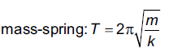

Kinematics Example: **(Are you in RADIANS????)**

A SHO goes up and down, and has a period of 12 seconds, and an amplitude of 5.0 m. If it starts in the middle going upward, write an equation of its motion:

a) What is its position and acceleration in 6.5 seconds?

b) What is its velocity in 6.5 seconds?

c) What times will it be at the top?

d) When will it be at the bottom?

e) What is its speed and acceleration when it is at a position of 1.75 m?

**Noteguide for Simple Harmonic Motion Energy (Video 11B) Name**

ET – Total energy (Ek + Ep)

Ek – Kinetic Energy

Ep – Potential Energy

ω – “Angular” velocity (rad/s)

x – Position (at some time) (m)

xo – Max Position (Amplitude) (m)

v – Velocity (at some time) (m/s)

 

  

Energy Example – An SHO has an amplitude of 0.480 m, a mass of 1.12 kg, and a period of 0.860 seconds.

a) What is its angular velocity?

b) What is its total energy? What is the maximum kinetic energy and maximum potential energy?

c) What is the kinetic and potential energy when the velocity is 3.00 m/s?

d) What is the kinetic energy when it is 0.230 m from equilibrium? What is its potential energy here?

e) Write possible equations for its position and velocity:

**Noteguide for Simple Harmonic Motion Graphs (Video 11A2) Name**

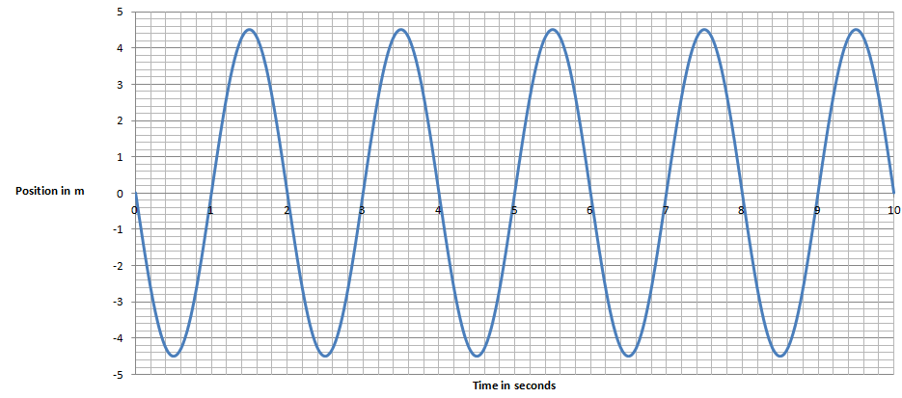

Given this graph of position vs. time for a SHO, determine:

Period = Amplitude =

2. Write an equation for its position:

3. Write an equation for its velocity: (EC - write one for its acceleration)

4. At 1.80 seconds, what is the position, velocity, and acceleration?

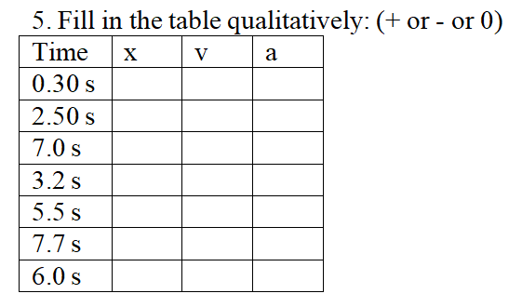

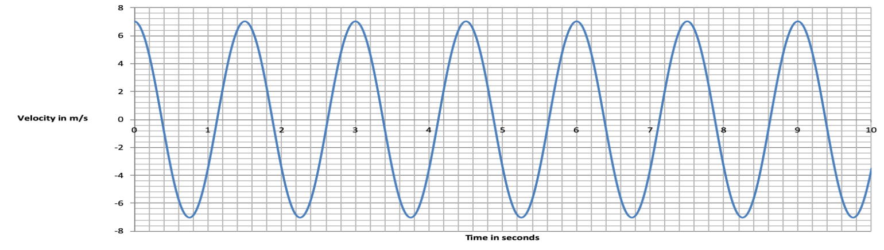

What is the period? Can you draw the position vs time graph?

**Noteguide for Pendulums (Videos 11C) Name**

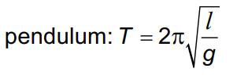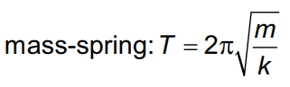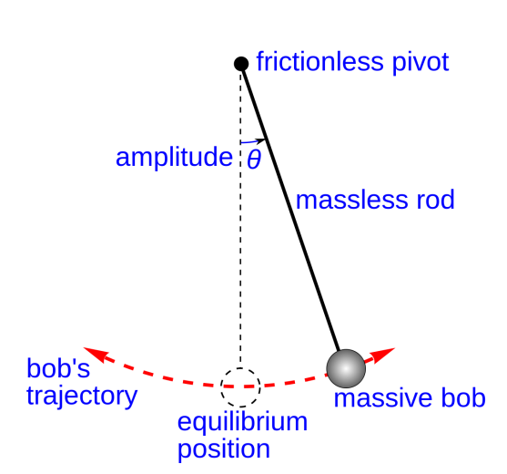

**Example: What is the period of a pendulum that is 12 cm long? (0.69 s)**

**What is its frequency? (1.4 Hz)**

Whiteboards:

1. A Foucault pendulum is 25.0 m long. What is its period? (10.0 s)

2. A pendulum has a period of 2.00 s. What is its length? (0.994 m)

3. A pendulum on the moon that is 50 cm long, has a period of 3.5 seconds. What is the acceleration of gravity on the moon? (1.6 m/s/s)

**Noteguide for Resonance (Videos 11D) Name**

In resonance - there is a driving frequency, and a resonant or natural frequency.

Watch the first two short videos. What must be true about the driving and natural frequencies for there to be resonance?

Resonance and Damping:

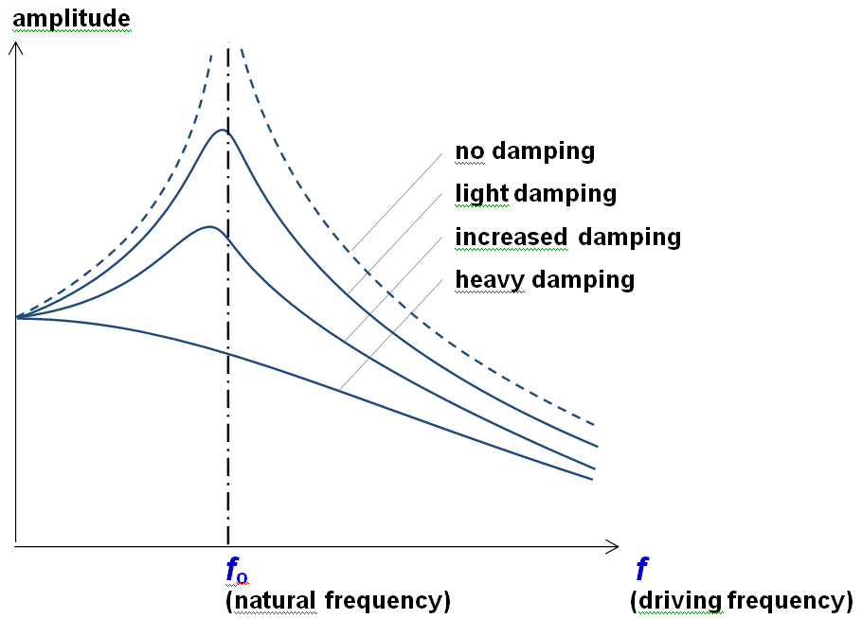Two things happen when there is more damping (friction)

1.

2.

Phase lag and resonance: (Watch the demo video first, then the main video)

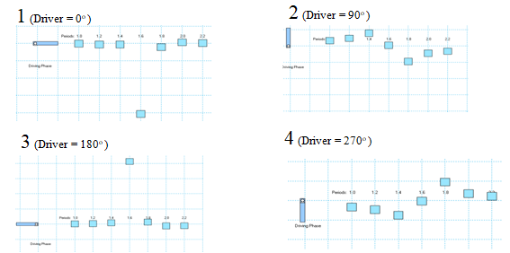Faster oscillators are:

Resonant oscillators are:

Slower oscillators are:

Interpreting Phase lag graphs:

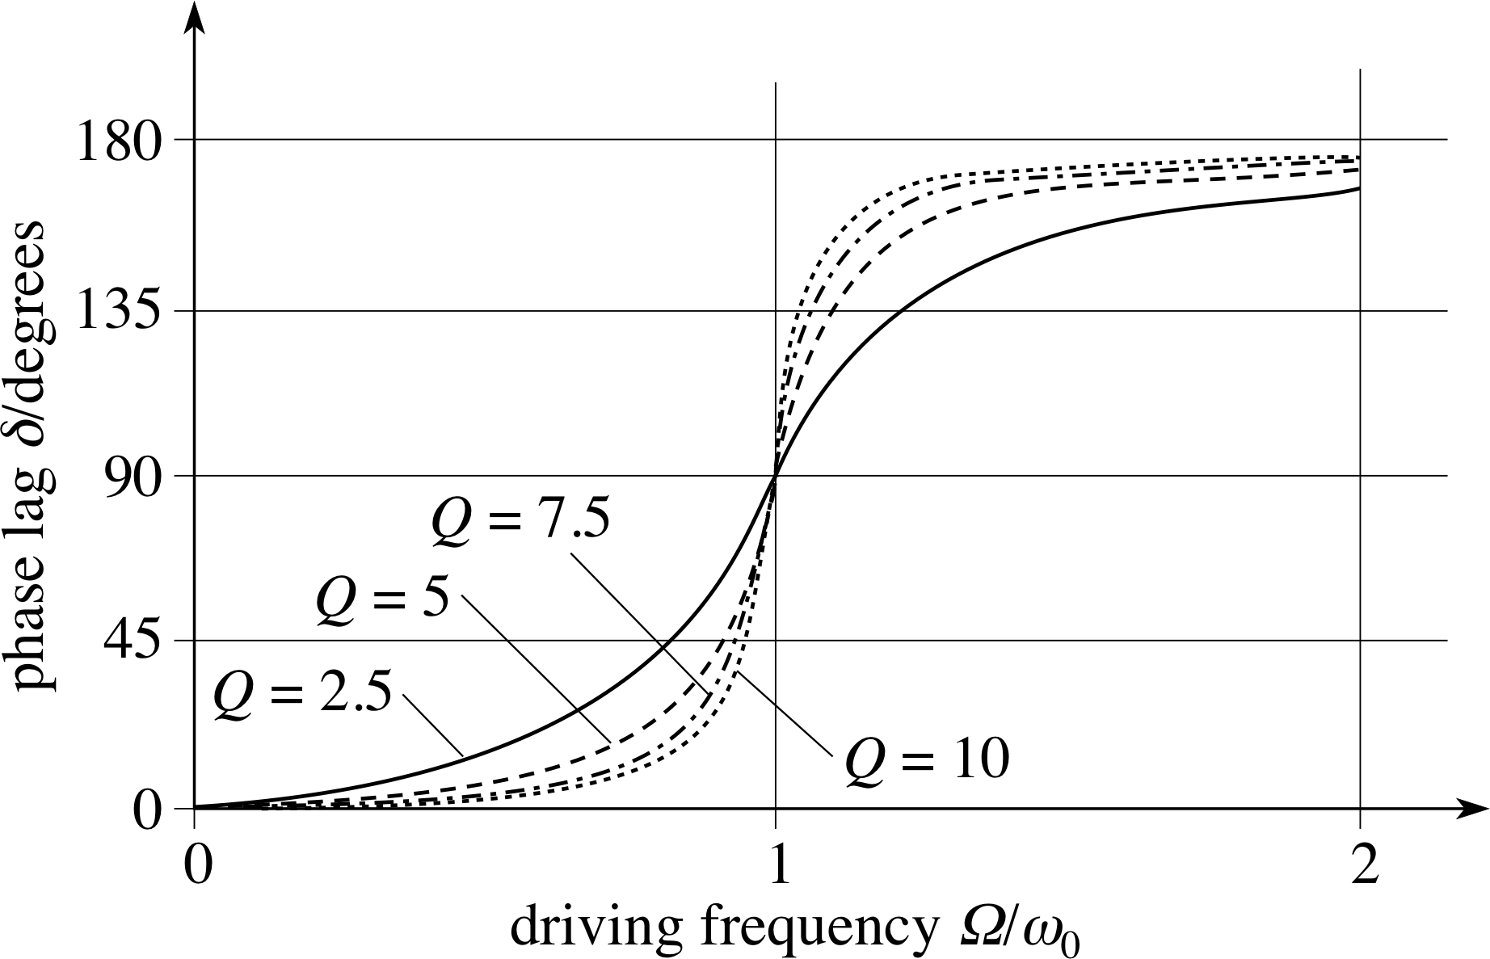

**Noteguide for Damping and Q Factor (Videos 11E) Name**

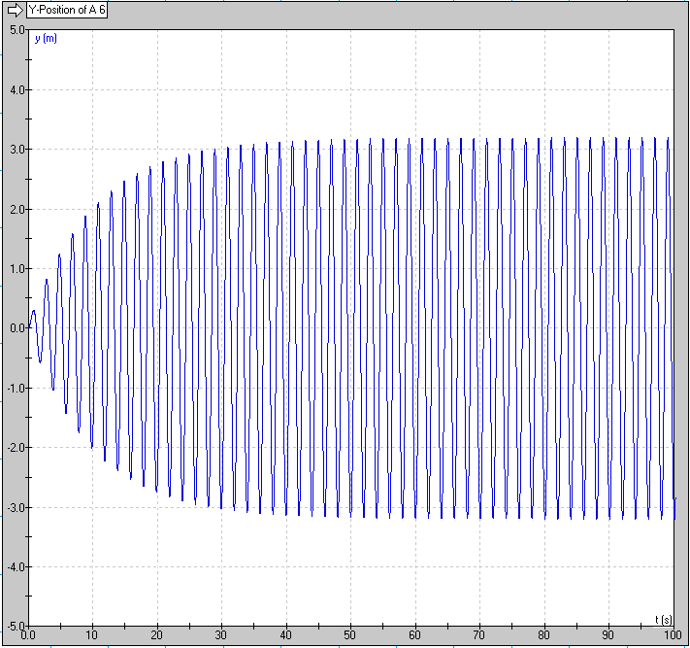Damping in General:

0-40 seconds:

40-infinity seconds:

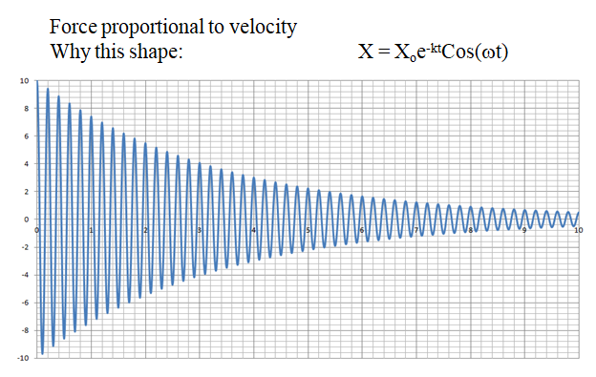

Why the graph is shaped like this:

What is the envelope of the graph:

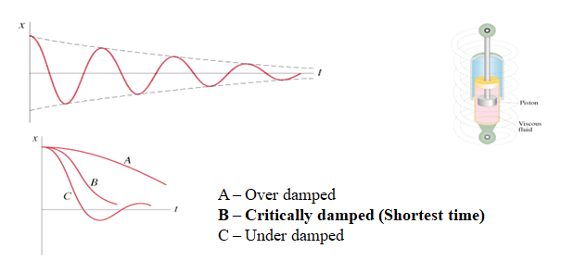

Q factor Demo - What is the basic idea behind Q factor? Is a high or low Q factor heavily damped?

Is a high or low Q factor lightly damped?

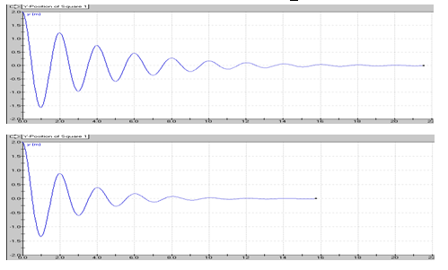

Q =

Q =

Critical Damping and Q factor:

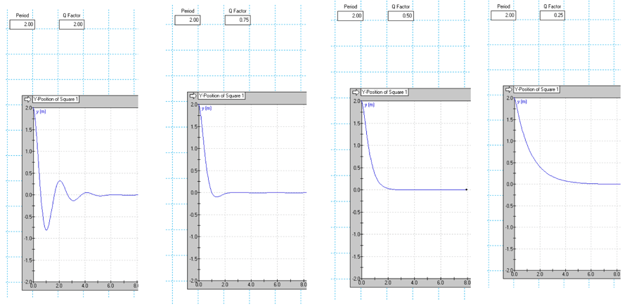

**Calculations:**

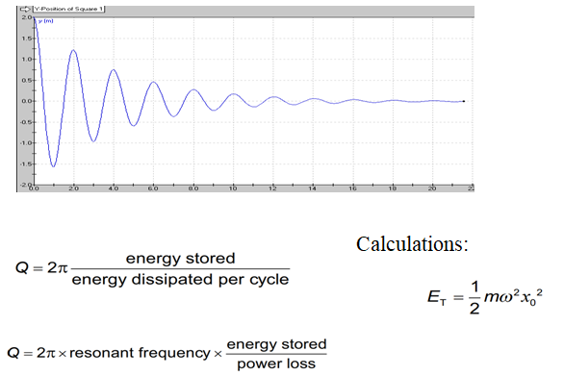**Part 2:**

Write down the sample calculation I do here:

**Part 3:**

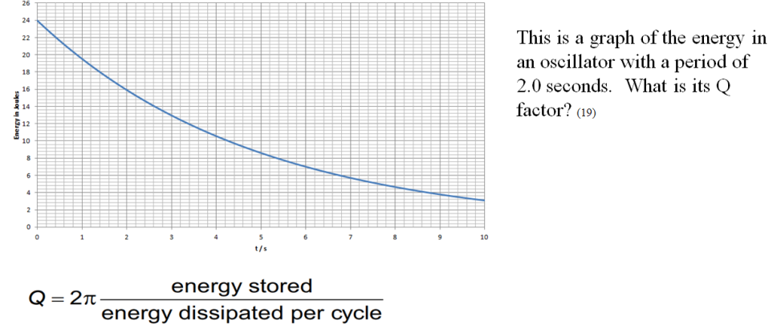

**Part 4:**

