IB Physics
FA12.2A - Diffraction

Name

Miyazaki or Disney?
Show your work, round to the correct significant figures, circle your answers, and label them with units.
1-2: Two slits are separated by a distance of 0.112 mm and are illuminated by 512 nm light. The interference pattern falls on a screen that is 4.80 m away.
1. What distance separates the fringes on the screen?

2. What is the angle between the central maximum and the third order maximum?

3. A single slit with a diameter of 0.0215 mm is illuminated by 550 nm light. What is the angle between the center of the central maximum, to the center of the first maximum on one side?

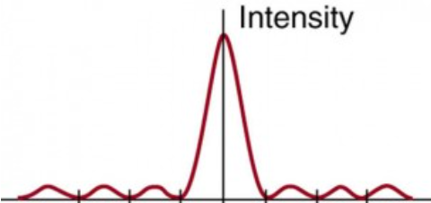

4. A single slit has a width of 0.0450 mm and is illuminated by monochromatic light. A screen 1.85 m away has a central maximum pattern that is 2.10 cm wide. What is the wavelength of the light?

5. A diffraction grating has 2450 lines per cm. It is illuminated by 632.8 nm light. What angle separates the first order and the fifth order fringes?

