IB Physics
FA11.2 – Resonant Systems

Name

Childhood Nickname

1. A critical mechanical component of a truck has this variation of amplitude of vibration vs. driving frequency with a moderate amount of damping:

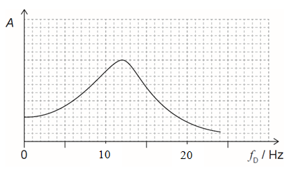
a. What is the resonant frequency of the component?

b. On the graph to the left, draw the curve if the damping is slightly increased. Would the Q factor be more or less?
c. On the graph to the left, draw the curve if the damping is slightly decreased. Would the Q factor be more or less?

d. A rumble strip has bumps across the road that are spaced out 0.820 m from each other. At what speed would this component resonate?

e. For each of these driving frequencies, outline what would be true about the amplitude, and the phase of the component relative to the driver
f_{D} = 2.0 Hz  Amplitude: Phase: | f_{D} = 12.0 Hz  Amplitude: Phase: | f_{D} = 30.0 Hz  Amplitude: Phase:

2. Given this graph of the motion of a damped oscillator, calculate the Q factor:
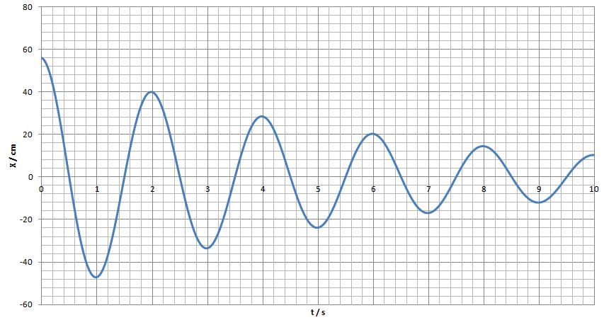

3. An oscillator has a Q factor of 54 and starts with an amplitude of 86.0 cm. What is the amplitude of the oscillator after one complete cycle?

4-5: An oscillator has an initial amplitude of 23.0 cm m, a mass of 412 g, and a period of 1.30 s.
4. What is its initial stored energy? 5. If it loses power initially at a rate of 45.0 mW, what is its Q value?

