Videos 10J – Bernoulli Name

Write down the derivation:
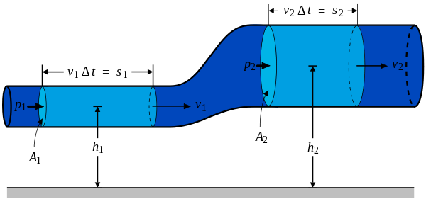

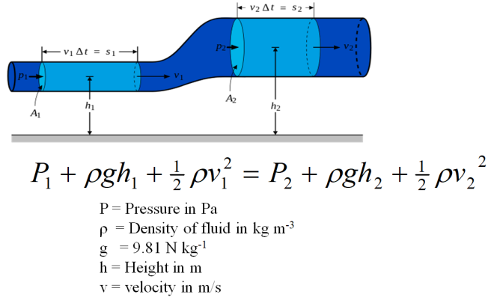 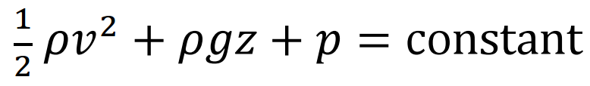(data packet)

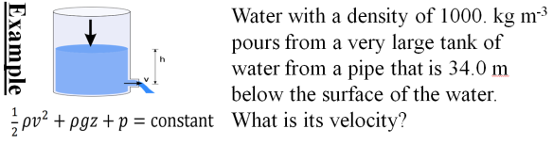

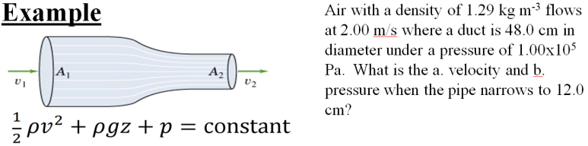

Whiteboards.
1. The wind is moving horizontally at 12.0 m/s over a level rectangular roof that measures 4.50 m by 8.00 m.  A. What is the pressure difference between the bottom (still air) and the top (moving air) of the roof surface? Use 1.29 kg m⁻³ for the density of the air, neglect the change in height, and assume (if you need to) that the pressure underneath is 1.013x10⁵ Pa. B. What is the net upward force on the roof?  (92.9 Pa, 3340 N (751 lbs) ) | 2. A very large Nitrogen tank is at 2000. PSI. If nitrogen at STP has a density of 1.17 kg m⁻³, how fast is the gas going if the valve breaks off when the tank is horizontal  (assume P1 is 2000 PSI (convert), v1 is zero?, P2 is 1.013E5 Pa, solve for v2. Ignore change in height.) 1 atm = 14.7 PSI  (4835.9 or roughly 4840 m/s, 3090 N (695 lbs) )
3. What pressure is needed in a fountain if it is spraying water straight up to a height of 23.2 m? What is the gauge pressure?  ρ = 1000. kg m⁻³, P₂ = 1.013E5 Pa  (3.29x10⁵ Pa, 2.28x10⁵ Pa) | 4. A water faucet breaks in the Physics room, spraying water upwards. If the gauge pressure in the water mains is 21.0 PSI, (at v = 0) with what speed does the water hit the ceiling 4.80 m above the faucet? How much time does it take a custodian to come down and fix the leak?  ρ = 1000. kg m⁻³, P₂ = 1atm = 1.013E5 Pa. 1 atm = 14.7 PSI  (14.0 m/s )
5. Water flows at 2.00 m/s at ground level with a pressure of 1.15x10⁵ Pa through a 10.0 cm diameter pipe. What is the pressure if it is at an elevation of 3.50 m going through a 6.00 cm diameter pipe? (Find the second speed first. ρ = 1000. kg m⁻³)
(6.72x10⁴ Pa )

