Videos 10G – Pascal’s Principle Name

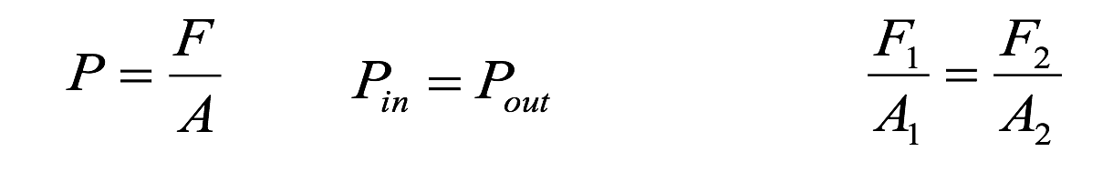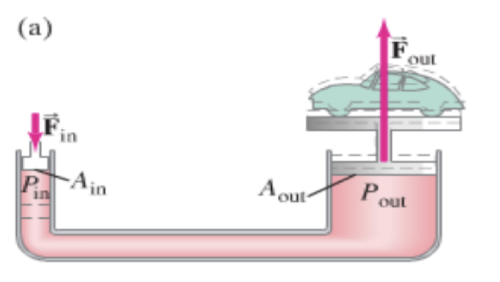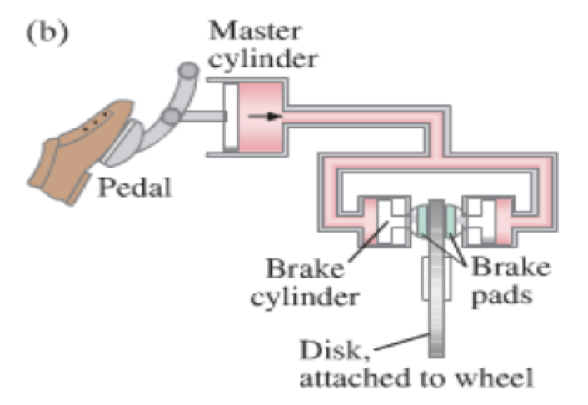

Example – A hydraulic jack has an input piston with a diameter of 8.20 mm, and an output piston diameter of 95.0 mm. What force in Newtons do you need to apply to lift a ton? (8900 N) What is the pressure in Pa? How far must you move the input cylinder to raise the car 10.0 cm?

Whiteboards:
1. A car has a master cylinder bore size of 2.50 cm, and a caliper bore of 4.40 cm. What force does the caliper exert if you press on the master cylinder with a force of 150 N?  (465 N) | 2. A hydraulic jack has an output cylinder with a 5.2 cm bore, and needs to lift a 53,400 N weight with an input force of 356 N. What is the diameter of the input cylinder needed?  (0.0042 m or 0.42 cm)

