Videos 10F - Hydrostatic Pressure Name
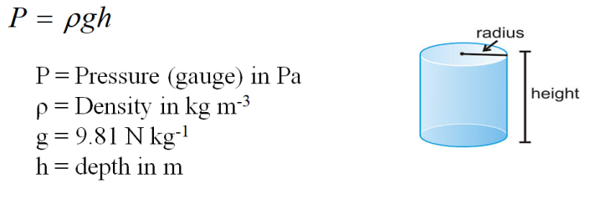

Example – What is the gauge pressure 3800 m (12,500 ft) deep in the ocean where the wreck of the Titanic lies? Calculate it in Pa, PSI and atm. (ρ = 1.025x10³ kg m⁻³)

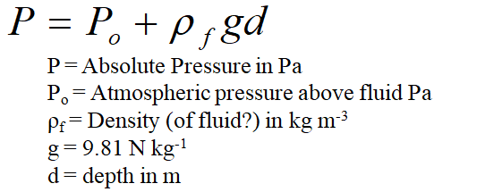
Example – At what depth below fresh water is the absolute pressure 100. PSI? (Po = 1.013x10⁵ Pa, ρ = 1.00x10³ kg m⁻³)

Whiteboards:
1. The water level in a water tower is 30. m above the point where a faucet is. What is the absolute pressure in Pa and PSI? (P_{o} = 1.013x10⁵ Pa, ρ = 1.00x10³ kg m⁻³) What is the gauge pressure in PSI? P = P_{o} + ρgh (4.0E5 Pa, 57 psi, 43 psi) | 2. The density of air at STP is 1.29 kg m⁻³. What is the difference in air pressure between the top and the bottom of the 381 m tall Empire State Building in Pa? (assume the density is constant….) ΔP = ρgh  If the pressure is 1.025x10⁵ Pa at the bottom, what is the pressure at the top?  (4.82E3 Pa, 0.977E5 Pa (9.77E4 Pa))
3. At what depth in mercury is the gauge pressure equal to one atmosphere? (ρ = 13.6x10³ kg m⁻³)
(answer in m and mm)
P = ρgh
1 atm = 1.013 x 10⁵ Pa = 101.3 kPa = 760 Torr = 14.7 psi
(0.759 m, 760 mm)

