Videos 10E - Gauge Pressure Name
Most pressure gauges compare to Atmospheric
Gauge pressure is how much more a pressure is
than atmospheric
(i.e. this room is at 0 Gauge - Absolute P is 1 atm more)
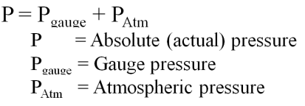
Example 1 – If your tyre pressure gauge reads 220 kPa, what is the actual pressure in the tyre in kPa and Pa?

Example 2 – What is the gauge pressure if you have an actual pressure of 1072 Torr?

Whiteboards: 1 atm = 1.013 x 10⁵ Pa = 101.3 kPa = 760 Torr = 14.7 psi
1. What is the absolute pressure if you read 35 psi gauge? Answer in psi and Pascals  (49.7 psi, 3.42E5 Pa) | 2. If you have an absolute pressure of 812 Torr, what is the gauge pressure? Answer in Torr  (52 Torr )
3. What is the absolute pressure if the gauge pressure is 2.17 x 10⁵ Pa. Answer in Pa  (3.18 x 10⁵ Pa ) | 4. If you have an absolute pressure of 42.0 kPa, what is the gauge pressure in kPa?  (-59.3 kPa)

