Videos 10D - Pressure Conversions Name
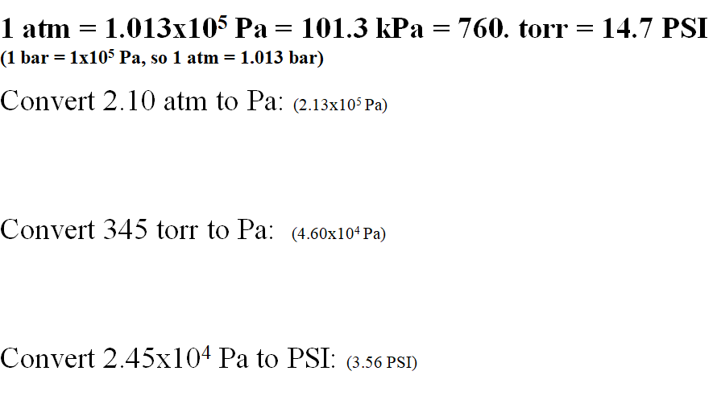

Whiteboards:
1. Convert 32 psi to kPa  (220 kPa) | 2. Convert 890 Torr (mm Hg) to Pa  (1.2x10⁵ Pa )
3. Convert 2000 psi to atm:
(136 atm ≈ 100 atm )

