Angular Rolling and Energy Noteguide
Handy Substitutions:
Γ = Iα
Γ = rF
so F = Γ/r = Iα/r
s = θr, so θ = s/r
v = ωr, so ω = v/r
a = αr, so α = a/r
and I = ¹/₂mr² or ²/₅mr² etc.

Rolling objects accelerate linearly and angularly:
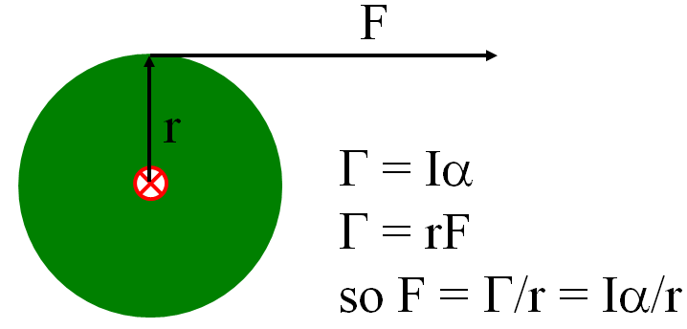
So F = ma turns into: F = ma + Iα/r into which we will substitute for I, and α

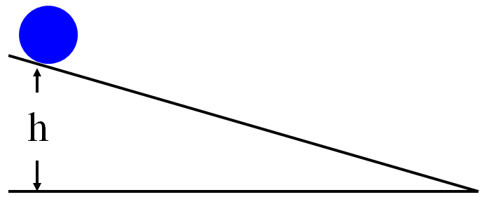

Inclined plane problem:
An 11.0 g, 0.0130 m radius cylinder rolls down an incline that is 2.90 m long, and loses 0.340 m of elevation. What is its acceleration down the plane, and its velocity at the bottom of the plane?
Using Dynamics | Using Conservation of energy:

Rotational Kinetic Energy:
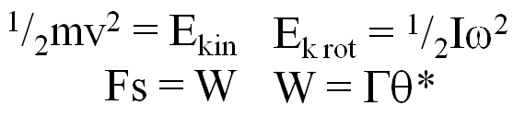
Example: A 23.7 kg 45 cm radius cylinder is rolling at 13.5 m/s at the bottom of a hill.
What is its translational kinetic energy? What is its rotational kinetic energy?

What is the total kinetic energy? What was the height of the hill?

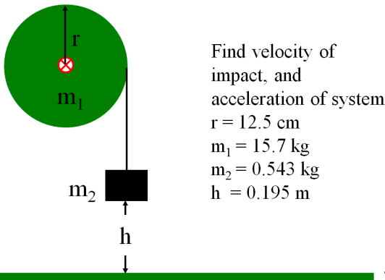
In General: I tend to solve all rotational dynamics problems using energy.
- Set up the energy equation
- (Make up a height)
- Substitute linear for angular:
  - ω = v/r
  - I = ?mr²
- Solve for v
- Go back and solve for accelerations

