Noteguide for Centripetal Acceleration (Videos 8D) Name

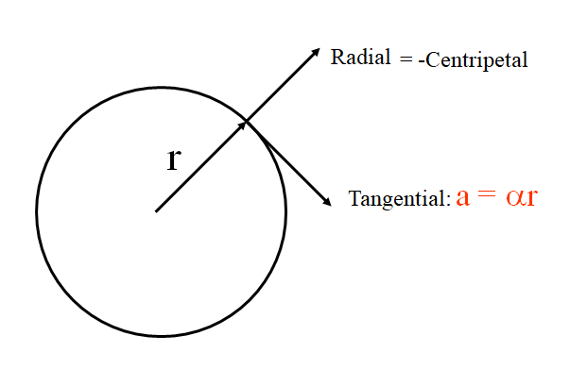

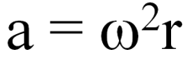

Example: What’s the centripetal acceleration 5.0 cm from the axis of a 10,000 RPM centrifuge?

Whiteboards:
1. What is the centripetal acceleration of a point 35 cm from an axis of a wheel that has an angular velocity of 12 rad/s? (50. m/s/s) | 2. A car has 68 cm diameter wheels, and is going at a constant speed of 32 m/s. What is the tangential acceleration, and what is the radial (centripetal) acceleration? (0 m/s/s, 3000 m/s/s)
3. What is the angular velocity of a centrifuge if it pulls 2000. “g”s with a radius of 6.7 cm? How many RPMs is this? (540 rad/s, 5200 RPM)

Noteguide for Angular Kinematics (Videos 8E)

Angular Kinematics:
Linear:  u + at = v  ut + ¹/₂at² = s  u² + 2as = v²  (u + v)t/2 = s | Angular:  ω_{f} = ω_{i} + αt  θ = ω_{i}t + ¹/₂αt²  ω_{f} ² = ω_{i}² + 2αθ  θ = (ω_{i} + ω_{f})t/2*  * not in data packet

Example: My gyro spinner speeds up to 10,000 RPM, in 0.78 sec.
What is its angular acceleration?

What angle does it go through?

What distance does a point on the edge travel if the diameter is 1.1 cm?

(Whiteboards on the back)

Whiteboards:
1. A turbine speeds up from 34 rad/s to 89 rad/s in 2.5 seconds. What is the angular acceleration?  (22 rad/s/s) | 2. A drill slows from 145 rad/s to 54.0 rad/s with an angular acceleration of -1.80 rad/s/s. Through what angle did it go?  How many rotations?  (5030 radians, 801 rotations)
3. A motor going 45.0 rad/s has an angular acceleration of 12.4 rad/s/s for 3.70 seconds. What angle does it go through? (251 rad) | 4. A hard drive speeds up from rest to 4200. RPM in 3.50 seconds. How many rotations does it make doing this? (122.5 rotations)
5. A potter’s wheel is spinning at 71.0 RPM and stops in 5.30 revolutions. (a) What is its angular deceleration in rad/s/s? (-0.830 rad/s/s ) | 6. A hard drive slows from 7200. RPM to rest in 16.2 seconds. What distance does a point 3.10 cm from the center travel as it is slowing down?  (189 m)

Noteguide for Torque (Videos 8F)

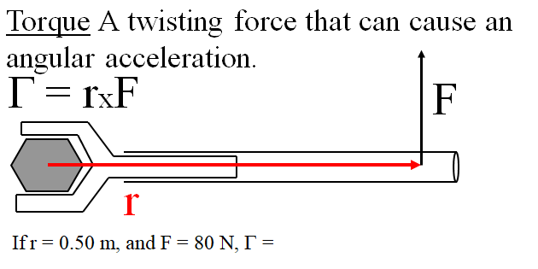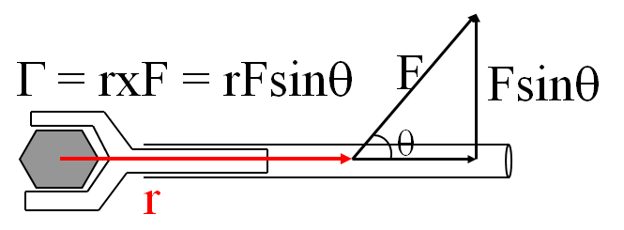

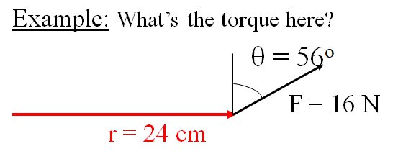

Whiteboards:
1. What is the torque when you have 25 N of force perpendicular 75 cm from the center of rotation?  (19 mN) | 2. If you want 52.0 mN of torque, what force must you exert at an angle of 65.0º to the end of a 0.340 m long wrench?
3. 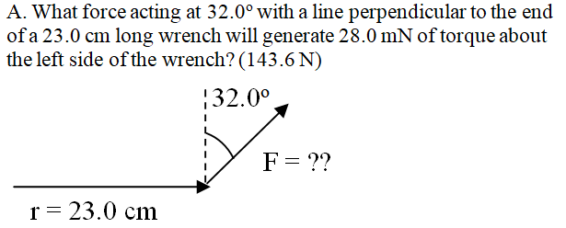 | 4. 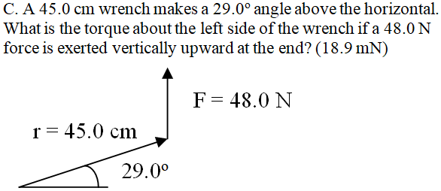

Noteguide for Moment Of Inertia (Videos 8G)

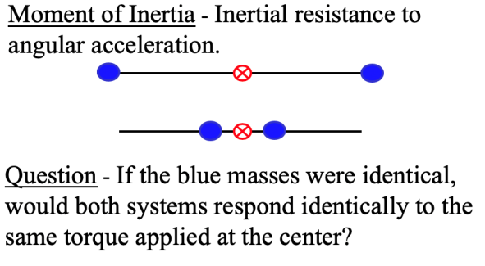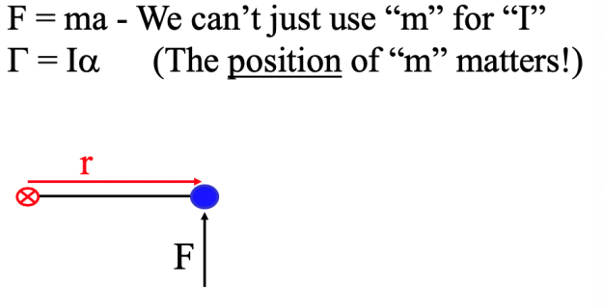

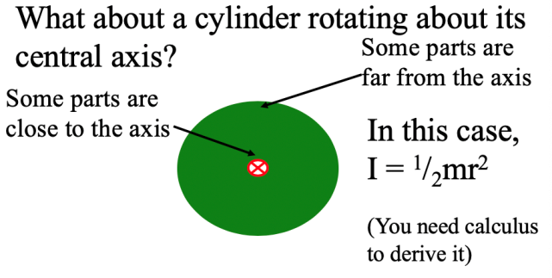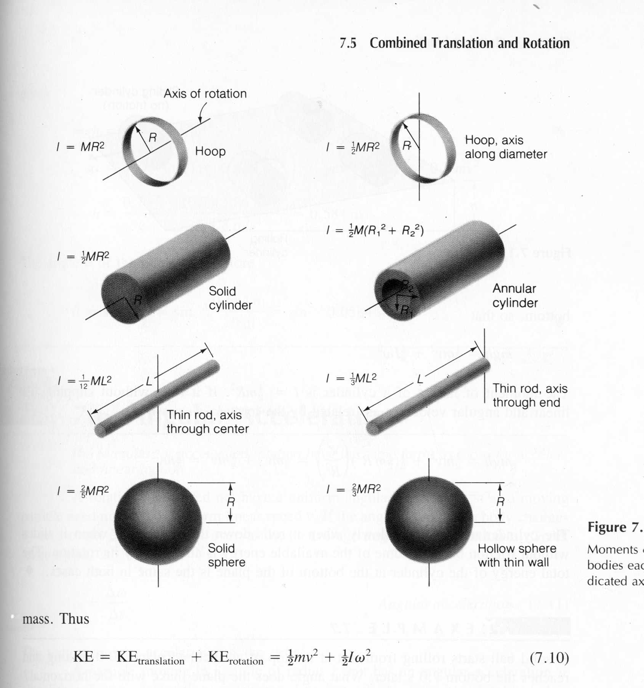

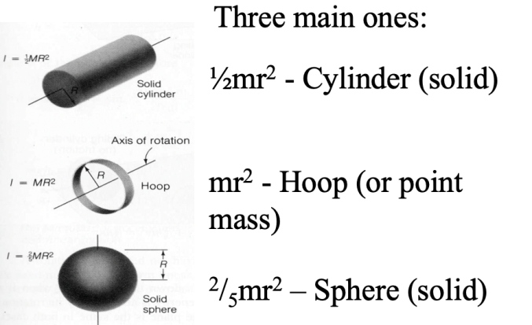

Example: Three 40. kg children are sitting 1.2 m from the center of a merry-go-round that is a uniform cylinder with a mass of 240 kg and a radius of 1.5 m. What is its total moment of inertia?

(Whiteboards on the back)

Whiteboards;
1. What is the moment of inertia of a 3.5 kg point mass that is 45 cm from the center of rotation?  (0.71 kg m²) | 2. A uniform cylinder has a radius of 1.125 m and a moment of inertia of 572.3 kg m². What is its mass?  (904.4 kg)
3. A sphere has a mass of 45.2 grams, and a moment of inertia of 5.537 x 10⁻⁶ kg m². What is its radius?
(0.0175 m)

Noteguide for Angular Dynamics (Videos 8H)

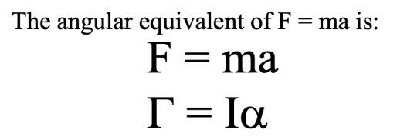

Example: A string with a tension of 2.1 N is wrapped around a 5.2 kg uniform cylinder with a radius of 12 cm. What is the angular acceleration of the cylinder? How many rotations will it make before it reaches a speed of 2300 RPM from rest?

(Whiteboards on the back)

Whiteboards:
1. What torque is needed to accelerate a 23.8 kg m² wheel at a rate of 388 rad/s/s?  (9230 mN) | 2. An object has an angular acceleration of 23.1 rad/s/s when you apply 6.34 mN of torque. What is the object’s moment of inertia?  (0.274 kgm²)
3. If a drill exerts 2.5 mN of torque on a 0.075 m radius, 1.75 kg grinding disk, what is the resulting angular acceleration?  (510 rad/s/s) | 4. What torque would accelerate an object with a moment of inertia of 9.3 kg m² from 2.3 rad/s to 7.8 rad/s in 0.12 seconds? (1 hint)  (430 mN)
5. If you exert 12.0 N tangentially at the edge of a 45.0 kg 72.0 cm diameter cylindrical potter’s wheel, what is its angular acceleration?  (1.48 rad/s/s) | 6. A merry go round is a uniform solid cylinder of radius 2.0 m. You exert 30. N of force on it tangentially for 5.0 s and it speeds up from rest to 12.9 RPMs. What’s its mass?  (110 kg)

Noteguide for Rolling Dynamics (Videos 8I)

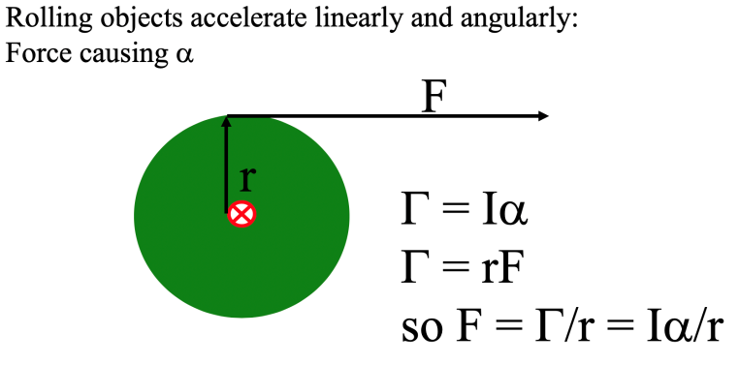

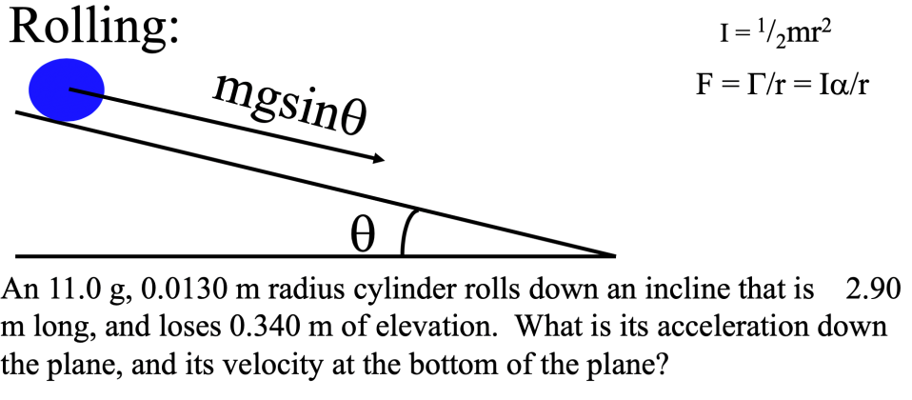

(Try the whiteboard on the back for a different object rolling down the incline)

A marble (a solid sphere: I = ²/₅mr²) has a mass of 23.5 g, a radius of 1.2 cm, and rolls 2.75 m down an incline that loses 0.650 m of elevation.
1. Solve for a in terms of g and sinθ (⁵/₇gsinθ)
2. Plug in and get the acceleration (1.66 m/s/s)
3. suvat for the final velocity (3.02 m/s)

Noteguide for Complex Dynamics (Videos 8J)

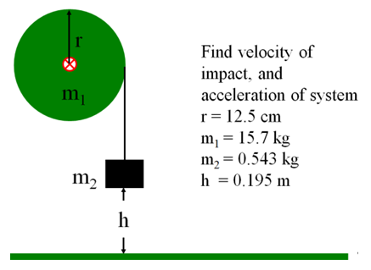

A string is wrapped around a 12.0 cm radius 4.52 kg thin ring. A mass of 0.162 kg is hanging from the end of the string. What is the acceleration of the system, and what is the velocity of m2 when it has fallen 1.00 m? (Assume it is released from rest)
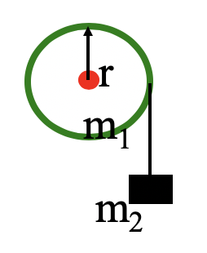

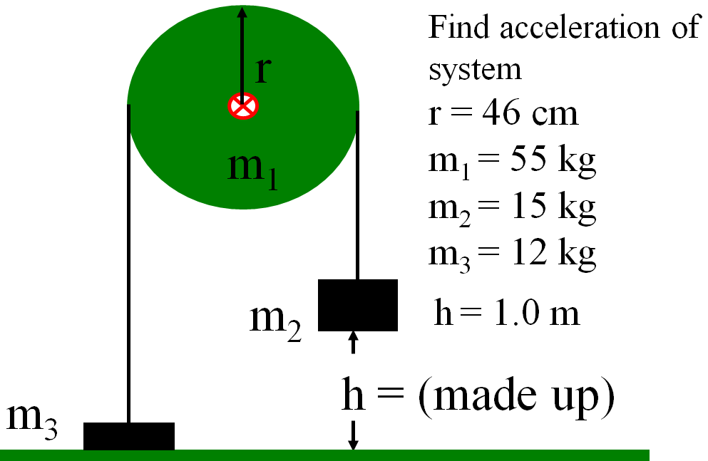

Noteguide for Rotational Kinetic Energy (Videos 8K)

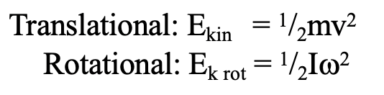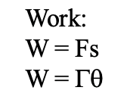
Example: A 23.7 kg 45 cm radius cylinder is rolling at 13.5 m/s at the bottom of a hill.
What is its translational kinetic energy?

What is its rotational kinetic energy?

What is the total kinetic energy? What was the height of the hill?

Whiteboards
1. What is the rotational kinetic energy of an object with an angular velocity of 12.0 rad/s, and a moment of inertia of 56.0 kg m²?  (4.0 x 10³ J) | 2. What must be the angular velocity of a flywheel that is a 22.4 kg, 54 cm radius cylinder to store 10,000. J of energy?  (78 rad/s)
3. What is the total kinetic energy (Translational and rotational) of a 2.5 cm diameter 405 g sphere rolling at 3.5 m/s?  (3.5 J) | 4. If you exert 14.0 mN of torque through 3.10 rotations on a potter’s wheel that is a 26.0 kg, 68.0cm diameter uniform cylinder, what will be the final angular velocity?  (19.1 rad/s)

Noteguide for Rolling COE (Videos 8L)

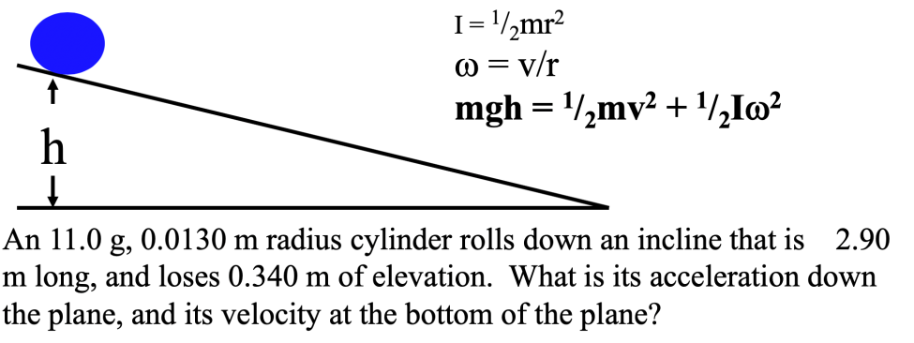

Try this one:
A marble (a solid sphere) has a mass of 23.5 g, a radius of 1.20 cm, and rolls 2.75 m down an incline that loses 0.650 m of elevation.
, 3.02 m/s, 1.66 m/s/s

Noteguide for Complex COE (Videos 8M)

A string is wrapped around a 12.0 cm radius 4.52 kg thin ring. A mass of 0.162 kg is hanging from the end of the string. What is the acceleration of the system, and what is the velocity of m2 when it has fallen 1.00 m? (Assume it is released from rest)

Noteguide for Angular Momentum (Videos 8N, 8O, 8P)

8N: p = mv, L = Iω

Example: What is the angular momentum of a 23 cm radius 5.43 kg grinding wheel at 1500 RPMs?

Whiteboards:
1. What is the Angular Momentum of an object with an angular velocity of 12 rad/s, and a moment of inertia of 56 kgm²? (670 kg m²/s) | 2. What must be the angular velocity of a flywheel that is a 22.4 kg, 54 cm radius cylinder to have 450 kgm²/s of angular momentum? (140 rad/s)

8O: Ft = mΔv , Γt = IΔω

Example: A merry go round that is a 340. kg cylinder with a radius of 2.20 m. If a torque of 94.0 mN acts for 15.0 s, what is the change in angular velocity of the merry go round?

Whiteboards:
1. For what time does a torque of 12.0 mN need to be applied to a cylinder with a moment of inertia of 1.40 kgm² so that its angular velocity increases by 145 rad/s? (16.9 s) | 2. A grinding wheel that is a 5.60 kg 0.125 m radius cylinder goes from 152 rad/s to a halt in 22.0 seconds. What was the frictional torque?  (0.302 mN )

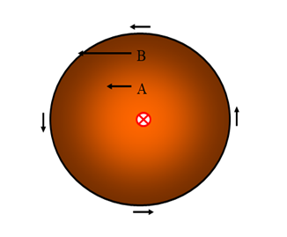
Angular Momentum is Conserved just like linear momentum!!!

8P: I₁ω₁ = I₂ω₂

Example: A figure skater spinning at 3.20 rad/s pulls in their arms so that their moment of inertia goes from 5.80 kgm² to 3.40 kgm². What is their new rate of spin? What were their initial and final kinetic energies?
(Where does the energy come from?)

Example: A merry go round is a 210 kg 2.56 m radius uniform cylinder. Three 60.0 kg children are initially at the edge, and the MGR is initially moving at 23.0 RPM. What is the resulting angular velocity if they move to within 0.500 m of the center?

Whiteboards:
1. A gymnast with an angular velocity of 3.4 rad/s and a moment of inertia of 23.5 kgm² tucks their body so that their new moment of inertia is 12.3 kgm². What is their new angular velocity?  (6.5 rad/s) | 2. A 5.4 x 10³⁰ kg star with a radius of 8.5 x 10⁸ m and an angular velocity of 1.2 x 10⁻⁹ rad/s shrinks to a radius of 1350 m What is its new angular velocity? hint  (480 rad/s)
3. A 12 kg point mass on a massless stick 42.0 cm long has a tangential velocity of 2.0 m/s. How fast is it going if it moves in to a distance of 2.0 cm? hint
(2100 rad/s)

Noteguide for Vector Cross Product and Precession (Videos 8Q) Name

Vector Cross Product:

AxB = ABsin(θ) in the right hand direction

The Right Hand Direction is Funky:

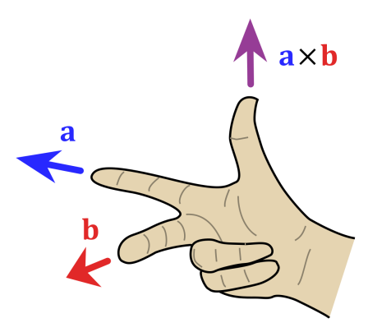
Using your Right hand:
Index Finger: First vector (a in this case)
Middle Finger Second Vector (b in this case)
Thumb: Direction of the cross product

Note that cross products are NOT commutative. (AxB = -BxA)

Whiteboards: (. is out of the page, and x is into the page. The x in the middle just means cross product)
X
X
X
X

x
.
.

Out of the page | Up the page | Left | Right

So Gyroscopes precess because of torque:

Γ = rxF

A wheel spinning anti clockwise has an angular velocity and momentum that is represented by a vector pointing straight at you. (This is another right hand rule that I will explain in class) The tip of that angular momentum vector will go in the direction of rxF using the right hand rule above.

Watch the Ve video and we will do some examples in class.

