Noteguide for Angular Momentum (Videos 8N, 8O, 8P) Name
8N: p = mv, L = Iω

Example: What is the angular momentum of a 23 cm radius 5.43 kg grinding wheel at 1500 RPMs?

Whiteboards:
1. What is the Angular Momentum of an object with an angular velocity of 12 rad/s, and a moment of inertia of 56 kgm²? (670 kg m²/s) | 2. What must be the angular velocity of a flywheel that is a 22.4 kg, 54 cm radius cylinder to have 450 kgm²/s of angular momentum? (140 rad/s)

8O: Ft = mΔv , Γt = IΔω

Example: A merry go round that is a 340. kg cylinder with a radius of 2.20 m. If a torque of 94.0 mN acts for 15.0 s, what is the change in angular velocity of the merry go round?

Whiteboards:
1. For what time does a torque of 12.0 mN need to be applied to a cylinder with a moment of inertia of 1.40 kgm² so that its angular velocity increases by 145 rad/s? (16.9 s) | 2. A grinding wheel that is a 5.60 kg 0.125 m radius cylinder goes from 152 rad/s to a halt in 22.0 seconds. What was the frictional torque?  (0.302 mN )

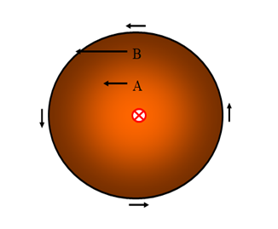
Angular Momentum is Conserved just like linear momentum!!!

8P: I₁ω₁ = I₂ω₂

Example: A figure skater spinning at 3.20 rad/s pulls in their arms so that their moment of inertia goes from 5.80 kgm² to 3.40 kgm². What is their new rate of spin? What were their initial and final kinetic energies?
(Where does the energy come from?)

Example: A merry go round is a 210 kg 2.56 m radius uniform cylinder. Three 60.0 kg children are initially at the edge, and the MGR is initially moving at 23.0 RPM. What is the resulting angular velocity if they move to within 0.500 m of the center?

Whiteboards:
1. A gymnast with an angular velocity of 3.4 rad/s and a moment of inertia of 23.5 kgm² tucks their body so that their new moment of inertia is 12.3 kgm². What is their new angular velocity?  (6.5 rad/s) | 2. A 5.4 x 10³⁰ kg star with a radius of 8.5 x 10⁸ m and an angular velocity of 1.2 x 10⁻⁹ rad/s shrinks to a radius of 1350 m What is its new angular velocity? hint  (480 rad/s)
3. A 12 kg point mass on a massless stick 42.0 cm long has a tangential velocity of 2.0 m/s. How fast is it going if it moves in to a distance of 2.0 cm? hint
(2100 rad/s)

