Noteguide for Rolling COE (Videos 8L) Name

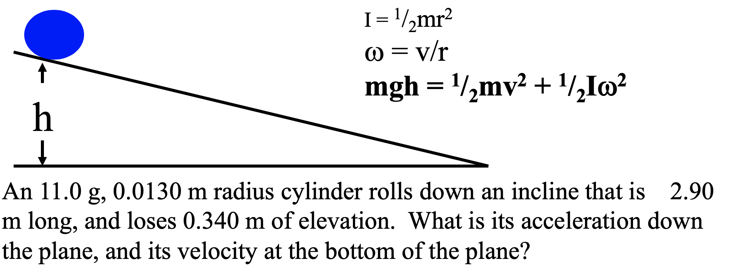

Try this one:
A marble (a solid sphere) has a mass of 23.5 g, a radius of 1.20 cm, and rolls 2.75 m down an incline that loses 0.650 m of elevation.
, 3.02 m/s, 1.66 m/s/s

