Noteguide for Complex Dynamics (Videos 8J) Name

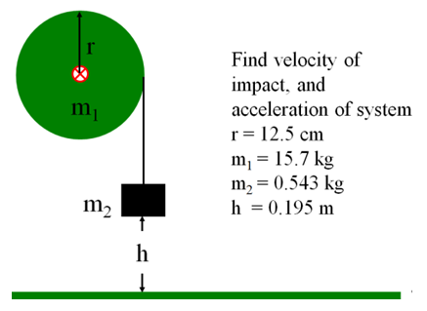

A string is wrapped around a 12.0 cm radius 4.52 kg thin ring. A mass of 0.162 kg is hanging from the end of the string. What is the acceleration of the system, and what is the velocity of m2 when it has fallen 1.00 m? (Assume it is released from rest)
