Noteguide for Rolling Dynamics (Videos 8I) Name

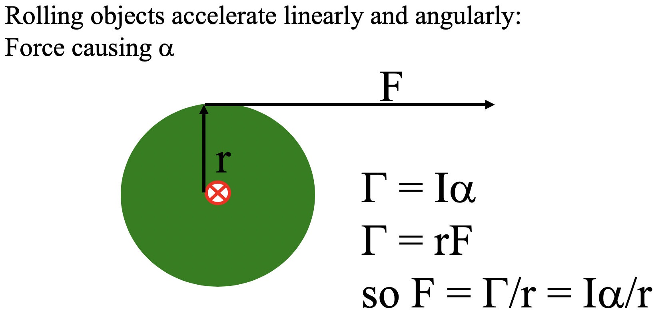

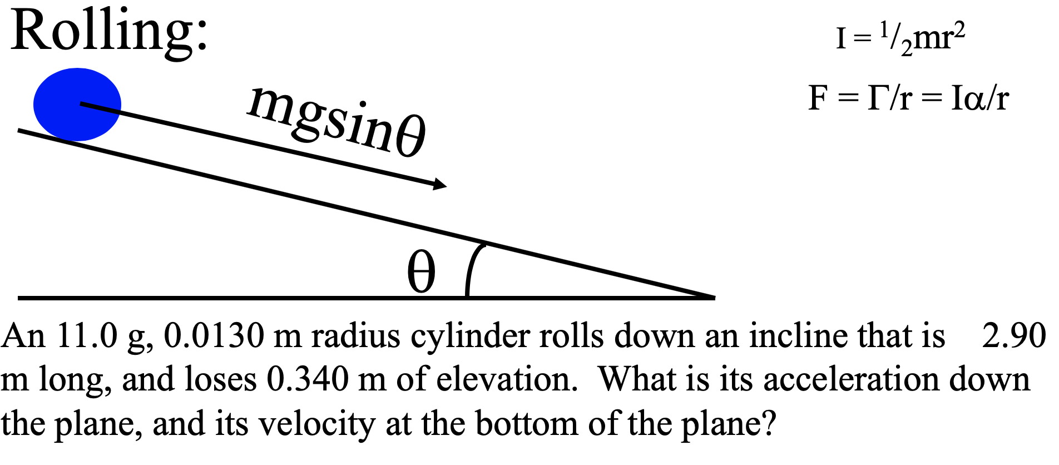

(Try the whiteboard on the back for a different object rolling down the incline)

A marble (a solid sphere: I = ²/₅mr²) has a mass of 23.5 g, a radius of 1.2 cm, and rolls 2.75 m down an incline that loses 0.650 m of elevation.
1. Solve for a in terms of g and sinθ (⁵/₇gsinθ)
2. Plug in and get the acceleration (1.66 m/s/s)
3. suvat for the final velocity (3.02 m/s)

