Noteguide for Angular Dynamics (Videos 8H) Name

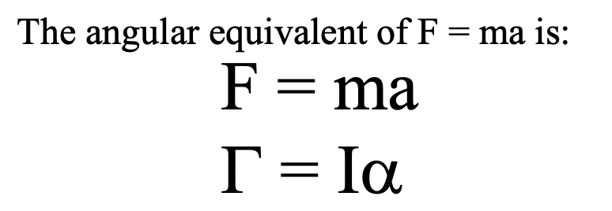

Example: A string with a tension of 2.1 N is wrapped around a 5.2 kg uniform cylinder with a radius of 12 cm. What is the angular acceleration of the cylinder? How many rotations will it make before it reaches a speed of 2300 RPM from rest?

(Whiteboards on the back)

Whiteboards:
1. What torque is needed to accelerate a 23.8 kg m² wheel at a rate of 388 rad/s/s?  (9230 mN) | 2. An object has an angular acceleration of 23.1 rad/s/s when you apply 6.34 mN of torque. What is the object’s moment of inertia?  (0.274 kgm²)
3. If a drill exerts 2.5 mN of torque on a 0.075 m radius, 1.75 kg grinding disk, what is the resulting angular acceleration?  (510 rad/s/s) | 4. What torque would accelerate an object with a moment of inertia of 9.3 kg m² from 2.3 rad/s to 7.8 rad/s in 0.12 seconds? (1 hint)  (430 mN)
5. If you exert 12.0 N tangentially at the edge of a 45.0 kg 72.0 cm diameter cylindrical potter’s wheel, what is its angular acceleration?  (1.48 rad/s/s) | 6. A merry go round is a uniform solid cylinder of radius 2.0 m. You exert 30. N of force on it tangentially for 5.0 s and it speeds up from rest to 12.9 RPMs. What’s its mass?  (110 kg)

