Noteguide for Torque (Videos 8F) Name

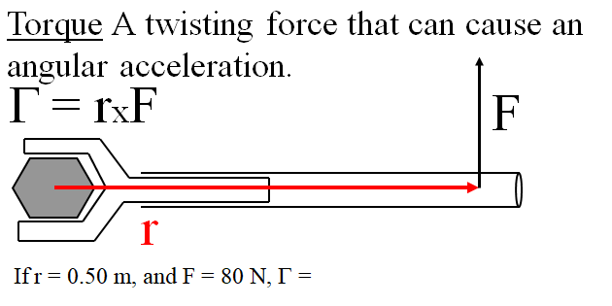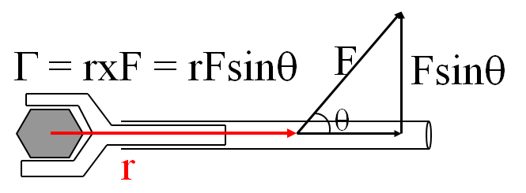

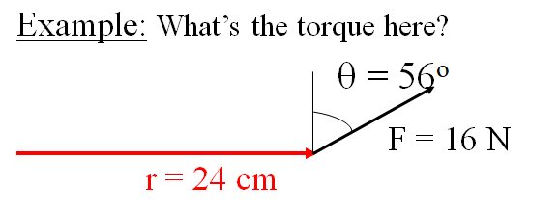

Whiteboards:
1. What is the torque when you have 25 N of force perpendicular 75 cm from the center of rotation?  (19 mN) | 2. If you want 52.0 mN of torque, what force must you exert at an angle of 65.0º to the end of a 0.340 m long wrench?
3. 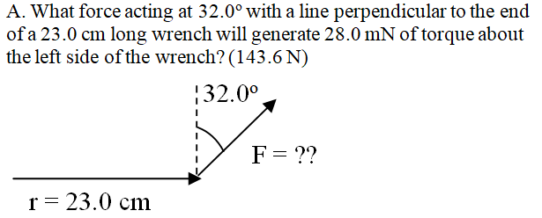 | 4. 