Noteguide for Centripetal Acceleration (Videos 8D) Name

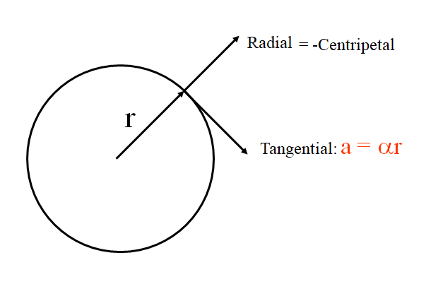

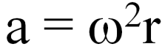

Example: What’s the centripetal acceleration 5.0 cm from the axis of a 10,000 RPM centrifuge?

Whiteboards:
1. What is the centripetal acceleration of a point 35 cm from an axis of a wheel that has an angular velocity of 12 rad/s? (50. m/s/s) | 2. A car has 68 cm diameter wheels, and is going at a constant speed of 32 m/s. What is the tangential acceleration, and what is the radial (centripetal) acceleration? (0 m/s/s, 3000 m/s/s)
3. What is the angular velocity of a centrifuge if it pulls 2000. “g”s with a radius of 6.7 cm? How many RPMs is this? (540 rad/s, 5200 RPM)

