Objective E: Conservation of Momentum
- A 1200 Kg car going 13 m/s collides with a 4200 Kg truck at rest. Their bumpers lock. What is their speed afterwards? (2.89 m/s)
- A 60.0 Kg person running 3.00 m/s East collides head on with a 100. Kg person running 2.00 m/s the other way. What is their final velocity if they stick together? (0.125 m/s West)
- A 50. Kg ice skater at rest throws a 5.0 Kg shot put at a velocity of +3.5 m/s. What is the recoil velocity of the skater? (-0.35 m/s)
- A 1200 Kg car going 15 m/s rear-ends with a 800. Kg car going 5.0 m/s in the same direction. Their bumpers lock. What is their speed afterwards? (11 m/s)
- A 2000. Kg airplane going 45.0 m/s fires a 2.00 Kg shell forward at a speed of 1200. m/s. What is the final velocity of the plane? (Planes crashed because of this!) (43.8 m/s)
- A 14.5 g bullet traveling 783 m/s horizontally strikes a 9.24 Kg block of wood at rest on a level frictionless table. The bullet goes through the block, but is traveling only 382 m/s in the same direction after the collision. What is the velocity of the block after the collision? (Assume the block loses no mass) (0.629 m/s)
- Bumper car A (326 Kg) with velocity 3.7 m/s East collides with the rear of car B (536 Kg) which has a velocity of 2.4 m/s East. After the collision, car A has a velocity of 1.2 m/s to the West. What is the velocity of car B after the collision? (5.4 m/s East)
- A 132.45 g bullet traveling at 386 m/s rips a hole through a 1.34 Kg block of wood at rest on some frictionless ice. The bullet is traveling 153 m/s following the collision, what is the speed of the block? (23.0 m/s)
- A 153 gram bullet going 452 m/s goes through the first of two stationary 3.50 kg blocks of wood, and sticks in the second. After this, the first block is traveling at 6.50 m/s in the same direction.
  - What speed are the second block and bullet going? (12.7 m/s)
  - What is the bullet’s velocity between the blocks? (303 m/s)
- Two 746 g blocks of wood are at rest on that by now familiar frictionless surface. A 123 g bullet is shot through the first and sticks in the second. Following this the first block is moving 12.5 m/s, and the second with the bullet stuck in it 34.6 m/s. Neither the bullet nor the blocks lose any pieces.
  - What was the bullet's velocity between the blocks? (244 m/s)
  - What was the bullet's velocity before it hit the first block? (320. m/s)
  - Suppose the bullet's interaction with the first block had taken .0200 seconds. What force would it have exerted on the block? (466 N)
  - If in actuality there had been a frictional force of about .50 N on the second block with the bullet stuck in it, over what time would it have been brought to rest? (60. s)
  - Suppose the bullet had stuck in the first block, causing it to slide into and stick to the second block. What would have been the velocity of the bullet and the two blocks? (24.4 m/s)
- 60.0 kg Brennen is playing on two flatbed rail cars initially at rest. Car A has a mass of 560. kg and B 780. kg. He reaches a velocity of +5.20 m/s on A, before jumping to B where he slows to +3.40 m/s before jumping off the other end. The cars are uncoupled, and rest on a frictionless track:
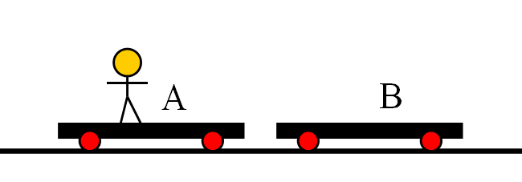
  - What is the velocity of car A when he is in midair? (-0.557 m/s)
  - What is the velocity of car B when he leaves it? (+0.138 m/s)
  - What would have been the velocity of car B had he remained there, and not jumped off? (+0.371 m/s)
  - What would the velocity of car B have been had he jumped off the back of it to give himself a velocity of zero? (+0.40 m/s)
- 109 Kg Thor and his 5.26 Kg hammer are at rest on top of the first of two uncoupled frictionless 89.7 Kg carts that are next to each other. (Ok – it’s a physics word problem) Thor runs and jumps from one cart to the other and lands on it. (Still holding the hammer) He, the hammer, and the cart are going +1.56 m/s in the end.
  - What must be the velocity of the other cart? (-3.55 m/s)
  - What was Thor's velocity after he left the first cart, but before he landed on the second? (2.78 m/s)
  - With what velocity must he throw his hammer to give himself and the cart he lands on (Not the one he starts on) a velocity of 2.00 m/s? (-15.1 m/s)
  - If instead of throwing the hammer in C), he were to jump from the second cart in such a way that he was not moving horizontally with respect to the ground, what would be the velocity of the second cart? (3.55 m/s)
- Problems from Chapter 7: 4(-0.901 m/s), 6(4.8 m/s), 7(12.6 m/s), 8(1.4E4 kg), 10(7.9 m/s), 11(4.2E3 m/s), 12(0.69 m/s)

