Noteguide for Energy and Momentum (Videos 7F) Name
Example 1: 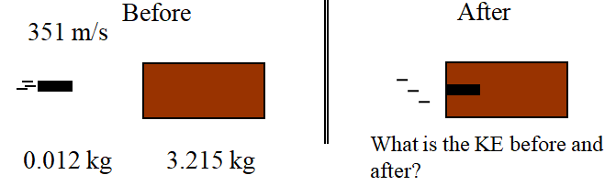

Example 2: A 220. gram air track glider going 0.120 m/s collides head on with a 410. gram glider going the other way at 0.380 m/s. The gliders then stick together. What is their post collision speed? How much kinetic energy is lost in the collision?

Example 3: 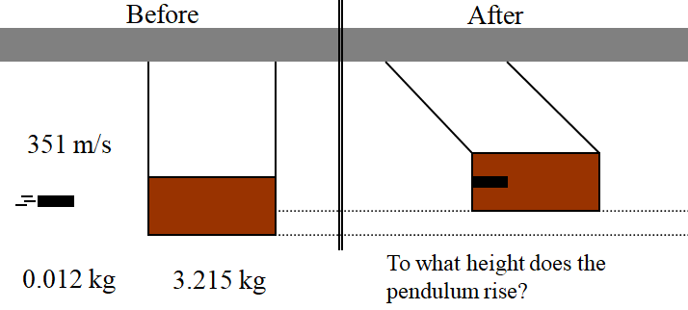

(See if you can work this one out...)
Whiteboard 4: A 4.50 g bullet going 916 m/s horizontally sticks into a 1.12 kg block of wood hanging from a very long string. What is the velocity of the block right after the collision? To what height does the block rise on the string? (3.67 m/s, 0.685 m)

Example 5: 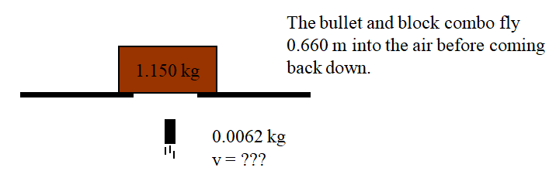

(See if you can work this one out...)
Whiteboard 6: A 6.30 g bullet going straight up at some speed strikes the bottom of a 1.65 kg block of wood at rest, and sticks in it without going through. The bullet and block combo fly 1.14 m up into the air. What was the post collision speed of the combo, and what was the bullet's original speed?
(4.73 m/s, 1243 m/s)

