Noteguide for Rocket Science (Videos 7D) Name
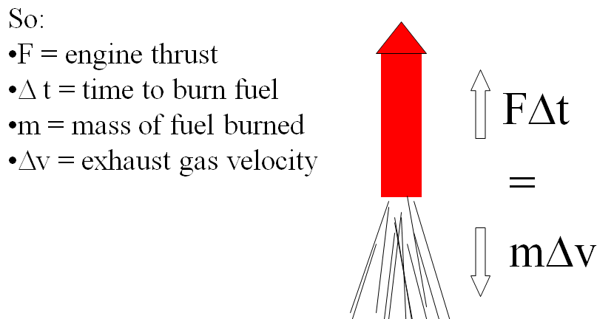
Example 1: A rocket burns fuel at a rate of 1.2 kg/s, with an exhaust velocity of 1250 m/s. What thrust does it develop?

Example 2: A model rocket has a mass of 0.238 kg, 0.126 kg of which is fuel. It burns its fuel at a rate of 0.0184 kg/s and has an exhaust velocity of 718 m/s
What are the rocket’s initial and final accelerations?

Whiteboards:
1. A certain rocket engine burns 0.0352 kg of fuel per second with an exhaust velocity of 725 m/s. What thrust does it generate? (25.5 N) | 2. The Saturn V’s first stage engines generated 33.82 MN of thrust (33.82 x 10⁶ N) with an exhaust velocity of 2254.7 m/s. What was its fuel burn rate? (15,000 kg/s)
3. A 270. kg rocket, 185 kg of which is fuel, burns all of its fuel in 26.0 seconds with an exhaust velocity of 852 m/s. What are its initial and final acceleration as it takes off from earth?  (12.6 m/s/s, 61.5 m/s/s) | 4. A 43.0 kg rocket (total mass of fuel and rocket), burns fuel at a rate of 1.54 kg/s for 13.7 seconds with an exhaust velocity of 821 m/s. What are its initial and final acceleration as it takes off from earth?  (19.6 m/s/s, 47.9 m/s/s)

Solid Fuel:
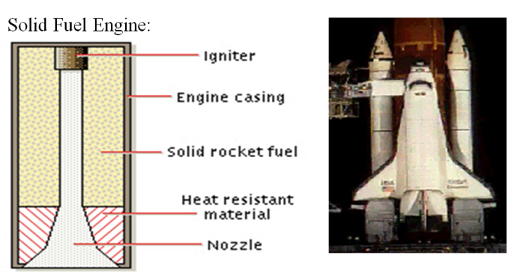

Liquid Fuel:
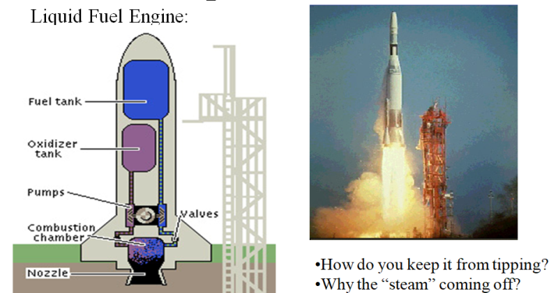

Ion Propulsion:
