Noteguide for MOMentum (Videos 7A) Name

Momentum:
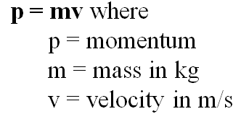
Head on collision - small vs big

Example: What is the momentum of a 145 g baseball going 40. m/s?

Example: 60 kg Fran is running at 4 m/s when she collides with 80 kg Joe. They hit and stop dead, so how fast was Joe going?

Conservation of momentum:

Whiteboards:
1. What is the momentum of a 22 g swallow going 5.2 m/s (0.11 kg m/s) | 2. What velocity must a 6.5 gram bullet have for its momentum to be 5.8 kg m/s? (890 m/s)
3. A bowling ball has a momentum of 43.6 kg m/s when it is going 12 m/s. What is its mass? (3.6 kg)

