Noteguide for MOMentum (Videos 7A) Name

Momentum:
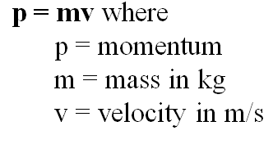
Head on collision - small vs big

Example: What is the momentum of a 145 g baseball going 40. m/s?

Example: 60 kg Fran is running at 4 m/s when she collides with 80 kg Joe. They hit and stop dead, so how fast was Joe going?

Conservation of momentum:

Whiteboards:
1. What is the momentum of a 22 g swallow going 5.2 m/s (0.11 kg m/s) | 2. What velocity must a 6.5 gram bullet have for its momentum to be 5.8 kg m/s? (890 m/s)
3. A bowling ball has a momentum of 43.6 kg m/s when it is going 12 m/s. What is its mass? (3.6 kg)

Noteguide for Impulse (Videos 7B) Name

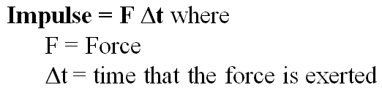
Impulse (change in momentum)
Example: What impulse is imparted by exerting a 12 N force for 4.0 s?

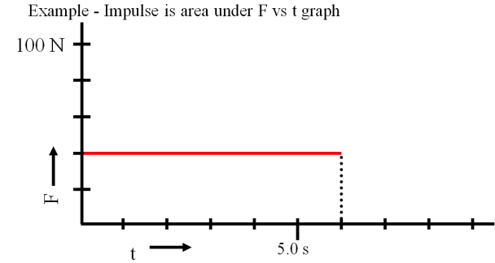

Whiteboards:
1. What is the impulse of a 6.12 N force acting for 2.3 seconds (14 N s) | 2. A rocket engine is rated at 14 N s of impulse, and burns for 1.7 seconds. What is the thrust of the engine? (8.2 N)
3. 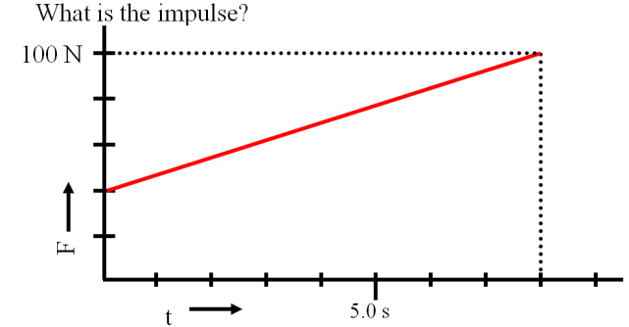  (560 N s) | 4. 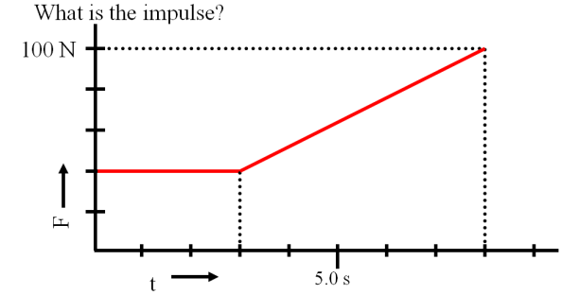  (470 N s)

Noteguide for Impulse and Momentum (Videos 7C) Name

Impulse = Change in momentum
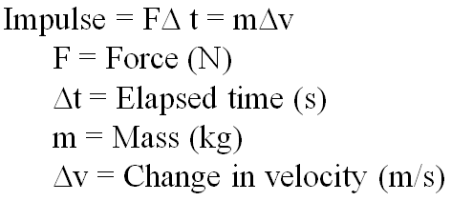
Example: A pitcher pitches a 0.145 kg baseball at 40. m/s, and the batter hits it directly back at 50. m/s to the outfield. What is the average force exerted by the bat if the collision lasted 0.013 s?

Deriving Newton’s second law:

Whiteboards:
1. What force for 10. seconds makes a 2.0 kg rocket speed up to 75 m/s from rest? (15 N) | 2. A baseball bat exerts a force of 200. N on a .50 kg ball for .10 seconds. What is the ball’s change in velocity? (40 m/s)
3. Jolene exerts a 50. N force for 3.0 seconds on a stage set. It speeds up from rest to 0.25 m/s. What is the mass of the set? (600 kg) | 4. A pitcher pitches a 0.145 kg baseball at 35.0 m/s, and the batter hits it directly back at 42.0 m/s to the outfield. The bat exerts an average force of 892 N on the ball. For what time does the collision last? (0.0125 s)

Noteguide for Rocket Science (Videos 7D) Name
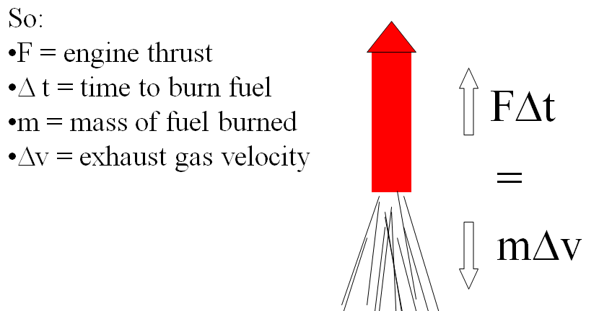
Example 1: A rocket burns fuel at a rate of 1.2 kg/s, with an exhaust velocity of 1250 m/s. What thrust does it develop?

Example 2: A model rocket has a mass of 0.238 kg, 0.126 kg of which is fuel. It burns its fuel at a rate of 0.0184 kg/s and has an exhaust velocity of 718 m/s
What are the rocket’s initial and final accelerations?

Whiteboards:
1. A certain rocket engine burns 0.0352 kg of fuel per second with an exhaust velocity of 725 m/s. What thrust does it generate? (25.5 N) | 2. The Saturn V’s first stage engines generated 33.82 MN of thrust (33.82 x 10⁶ N) with an exhaust velocity of 2254.7 m/s. What was its fuel burn rate? (15,000 kg/s)
3. A 270. kg rocket, 185 kg of which is fuel, burns all of its fuel in 26.0 seconds with an exhaust velocity of 852 m/s. What are its initial and final acceleration as it takes off from earth?  (12.6 m/s/s, 61.5 m/s/s) | 4. A 43.0 kg rocket (total mass of fuel and rocket), burns fuel at a rate of 1.54 kg/s for 13.7 seconds with an exhaust velocity of 821 m/s. What are its initial and final acceleration as it takes off from earth?  (19.6 m/s/s, 47.9 m/s/s)

Solid Fuel:
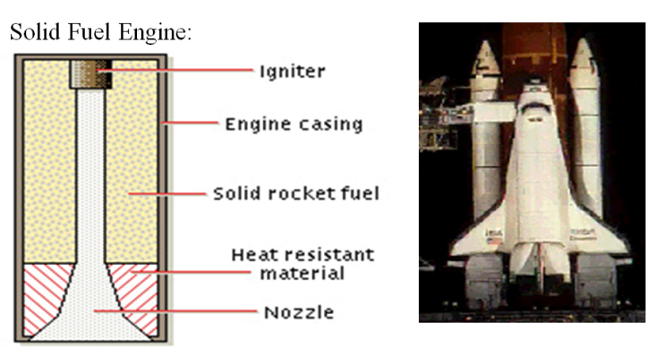

Liquid Fuel:
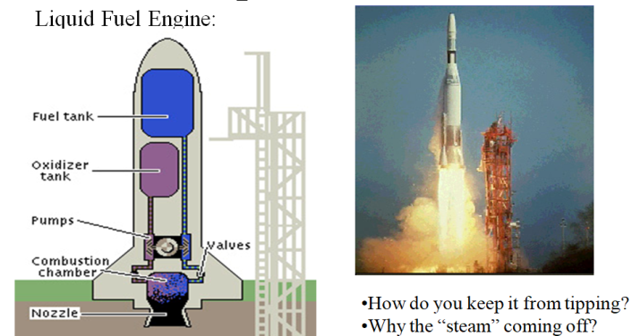

Ion Propulsion:
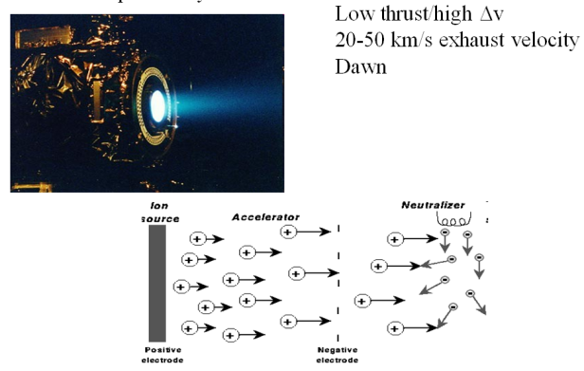

Noteguide for Conservation of Momentum (Videos 7E) Name
Why is momentum conserved:
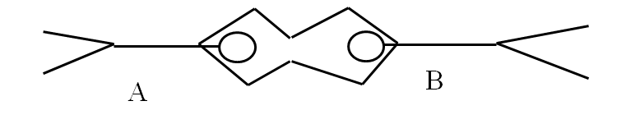

Example 1: A 4.30 g bullet travelling 925 m/s horizontally strikes and sticks in a 121 g block of wood. What is the velocity of the bullet and block after the collision?

Example 2: 60.0 kg Brennen is at rest on a 352 kg flatbed cart. He runs to the right and is going 5.30 m/s before he leaps from the car. What is the recoil velocity of the flatbed car? Ignore the friction of the wheels.

Example 3: A 2560 kg Mazda Protégé going 27.0 m/s strikes a Ford Escort traveling 13.0 m/s in the same direction from behind. The two cars stick together and are going 20.6 m/s after the collision. What is the mass of the Escort?

Example 4: Bumper car A (450 Kg) with velocity 2.90 m/s East collides with the front of car B (580. Kg) which has a velocity of 3.40 m/s West. After the collision, car B has a velocity of 1.20 m/s to the East. What is the velocity of car A after the collision? (Speed and direction)

Whiteboards:
1. 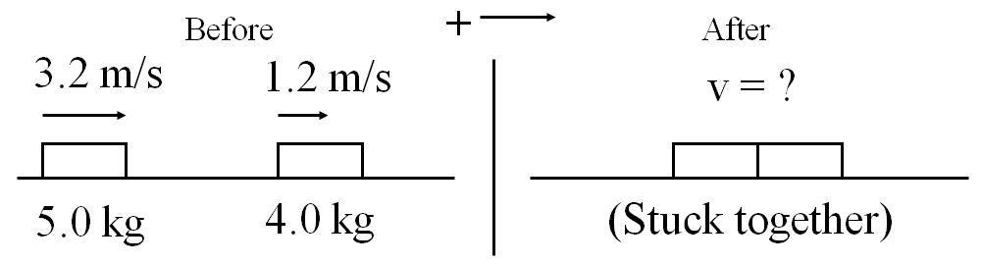(2.3 m/s to the right)

2. 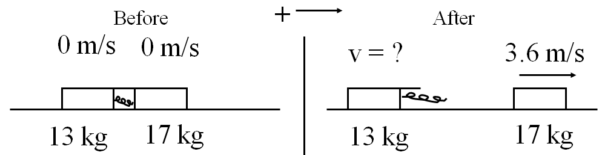 (4.7 m/s to the left)

3. 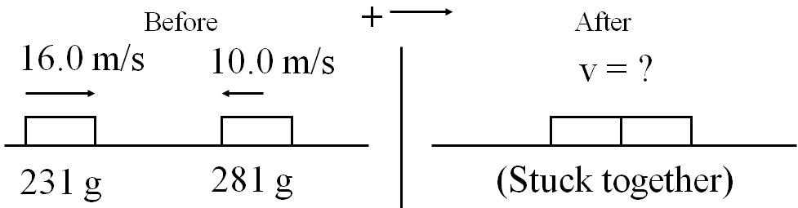 (1.73 m/s to the right)

4. 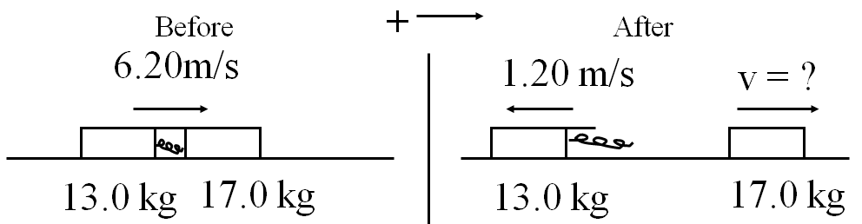 (11.9 m/s to the right)

Noteguide for Energy and Momentum (Videos 7F) Name
Example 1: 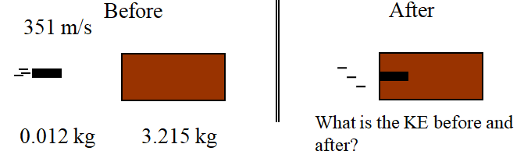

Example 2: A 220. gram air track glider going 0.120 m/s collides head on with a 410. gram glider going the other way at 0.380 m/s. The gliders then stick together. What is their post collision speed? How much kinetic energy is lost in the collision?

Example 3: 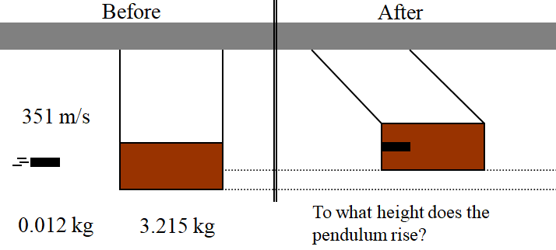

(See if you can work this one out...)
Whiteboard 4: A 4.50 g bullet going 916 m/s horizontally sticks into a 1.12 kg block of wood hanging from a very long string. What is the velocity of the block right after the collision? To what height does the block rise on the string? (3.67 m/s, 0.685 m)

Example 5: 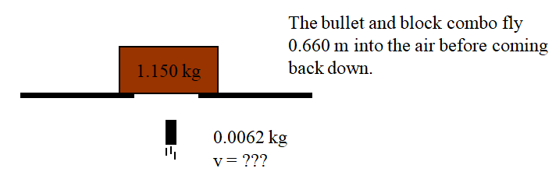

(See if you can work this one out...)
Whiteboard 6: A 6.30 g bullet going straight up at some speed strikes the bottom of a 1.65 kg block of wood at rest, and sticks in it without going through. The bullet and block combo fly 1.14 m up into the air. What was the post collision speed of the combo, and what was the bullet's original speed?
(4.73 m/s, 1243 m/s)

Noteguide for Basic Quantities and Conversions (Videos 8ABC) Name
8A:
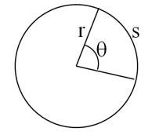
Radians:
360º = 2π radians = full circle

(Do 1-5 on the Worksheet)

Angular Quantities:
Linear:  s  v  a | Angular:  θ  ω  α

8B:
Conversions: (Let's use revolution as a synonym for rotation in this unit)
Radians  Revolutions  Rad/s  Rad/s  Rev/min (RPM) | = rev x (2π)  = rad ÷ (2π)  = RPM x (2π) ÷ (60)  = (rev/s) x (2π)  = (rad/s) x (60) ÷ ( 2π)

(Do 6-13 on the Worksheet)

8C:
Tangential relationships:
Linear:  (m) s  (m/s) v  (m/s/s) a | Tangential: (at the edge of the wheel)  = θr - Displacement*  = ωr - Velocity  = αr - Acceleration*  * not in data packet

(Do 14-23 on the Worksheet) - For 20-23, convert the angular quantity to radians, rad/s or rad/s/s, and then apply the tangential relationship.

