Noteguide for Work and Energy (Videos 6A and 6B) Name

What is Energy:

Electromagnetic Potential Kinetic Thermal

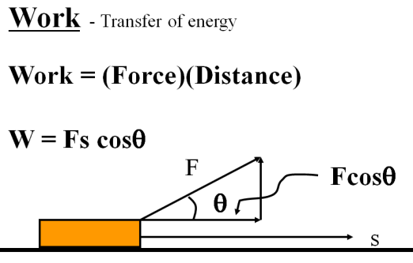
Example: What is the work done if you exert 12. N to drag a box 4.0 m across the floor? (Be sure to write down what a Joule is)

Whiteboards:
1. Fred O’Dadark exerts 13.2 N on a rope that makes a 32º angle with the ground, sliding a sled 12.5 m along the ground. What work did he do? | 2. Jane Linkfence does 132 J of work lifting a box 1.56 m. What is the weight of the box?
3. Helena Handbasket brings a 5.2 kg box down from a 1.45 m tall shelf. What work does she do?

Noteguide for Potential Energy (Videos 6C) Name

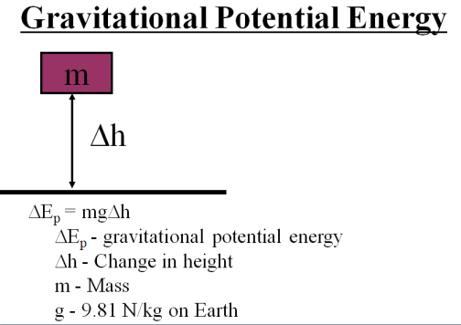

Example: What is the potential energy of a 5.00 kg mass that is 2.00 m above the ground?

Whiteboards:
1. What is the potential energy of a 4.5 kg bowling ball, 13.5 cm above the ground? (6.0 J) | 2. Toby Continued lifts a 75.0 kg box doing 1573 J of work. What is the change in height of the box?  (2.14 m)
3. Colin Host lifts himself up 15 m doing 9555 J of work. What is his mass? (65 kg)

Noteguide for Kinetic Energy (Videos 6D) Name

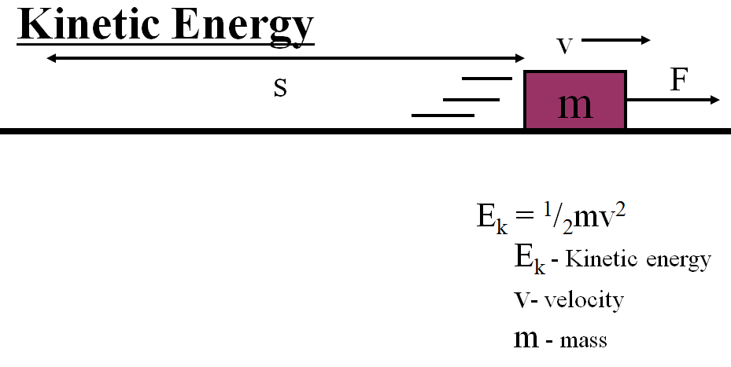

Example: What is the kinetic energy of a 0.145 kg baseball going 40.0 m/s? (about 90 mph)

Whiteboards:
1. What is the kinetic energy of a 4.20 g bullet going 965 m/s? (units?) (1960 J) | 2. What speed must a 0.563 kg hammer move to store 34 J of energy? (11 m/s)
3. A 4.0 kg shot is sped up from 6.0 m/s to 9.0 m/s. What is the change in kinetic energy? (90. J) | 4. A European swallow has 2.055 J of kinetic energy when it is flying at 14.23 m/s. What is its mass in grams? (20.29 g)

Noteguide for Spring Force (Videos 6E) Name

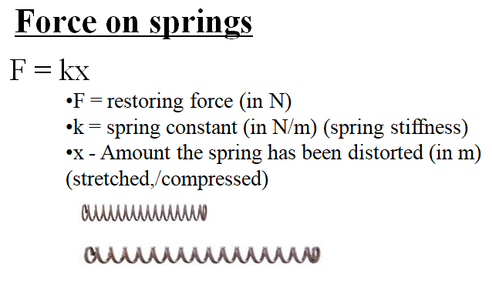

Example: Ali Zabov stretches a 53 N/m spring 13 cm with what force?

Whiteboards:
1. A spring requires 15 N to stretch 42 cm. What is the spring constant K? (35.7 N/m) | 2. Nona Zabov allows the weight of a 2.1 kg mass to stretch a 35 N/m spring. What distance does it stretch? (0.59 m)

Noteguide for Spring Energy (Videos 6F) Name

Energy Stored in a Spring:
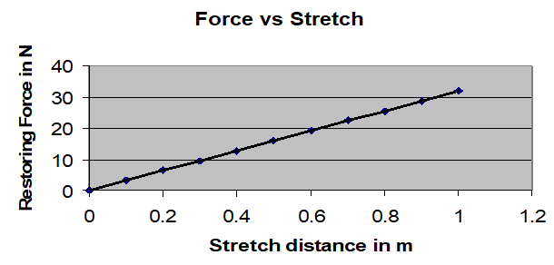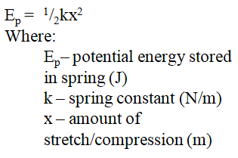

Example: What is the energy stored in a spring with a spring constant of 30. N/m when it is
stretched 15 cm?

Whiteboards:
1. Mary H. Little-Lamb has a 24 N/m spring that is 31 cm long un-stretched. What energy does she store in it if she stretches it until it is 46 cm long?  (0.27 J) | 2. A spring stores 56 J of energy being distorted 1.45 m. What is its spring constant? (53 N/m)
3. What amount must you distort a 14.5 N/m spring to store 98 J of energy? (3.7 m) | 4. How much work is it to stretch a 23.5 N/m spring from 1.14 m to 1.56 m of distortion?  (13.3 J)

Noteguide for Conservation Of Energy (Videos 6G) Name

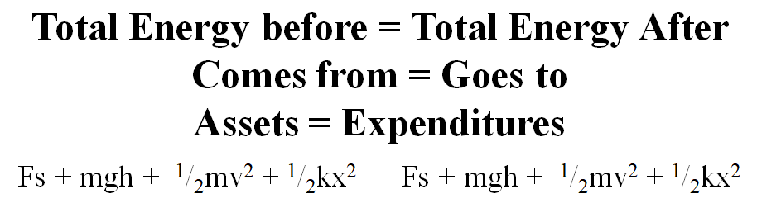

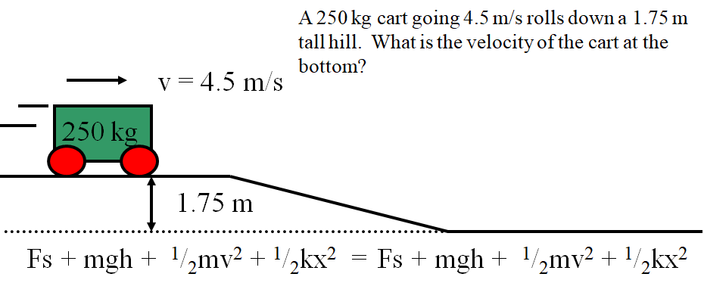

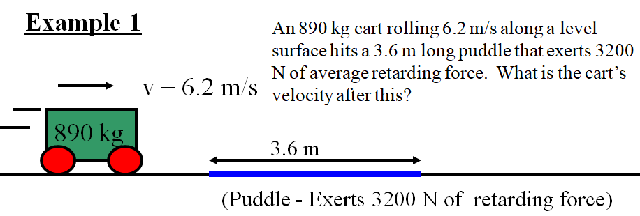

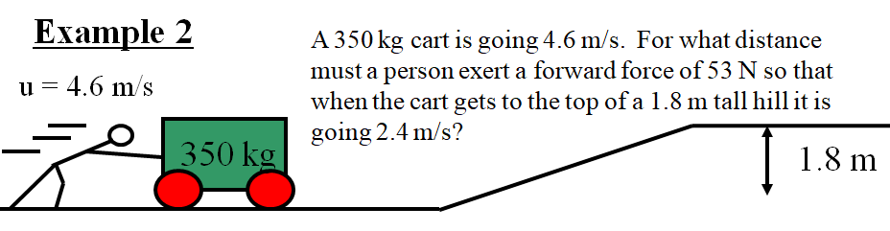

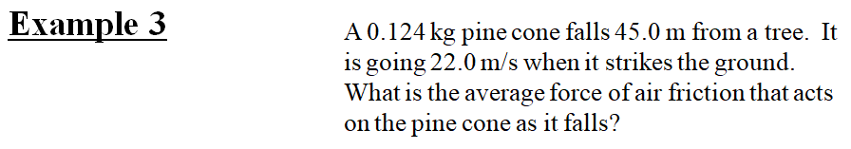

Noteguide for Power (Videos 6H) Name

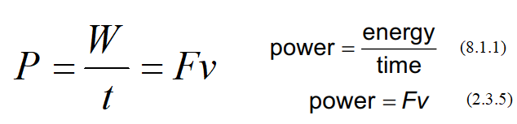
A person does 48 J of work in 6.0 s. What is their power output?

Examples
How much energy does a 75 Watt light bulb consume in a minute? (60 s) | My 30. HP van could go 25 m/s top speed. What was the force resisting its motion?  1 horsepower = 745.7 Watts, 1 kW = 1000 Watts

Whiteboards:
1. Joe Mama does 613 J of work in 2.13 seconds. What is his power output? (288 W) | 2. Ima Wonder can put out 127 W of power. What time will it take her to do 671 J of work? (5.28 s)
3. What work does a 1.5 HP motor do in 1 minute?  (1 hp = 745.7 W) (67,000 J) | 4. Bob N. Frappels slides a box with 43 N of force at a constant speed of 5.3 m/s. What is his power output? (230 W)
5. Frieda People can put out 430. W of power. With what speed can she push a car if it takes 152 N to make it move at a constant velocity? (2.83 m/s)

Noteguide for Work and Power (Videos 6I) Name

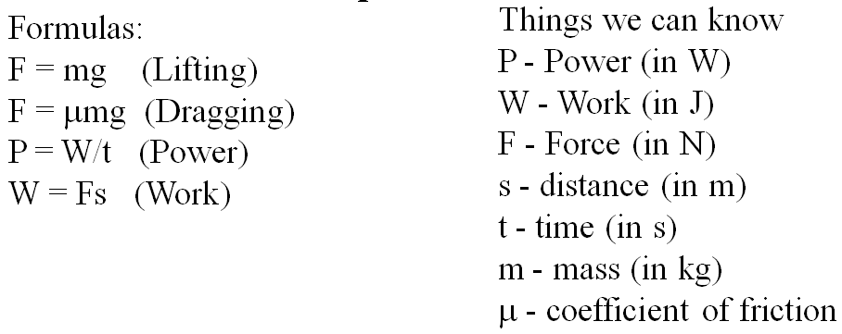
Example 1 - A 840 W winch can lift a 2350 kg Land Rover up 8.2 m into a tree in what time?

Example 2 - Gumi Baere drags a 45.1 kg box that has a coefficient of friction between it and the floor of 0.34 a distance of 16 m in 11.7 seconds. What is her power output?

Whiteboards:
1. What must be the power rating of a motor if it is to lift a 560 kg elevator up 3.2 m in 1.5 seconds? (11,700 W) | 2. A 560. W winch can lift a car 5.2 m in 37 seconds. What must be the mass of the car?  1 HP = 745.7 W (407 kg)
3. Red Elk leads a dog team that can put out 2.5 kW of power. They skid a 312 kg sled a distance of 340 m in 93 seconds. What must be the coefficient of friction? (0.22) | 4. A 50.0 HP tractor can drag a 982 kg load how far in a minute if the coefficient of friction between the load and the ground is 0.780.  1 HP = 745.7 W (298 m)

Noteguide for Efficiency (Videos 6J) Name

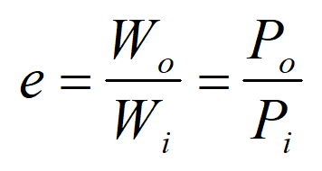 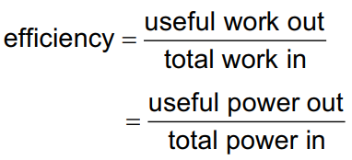 (2.3.6)

Example: A 1 HP motor consumes 815 W of power. What is its efficiency?

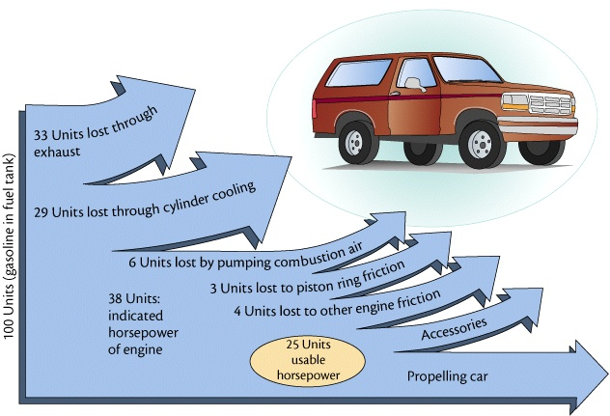

Whiteboards:
1. A motor consumes 425 J of energy and does 300 J of work. e = ? (0.71 or 71%) | 2. A person is 13% efficient. How much food energy to do 600. J of work? (4600 J)
3. A 60.% efficient heater uses 800. J of energy. What is its heat output? (480 J) | 4. A car is 25% efficient. What energy input does it need to climb a 320 m tall hill if its mass is 1200 kg? W_{o} = mgh for the car (1.5x10⁷ J)

