Noteguide for Spring Energy (Videos 6F) Name

Energy Stored in a Spring:
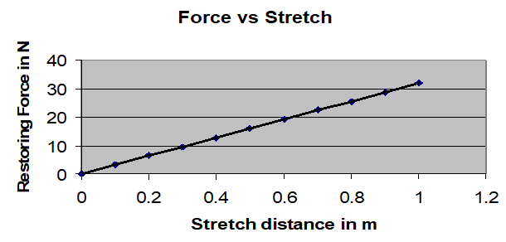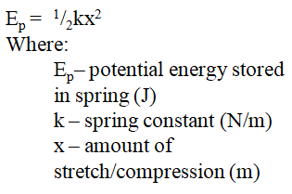

Example: What is the energy stored in a spring with a spring constant of 30. N/m when it is
stretched 15 cm?

Whiteboards:
1. Mary H. Little-Lamb has a 24 N/m spring that is 31 cm long un-stretched. What energy does she store in it if she stretches it until it is 46 cm long?  (0.27 J) | 2. A spring stores 56 J of energy being distorted 1.45 m. What is its spring constant? (53 N/m)
3. What amount must you distort a 14.5 N/m spring to store 98 J of energy? (3.7 m) | 4. How much work is it to stretch a 23.5 N/m spring from 1.14 m to 1.56 m of distortion?  (13.3 J)

