Noteguide for Spring Force (Videos 6E) Name

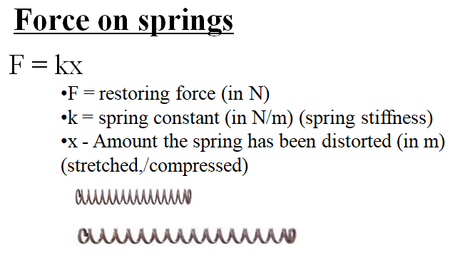

Example: Ali Zabov stretches a 53 N/m spring 13 cm with what force?

Whiteboards:
1. A spring requires 15 N to stretch 42 cm. What is the spring constant K? (35.7 N/m) | 2. Nona Zabov allows the weight of a 2.1 kg mass to stretch a 35 N/m spring. What distance does it stretch? (0.59 m)

