Noteguide for Kinetic Energy (Videos 6D) Name

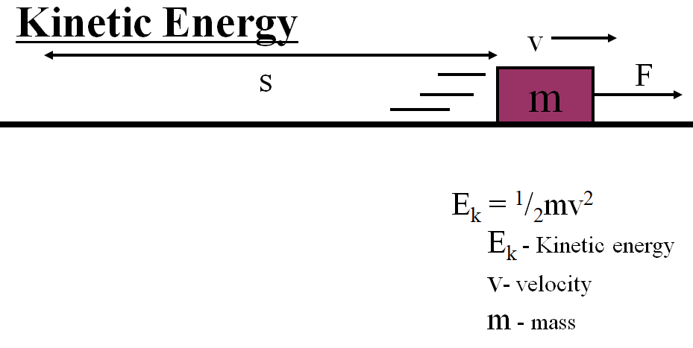

Example: What is the kinetic energy of a 0.145 kg baseball going 40.0 m/s? (about 90 mph)

Whiteboards:
1. What is the kinetic energy of a 4.20 g bullet going 965 m/s? (units?) (1960 J) | 2. What speed must a 0.563 kg hammer move to store 34 J of energy? (11 m/s)
3. A 4.0 kg shot is sped up from 6.0 m/s to 9.0 m/s. What is the change in kinetic energy? (90. J) | 4. A European swallow has 2.055 J of kinetic energy when it is flying at 14.23 m/s. What is its mass in grams? (20.29 g)

