Noteguide for Work and Energy (Videos 6A and 6B) Name

What is Energy:

Electromagnetic Potential Kinetic Thermal

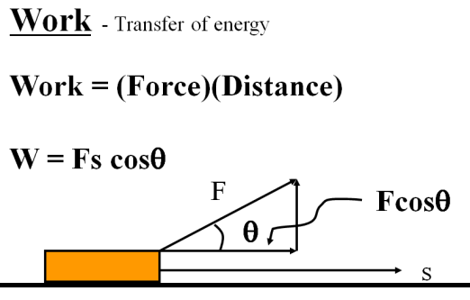
Example: What is the work done if you exert 12. N to drag a box 4.0 m across the floor? (Be sure to write down what a Joule is)

Whiteboards:
1. Fred O’Dadark exerts 13.2 N on a rope that makes a 32º angle with the ground, sliding a sled 12.5 m along the ground. What work did he do? | 2. Jane Linkfence does 132 J of work lifting a box 1.56 m. What is the weight of the box?
3. Helena Handbasket brings a 5.2 kg box down from a 1.45 m tall shelf. What work does she do?

