Name:______________________________________________ Date:_____________ Period:________

Plate Lab

Goal: to analyze the forces needed for circular motion and
understand what happens when those forces are removed.

A marble on a plate can be made to go in a circle. Push a marble along the edge of a whole (uncut) plate and think about and answer the questions below. For this activity, the drawings and images will be from the viewpoint directly above the plate looking down.

After your push, what is the force causing this circular motion? _______________
In the diagram below, imagine the ball is going anti-clockwise. Draw an arrow representing the instantaneous velocity at this point. Label it "V". Draw another arrow showing the direction of the force acting on the marble to make it go in a circle. Label it "F". Also label which way you think the acceleration is with an arrow labeled "a"
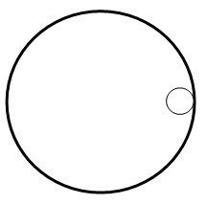
A second plate has a section cut out of it. If you give the marble a push near the top so that it travels along the plate counter-clockwise, predict what path you think the marble take when it exits the plate. Draw the predicted path on the picture below. Write a short sentence why you think this will happen.

Predicted: Actual:
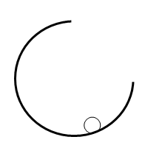

Test out your guess with the plate and marble. Do the experiment several times to make sure you know what actually happens. Draw the path it actually takes.

